You will be going back to school soon

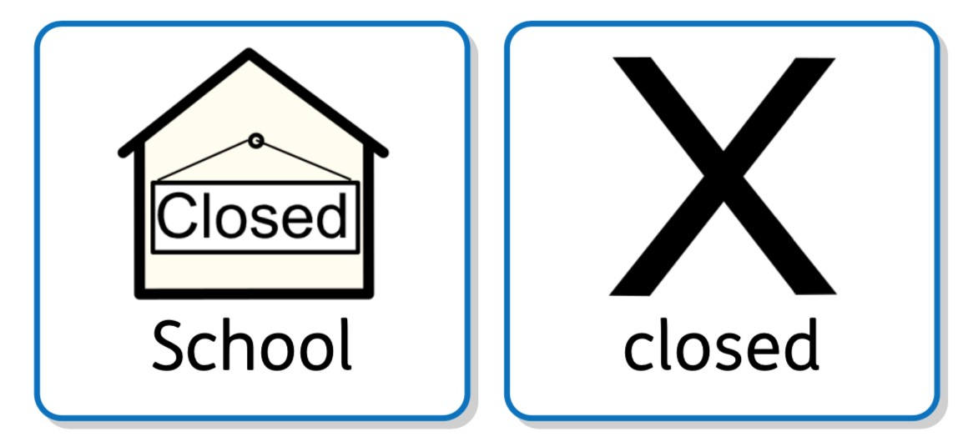

Since 23rd March 2020, most schools in England have closed to most of the children. It has been closed because of Coronavirus.
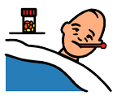

Some children still went to school each day because they have parents who work as key workers. Other children have been at home each day.

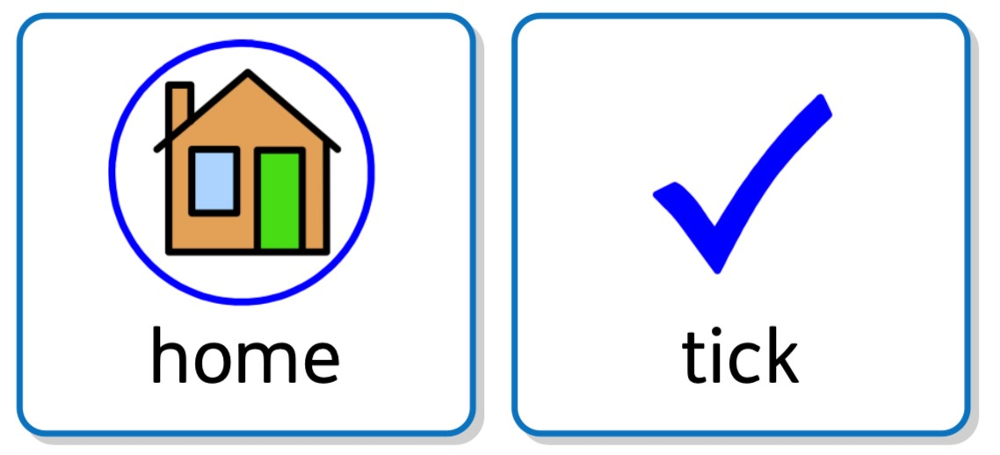
This time in lockdown has become a new normal for us all.

The government have now made the decision it is time for some children to come back to school.
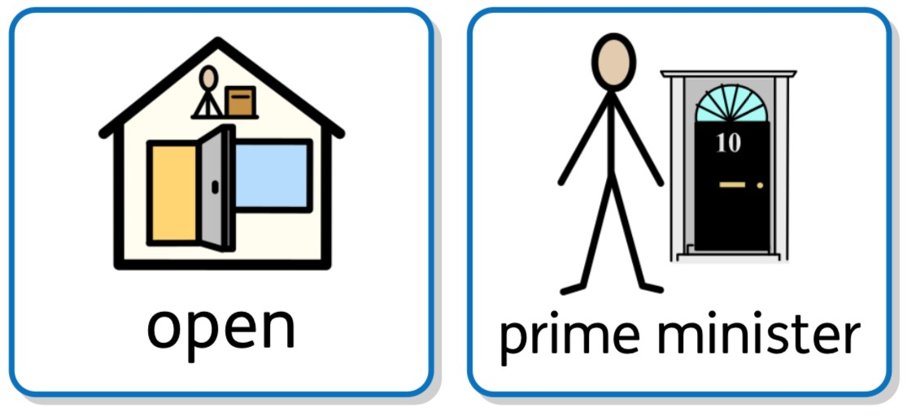

We will look forward to seeing you return, however some things might be different at school, but lots of things will still be the same.

You will go to school on:

Your classroom will be __________
Insert photo of classroom here

You will put your coat and bag here

Insert picture here

You will play outside here
Insert photo of play area here

You will eat your lunch/snack here

Insert photo here

You will go to the toilet here

Insert photo of toilet/changing place here

My teacher will be (insert name of teacher)
Insert photo of teacher here

Other adults to help me will be (insert names of support staff)
Insert photo of support staff here

You will only be able to play with the children in your classroom:
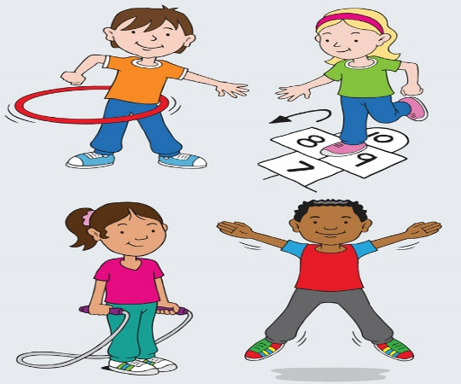

You will need to bring your own pencil case and equipment.
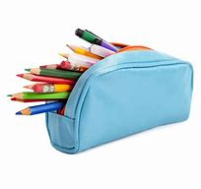

Going to school will be OK!

