Welcome to your new school!
Day One:
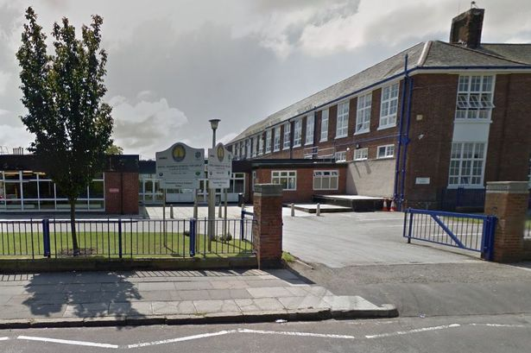 | This is the pupil entrance where you must enter the school unless you are late - the doors are only open until 8.50am. They open again at 3.40pm so you can leave. You may also leave by the main door by the office.
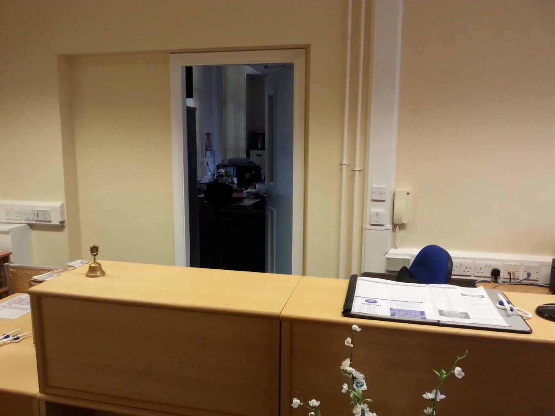 | If you are late to school, the pupil entrance will be locked so you will have to use the main entrance and sign in at the office.  If you are feeling poorly or need first aid you should come here too, or if you have any letters to hand in.
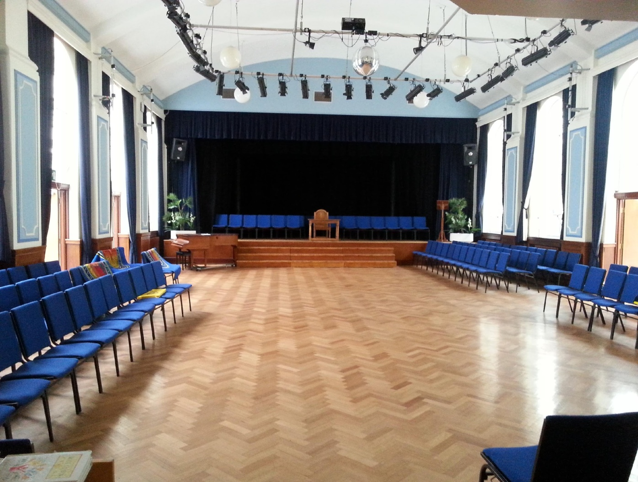 | Twice a week you will have main assembly in the hall. You have to line up with your class in silence and only sit down when the teacher in charge says so. You may sing a hymn, say prayers and listen to a short talk and notices. The hall is also used for other events in the school year, e.g. Christmas Fair. On your first day, you will come here to listen to the head teacher’s welcome talk.
Insert image | You will then go to your form room to spend some time with your form teacher, , and the rest of your class.  Here you will be given your school planner, timetable and go through the school rules and other useful information.
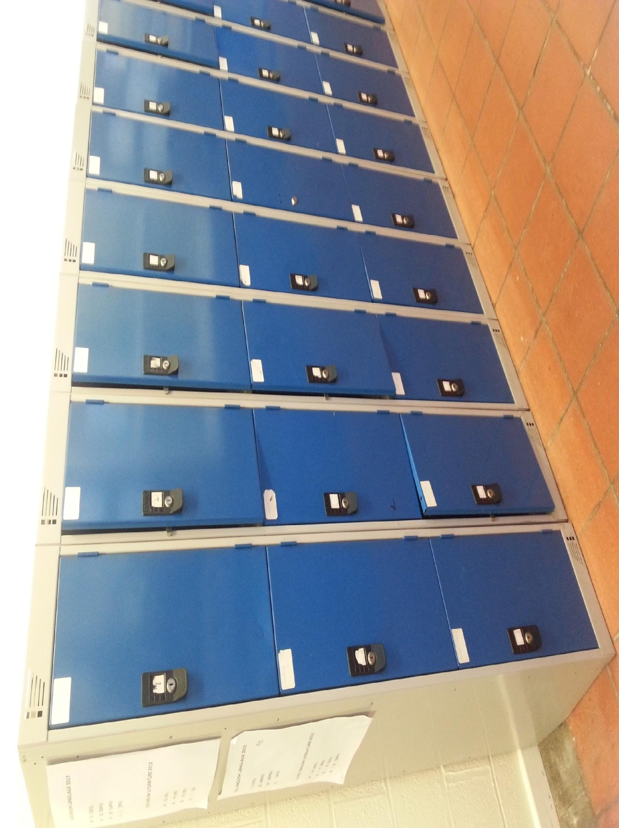 | You will be assigned a locker close to your form room each year. This will save you from carrying all of your books around. Just take out the ones you need before registration and at lunch. You can keep your coat in them too.
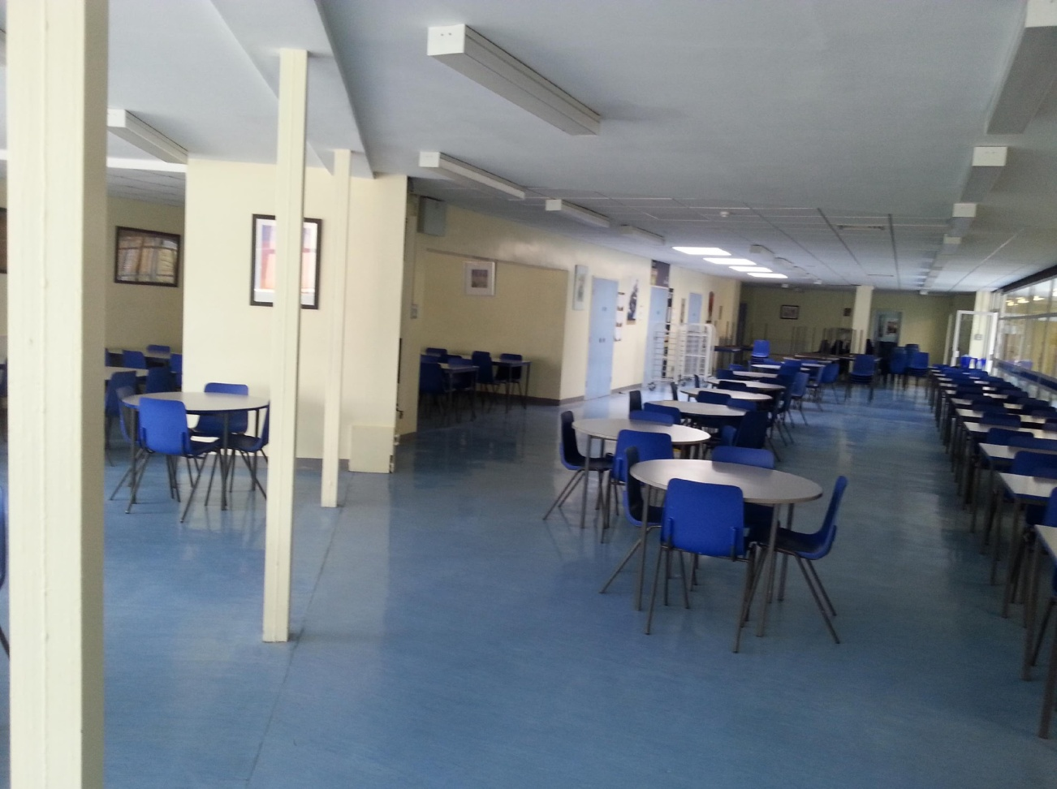 | The canteen is where a lot of pupils eat their break snack or lunch. No bags can be taken in here. If you are having canteen food you must line up outside but if you have packed lunch you can just sit down using the main entrance.
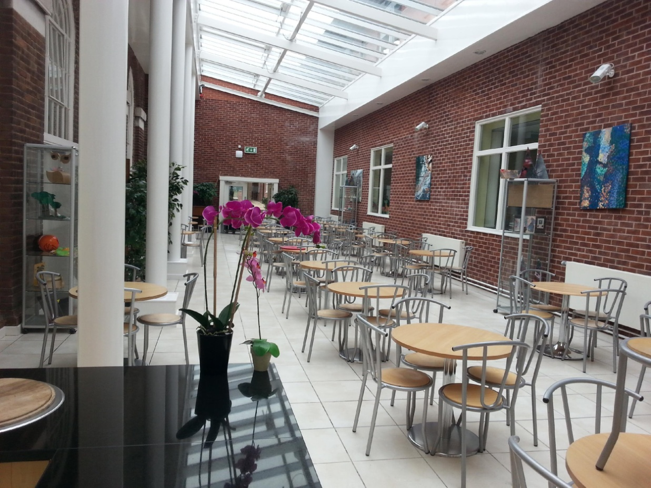 | The Atrium, next to the main hall, can be used at break and lunchtimes to eat your lunch or chat with friends. During the year some houses hold cake sales for charity and they are usually in the Atrium.
Other useful places to know about
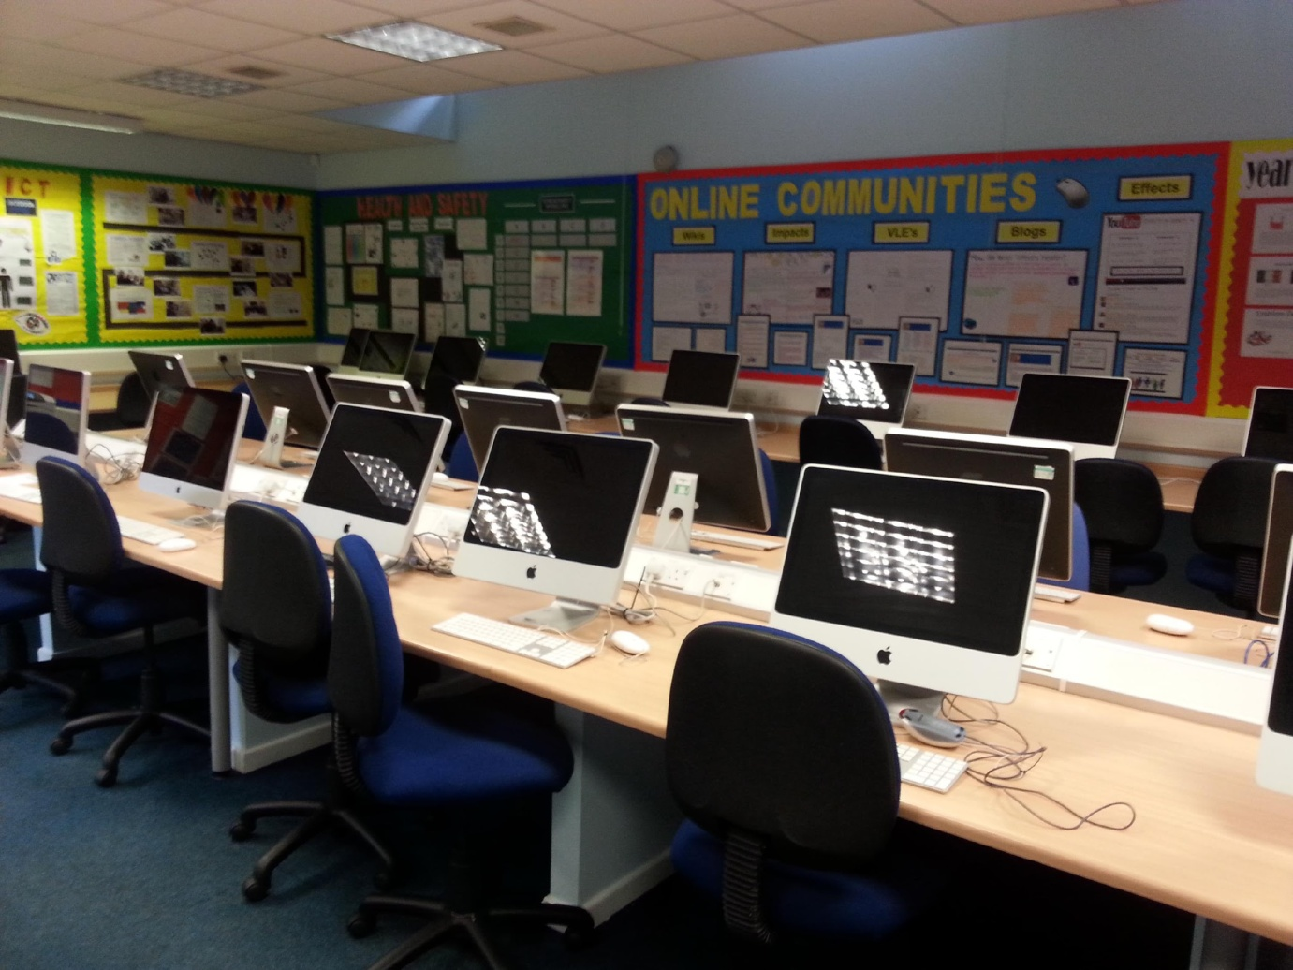 | The computer rooms (G17 & G20) can be used most lunchtimes to print out work or to do homework. You may also have you computing lessons in there.
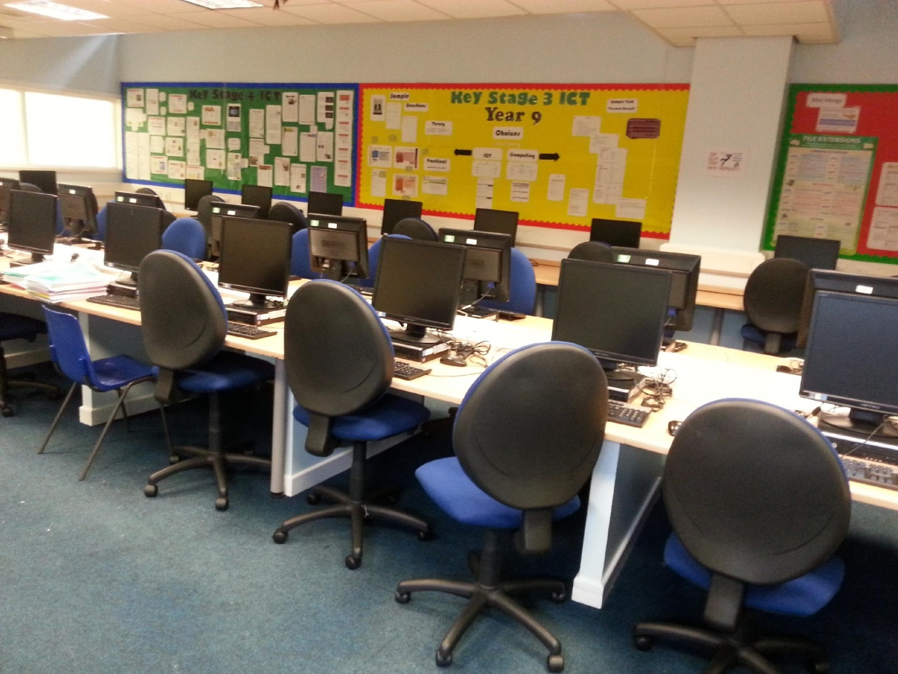 | This is the computer room G20 which can usually be used at lunchtime for printing work or doing homework. The ICT helpdesk technicians can be found in a room just off this one.
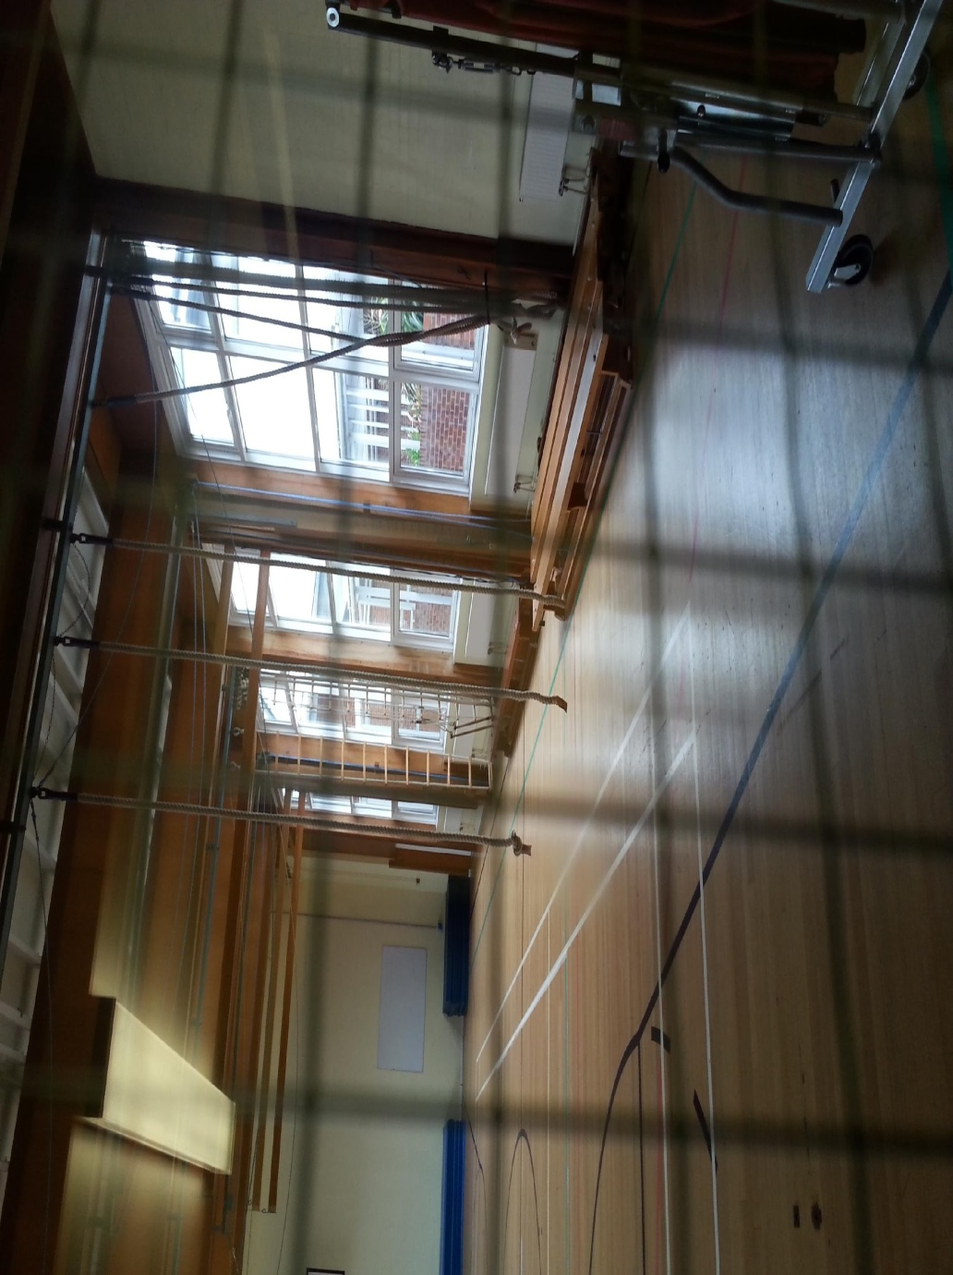 | The gym is used in lesson time and for lunchtime and after school clubs, e.g. trampolining.
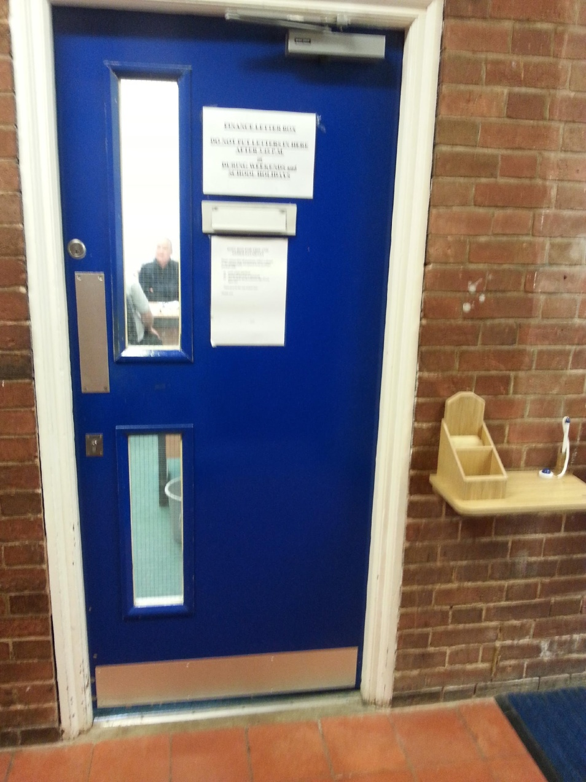 | The finance office is behind the hall on the English corridor. If you need to pay for anything, e.g. trips, then you should bring your money here.
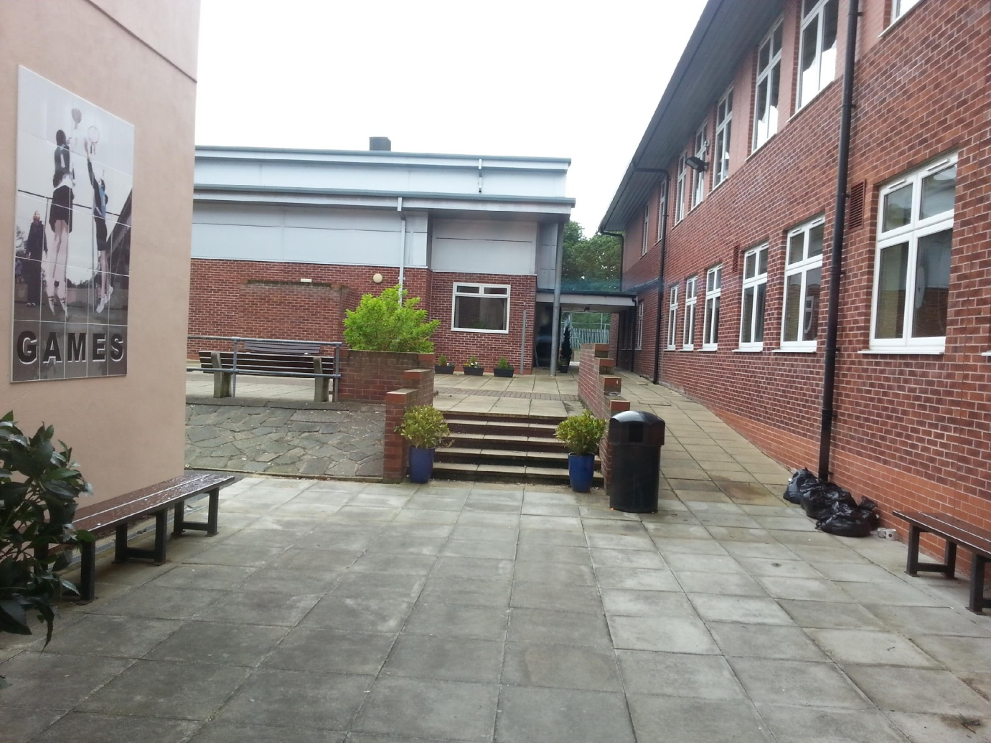 | The PE office is in the sports hall. You will often find the PE staff here. Many lunchtime and after school clubs are based here. There are benches around the outside which you can use at break and lunch.
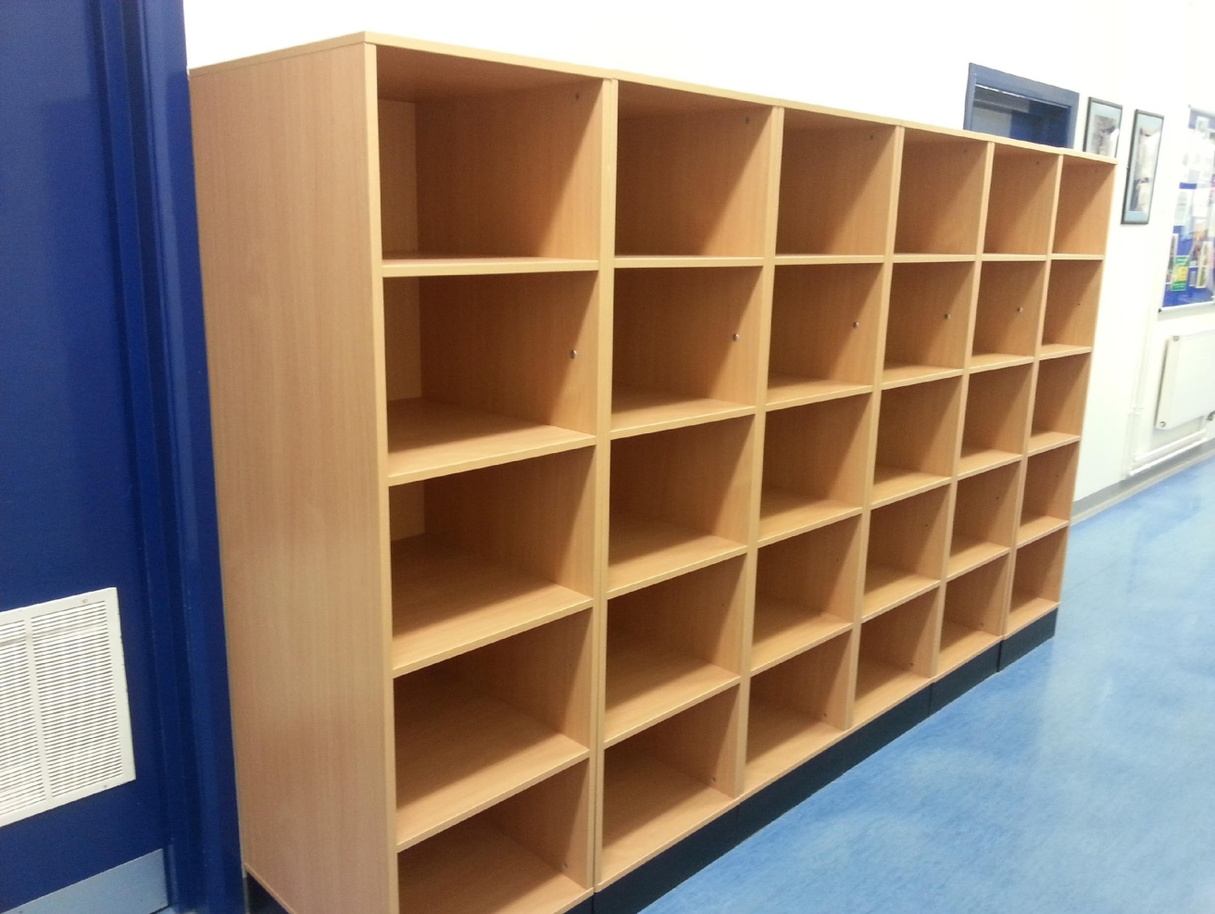 | In some lessons, e.g. technology, you will have to leave your school bag outside. If you have anything valuable you must put this is your own locker. The lockers outside technology are open ones.
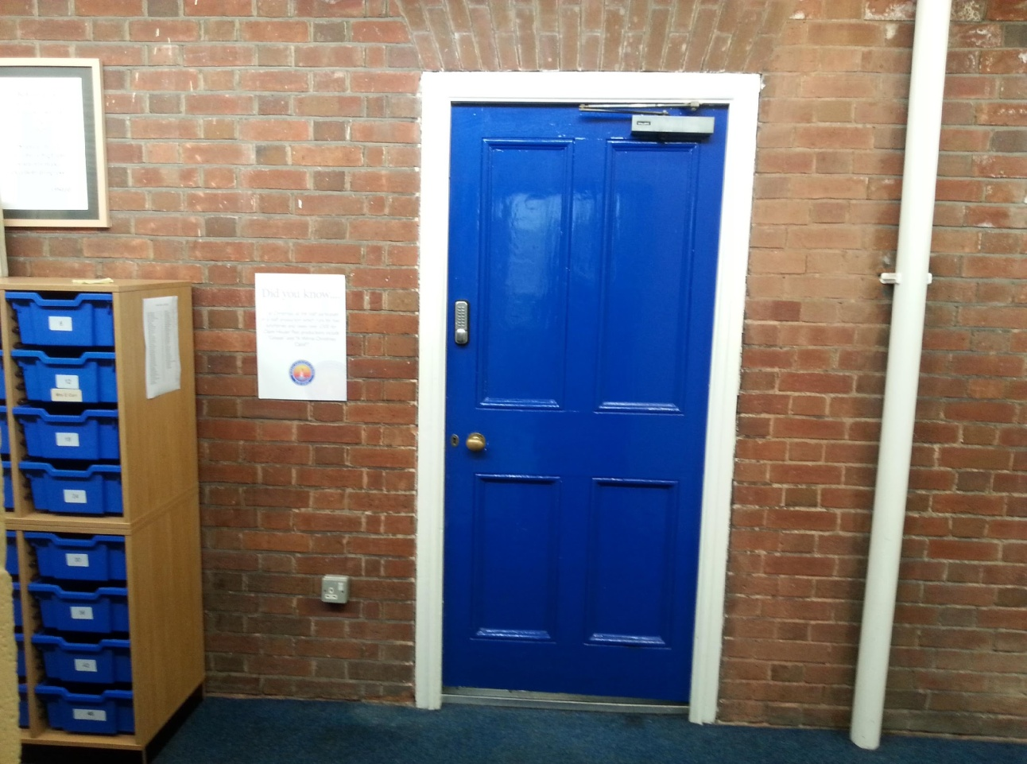 | The staffroom is near the main hall. The door will be shut. Unless it is an emergency, if you need to speak to a member of staff then wait by the door until a teacher goes in or out and ask them politely to see if the teacher you need is in the staffroom. Next to the door are shelving units with trays in. This is where teachers may ask you to leave homework. Each teacher has a different numbered tray.
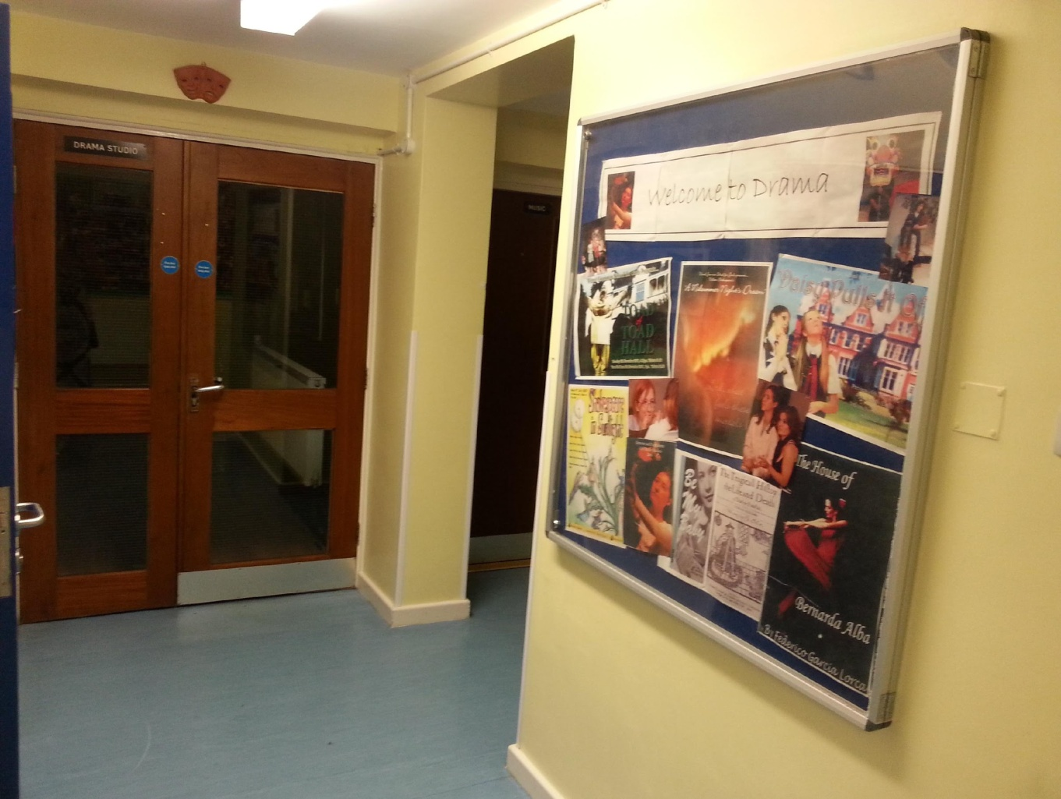 | The drama studio is where you will give performances in drama lessons. This is also where whole school productions rehearse.
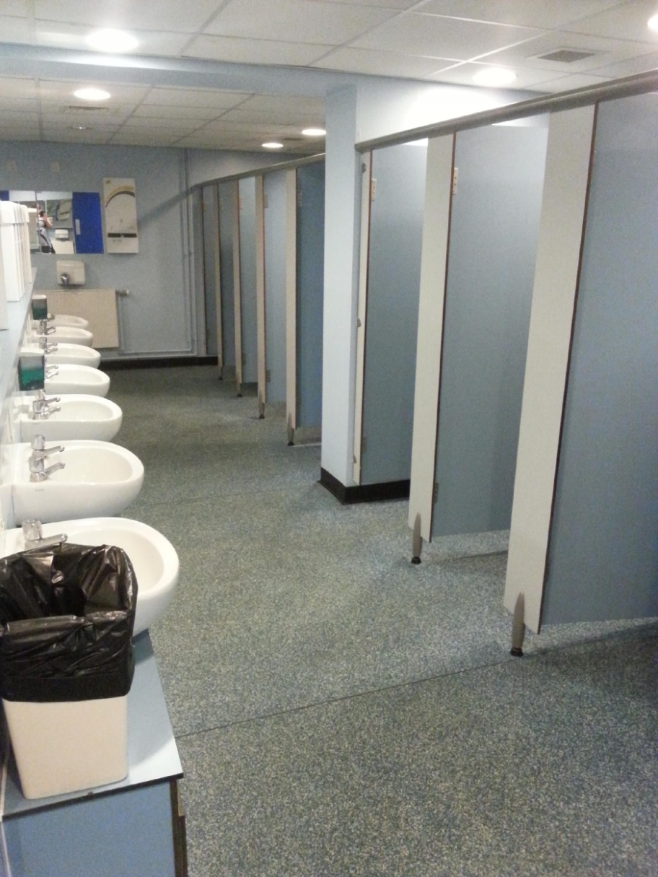 | Pupil toilets can be found by the computer room (G20), the drama studio and by the stairway near the assistant head teachers' offices. You should only use them at break or lunch - you will need to ask if you need to use them in lesson time.

