Spring Term 2020
PP / SEN Newsletter
Dear Staff,
Please find below our latest newsletter, which includes a few changes to the statistics due to the pupils on roll. Please come and speak to us about the disadvantaged pupils and ask any questions.
Many thanks,
Rob (Pupil Premium lead) and Emma (SENCo)
Vulnerable Group | Number | Percentage
PP pupils | 69 | 23%
SEN pupils | 45 | 18%
Service | 4 | 2%
PP pupils who are SEN | 19 | 28%
PP pupils with pastoral / healthcare needs | 18 | 26%
Combined figure | 37 | 54%

In-school barriers (issues to be addressed in school, such as poor oral language skills) | External barriers (issues which also require action outside school, such as attendance rates)
School is situated in an area of deprivation above the National average. | Evidence of poor home learning and some low/persistent absence attendance issues.
Pupils start school below the age related expectation of more affluent peers. | Engagement of some families.
Some PP pupils are also identified on our SEN register for a range of academic/social and emotional needs.
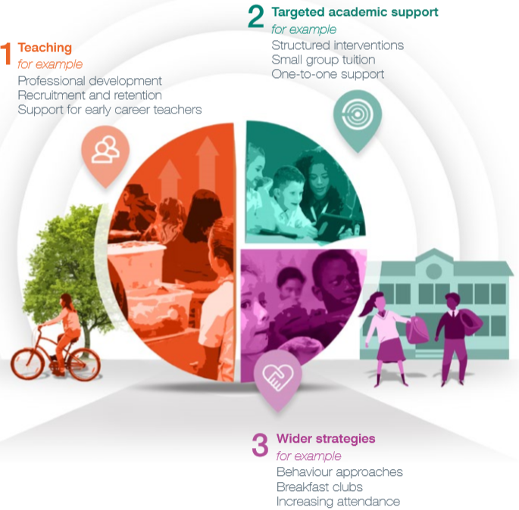
Whole-school approach to supporting pupils
In the Education Endowment Foundation’s Guide to Pupil Premium they have identified that:
Good teaching is the most important lever schools have to improve outcomes for disadvantaged pupils.
At *** Primary School, our tiered approach shows the new emphasis on the importance of teaching (1). Targeted academic support (interventions – 2) and wider strategies (3) are still important and these are evident in places such as the Pupil Premium Strategy, Provision Maps and SEN Learning Passports.
How do we know that Pupil Premium and SEN children are making progress in Maths & English?
Pre-teaching is highly recommended as a way of exposing disadvantaged pupils to new concepts prior to being in taught in class. This also ensures that these groups of children are better equipped and more resilient in lessons. Feedback is also important in ensuring that pupils know what they must do next and includes: verbal feedback, written feedback and instant feedback (live marking). Following on from feedback, we are targeting children who need fluid intervention to support their cognition and learning on a regular basis. In an ideal world, no pupil would leave the school without having had the support to make the progress needed. Through discussion with PP and SEN pupils, we aim to evaluate the range of feedback given to establish which type of feedback provides the best level of support and ensures greatest progress.
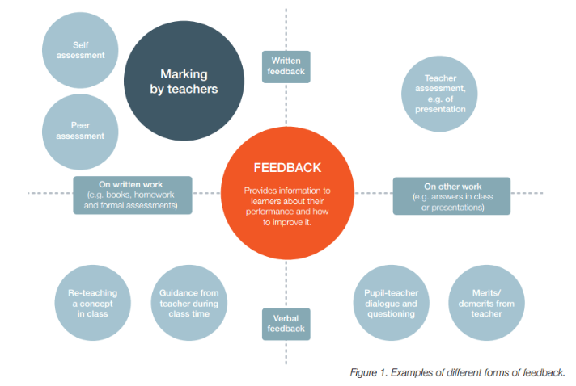
Pupil interviews and book looks: Wednesday 12th February 2020
We will be talking to a large proportion of Pupil Premium and SEN children during the day. They will need to bring their Maths book, English book and most recent theme folder. SEN Learning Passports should be brought if your phase agreed that Learning Passports are to be included within these books. The pupils will be asked a range of questions linked to our foci:
Focus 1: Compare support given in Maths and English in comparison to Foundation subjects.
Focus 2: Ascertain the impact of support given including: pre-learning, support during teaching and post-learning fluid intervention.
Focus 3: How feedback given has addressed any misconceptions and allowed pupils to achieve the Learning Objective.

