I spend a lot of time looking through my window at the world outside. Especially when I want to go out and can’t.
It is a very familiar view.
I can’t remember not seeing it, but I don’t always see it the 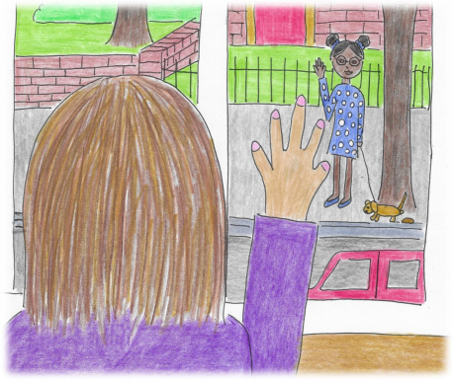same.
Sometimes when things change in the world, it changes the way you see things.
What has changed in your world?
We all have different views on the world. What does your view look like from your window?
If you could change your view and see anything you liked, what would you want to see?
I would like to look out and see this.
The beach makes me feel safe, happy and calm.
What view would you most like to see if you could choose anything you wanted?
How does it make you feel?
I wonder about lots of things when I am looking out of my window.
Like every person walking past has their own life and story, just like me.
I wonder what theirs looks like?
This is mine.

o
t

d
r
a
h

s
t
i

e
s
u
a
c
e
b

,
u
o
y

p
l
e
h

o
t

e
s
l
e

y
d
o
b
e
m
o
s

k
s
a

o
t

d
e
e
n

t
h
g
i
m

u
o
Y
(

?
s
r
u
o
y

t
u
o
b
a

t
a
h
W
)g
n
i
ht
y
r
e
v
e

r
e
b
m
e
m
e
r
Where are they all going?
Where do I want to go on this journey of life?
These are some things I want to do and be.
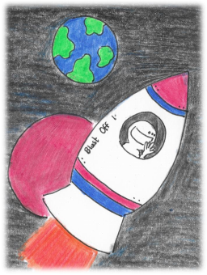
What are your hopes and dreams?
I wonder about odd questions like, if I turned into a superhero and I could choose three superpowers then what would they be?
Mine would be…
What would yours be? What would you look like?
Or if I turned into a monster, what would I look like?
This is what I think I might turn into.
How about you?
If I was a
superhero then what supervillain would I have to defeat?
How would I do this?
What about you?
Sometimes I look out of the window when I am worried at night and I can’t sleep.
The world looks different at night.
It is dark and full of shadows.
I worry about what’s in them.
I sometimes worry about different things.
I don’t always feel I can tell anybody.
I don’t always have the right words.
I think they might say, “don’t be so silly,” or, “you don’t have to worry about that.”
I still do!
It’s really good if you can think of somebody you can share them with, because holding worries together is much better than holding them alone
Do you ever worry about things?
When I get worried or upset my dog comes and cuddles me. It is like he is saying,
“It’s okay to be worried.
Sometimes
things are scary.
It’s okay to be upset.
Sometimes
things that
happen are really upsetting.
It’s okay feel all those hard
things, but it’s really difficult to go through them.
I’m here for you and we’ll go
through them together.”
Even though he can’t speak. Who can be there for you?
I try to think of things that I like when things seem very bad.
I do it through my senses.
Things I can see, things I can hear, things I can touch, things I can smell and things I can taste.
What things do you like?
It can be hard to stay
in our window if we
feel worried, upset
and scared.
There is something
called the window of
tolerance. We all
have of one of those.
Sometimes it is a
big window and
we feel like we
can deal with
anything.
Sometimes it is small
and everything
annoys us and seems
like a big thing.
When everything seems like too much (even if it is really a little thing) then we can fall out of our window.
Ogden et al (2006) Siegel (1999)
That’s what happens
when we get
overwhelmed.
There is too much
going on, our brains
can only take so much.
It starts to build up
I like to think of it like filling up a cup of water until the cup can’t hold anymore and it spills everywhere.
Fear, worry and overwhelm can
set off an alarm in our brain, like
a fire alarm.
That comes from a special part
of our brain called the
amygdala.
The amygdala’s job is to protect
us and if it thinks something is
threatening it will prepare our
body to react to keep us safe.
Even if it isn’t really a threat.
The amygdala can’t tell the
difference if it is a really big
threat or not. If it feels like
one it will react.
If you go up out of your window, then its hard to keep the
overwhelm inside. You might be really fidgety. Its hard to
stay still, to listen or follow instructions. You might lose your
temper really easily or even blow up like a volcano.
Then we fall out of our window You either fall down or go up.
If we fall down then we shut down. You might feel so
overwhelmed that it gets too much. You might pretend it isn’t happening, or feel nothing. You might want to hide. You might find it hard to show your feelings. That is because you are trying to protect yourself from feeling overwhelmed.
Everyone has a different way they might fall out of their window. We all do.
That’s part of being human.
Every time you start to wobble in your window or fall out of it, then there is a reason why, even if we don’t know what it is.
Usually it’s a feeling. Sometimes the thoughts we have trigger a feeling we find difficult.
Last time I fell out of my
window I refused to do
some of my homework. I
think my mum thought I
was just being naughty. All
she saw was this!
This is
how I
really felt
inside!
Have a look at the feelings iceberg and try to work out how you were feeling the last time you fell out of your window.
What was going on underneath that nobody saw?
Even grown-ups are always falling out of their window of tolerance!
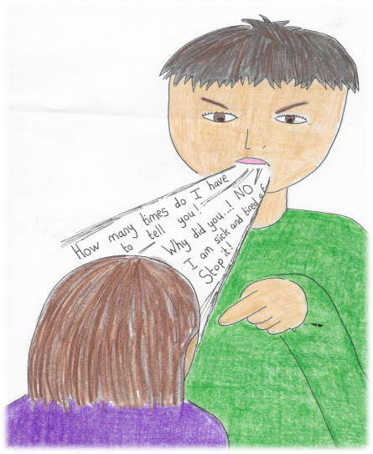
Which way do you usually fall out of your window when you have lots of big feelings and they get overwhelming?
You can fall out both ways but most people tend to do one more than the other.
Have a think about a few times it has happened.
What and who can help you get back in your window again?
There are as many ways to get back into your window as there are people.
Everybody has different things that work for them
Sometimes it doesn’t always work.
Keep trying!
Remember FAIL means First Attempt In Learning
It can take many tries to get back in properly!
What ways might help you get back in your window after you have fallen out?
What doesn’t help?
Sometimes people think they are being helpful, but they are really not.
Sometimes people think they know best and they are doing the right thing, but really you need them to do something else.
When that happens it can stop you from being able to get back in your window again and might even push you further out!
When things are scary on the news or things I hear people talk about then sometimes I want to hide from it. I think about it a lot even when I don’t want to. Then I started to see all the people who help!
However terrible things seem there are always kind people who look out for each other and help. That can help with that being overwhelming.
Remember my dog.
It’s okay to feel afraid.
It’s okay to feel worried.
It’s okay to have lots of feelings.
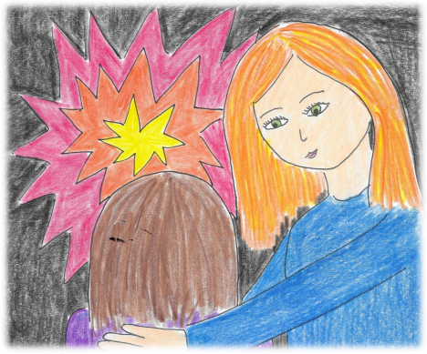I need some help to get through this!
We also need to have hope.
I like to think of hope as a rainbow
What does your hope look like?
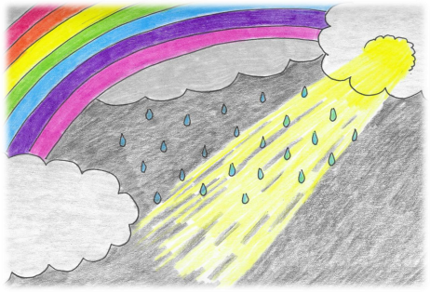I like to breathe in the rainbow. I drew one on a piece of paper in all the different colours.
When I get worried I trace my finger over each of the colours, starting from the bottom until I get to the highest point. Then as I go down the curve I breathe out. I do that for each colour.
That helps me get back in my window.
Sometimes I have to do it more than once.
The rainbow is my hope
I drew you a rainbow so you can do it too.
When I fall out of my window I know there are things that I and others can help me do to get back in it again. Sometimes it takes a bit of time but I’ll get there.
Every time I do, my window gets a bit bigger. That means my brain is learning to be able to calm down.
When I look out of my window I see the world in my own special way.
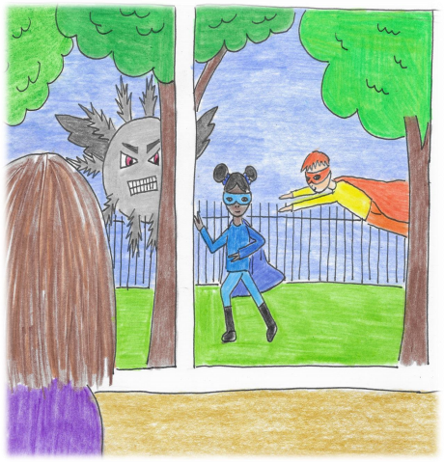Just like you.
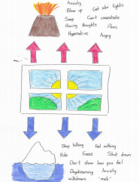
The Adult Page
Everybody who works with people is aware that they
have limits of what they can cope with. One way of
thinking about this is the window of tolerance.
(Ogden, 2006, Siegel,1999)
We all have one! When that limit is reached the person
is likely to become dysregulated. It is easy to focus on
behavioural consequences without really looking into
what that behaviour is communicating.
All behaviour is communication.
When under stress adults and children alike react to it in
different, often challenging ways. This can have a
contagion effect where the first person to become
dysregulated, then dysregulates others around them
and it snowballs from there. Sibling fights are an excellent
place to see this in action or, when you are trying to get
your child to do something that they do not want to do
The difficulty as adults is if we are not well regulated, or in our window, then it is very difficult to be able to help children stay in theirs. This is because children’s brains are still growing and developing and, whilst the brain is grown from the bottom up, it regulates itself from the top down.
When a child has completely fallen out of their window of tolerance (think toddler tantrum at their worst) then the parts of the brain that involve thinking, reasoning, ability to speak are completely offline and they are operating at a very primitive level. To help them get back in their window and get their higher brain online again, they might need help calming down. Only if we as adults are stressed, angry, frustrated and overwhelmed, we are out of our window and will struggle to help the child back in theirs. Children need adults to co-regulate with them BEFORE they learn to self-regulate. It is a developmental process. Even as adults think of the times we seek help in co-regulating from partners, friends and family. Children need us to help them with this so later they can do it for themselves.
It is useful to think about what triggers you to fall out of your window and what helps you get back in as an adult, as well as considering this for children.
I often get asked about why sometimes children seem to be in their window and then it goes from 0- 100 in no time at all. Quite simply whilst that child looked like they were in their window, this can be a false illusion. They might have only been just in it and it didn’t take much to dysregulate them again. Also some people, due to their experiences, have a much smaller window. Think the person you know who blows up over every little thing.
I hope this booklet will help support those who work with children, young people and even adults to think about challenging behaviour through a different lens, to know themselves better and be able to open honest, meaningful dialogues and both verbal and creative exploration to help each other.
If your child is very dysregulated remember to calm them before attempting any of this to help their higher brain come back online again.
Naomi (who spends most of her life helping people back into their windows)
Naomi is a play and creative arts therapist and therapeutic wellbeing practitioner for children, young people and families. She predominantly works in education, hospitals and in private practice delivering therapeutic service, workshops and CPD education to any and all interested in children’s mental health and emotional wellbeing.
She has worked extensively with children and young people in different capacities around the world and particularly enjoys challenges to overcome.
When she isn’t attempting to overcome challenges, Naomi is the author of ten therapeutic stories and believes passionately in using story to communicate difficult topics.
https://www.amazon.co.uk/Naomi
Moore/e/B07ZXMT9JX?ref=sr_ntt_srch_lnk_1&qid=1585223153&sr=8-1
She lives and works in London, UK but dreams of having
a different view from her window one day.
www.acornwellbeingoutreach.com
Facebook @AcornWellbeingOutreachResources

