Instructions for onset and rime activities

I have outlined the steps for introducing onset and rime and the consonant blends below, I will also but them in the notes:

- Cut the onset cards up and write the following rimes on a piece of card ip, it, in (these rimes are in the structure of beat dyslexia that she has already covered, you can add more rimes as you introduce more letters and vowels) like the picture below but with a different rime than pictured below

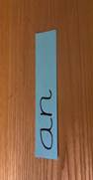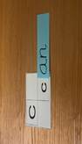

- Give C the set of onsets which will make real words using the focused rime.
- Ask C to choose 4/6 onsets and set them out in a vertical line.
- Give the C the focused rime (which should be on a different colour). Read the rime to C and ask her to repeat it.
- Say one of the possible words, C matches the rime to the correct onset in response to the word you have said.
- Repeat for other examples. Go over the same words more than once. C moves the rime each time to make the spoken word and repeats the word once made.
- 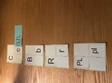Now ask C to move the rime down the line of onsets reading each word as she goes. If she is hesitant, support C by saying the tricky word.
- Swap roles. C says a possible word and you move the rime to make the word and repeat.
- Add in the st, sn and/or sp consonant blend onsets. Discuss that two consonants making a sound you would expect is called a consonant blend. Use the rime to make real words.
- If there are more onsets which will make real words, place them into 2 piles with the onsets already covered and take it in turns to take an onset, match it to the rime and read the words.
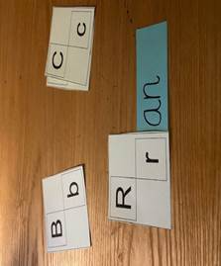
- Now ask C to say any of the words she can remember and you write these onto separate strips of paper / card as they are said. This could be completed as a shared activity, taking it in turns with you to remember words (especially if there are quite a lot of onsets!).
- 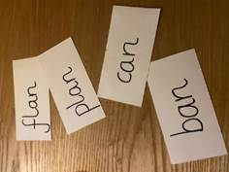
- Check through the pile of onsets together to ensure any words have not been forgotten, write any missed words on strips of card / paper.
- You can repeat the exercise with other onsets and rimes if she has enjoyed this exercise in other sessions.

