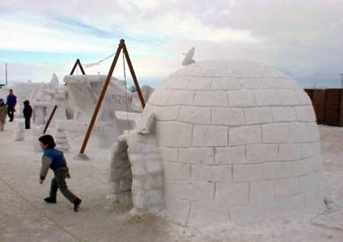



C:\Documents and Settings\perseus\Local Settings\Temporary Internet Files\Content.IE5\K2KEKQ8F\MC900083902[1].wmf

C:\Documents and Settings\perseus\Local Settings\Temporary Internet Files\Content.IE5\X6NG8ZGH\MC900359007[1].wmf

C:\Documents and Settings\perseus\Local Settings\Temporary Internet Files\Content.IE5\K2KEKQ8F\MC900133591[1].wmf

