Teaching Automatic Reading of High Frequency words (HFW).

Many HFW are phonically regular but some are irregular or contain phoneme-grapheme links which are not very common. This makes them difficult to decode. Students benefit from learning HFW by sight as it makes their reading more fluent, improving both confidence and understanding. The following activities are games to help pupils acquire a good sight vocabulary.

There are some excellent reading game resources on the Phonic Book website that are easy to download and print follow this link Free Teaching Resources - Phonic Books

You will find baseboards and instructions for the following reading games that can be used to practice and overlearn reading HFWs:
- Fishing game, (the fishes could have HFW words written on to them): Fishing Game - Phonic Books
- Dice game template: Dice Game Template - Phonic Books
- Stepping stone game template, (the blank template could have HFWs): Stepping Stone Game Templates - Phonic Books
- Snakes and ladders template, (the blank template could have HFWs) : Snakes and Ladder activities - Phonic Books
- Spin read and Spell activities ( the blank template can have HFWs written in it) Spin, Read and Spell Activities - Phonic Books
- Four in a row game: Four in a Row Game - Phonic Books
- Phonic HF Word Chart: Phonic High Frequency Word Chart - Phonic Books

Pairs :
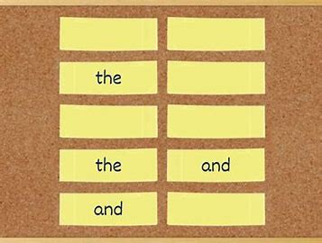

Resources needed:
- 5 or less target HFW written out twice on small pieces of rectangle card (see picture above)
- Use template below to make your target HFW cards.

How to play:
- The cards are placed face down and you and your pupil/child take it in turns to turn two cards over. If they match and the child can read the word, they get to keep the pair.
- Every time a card is turned over it is read aloud.
- The winner is the person with the most pairs

said | said
when | when
can | can
and | and
the | the
was | was
her | her
then | then
come | come

Reading Race – Reading

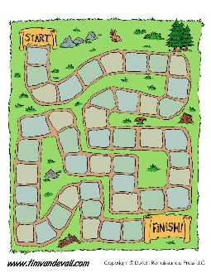

Resources needed:
A template of a maze or spiral. Along the maze or in the spiral the target words are written over and over again in any order. Chose 5 or less words depending on the individual you are working with.

How to play:
- Your pupil/child has to read them as fast of they can.
- An element of competition can be brought in if you encourage them to try to beat their personal best.
- If they get a word wrong add seconds on to their final time.
- Keep a record off their times and when a word has been mastered remove it from the maze or spiral and add a new one.

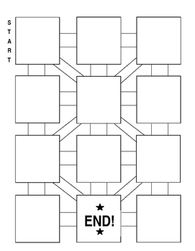

Climb the ladder – Reading

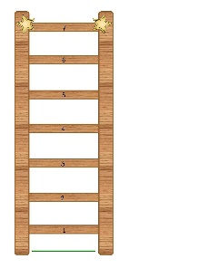

Resources needed:
Laminated picture of a mountain/ladder and a counter (or other suitable visual concept e.g. race track / football pitch / wall etc.)
A pile of 5-10 targeted HFW. (Many resource packs available in schools have suitable game boards which can be used or adapted for this activity)

How to play:
- The pupil /child picks a card from the pile and reads it.
- If s/he is correct he places his counter at the bottom of the mountain.
- If the pupil is incorrect, the correct word is given, and the card is replaced on the bottom of the pile.
- The aim is to get to the top of the mountain.
- To add challenge the word must be read in less than ten seconds.

Noughts and Crosses/ Boxes – Reading

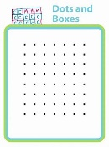
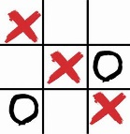

Resources:
Resources needed:
- Empty noughts and crosses’ grid/ boxes grid or a plan piece of paper and pen.
- Target high frequency word cards

How to play:
- Place a pile of target HFW words face down on the table
- Take it in turn to read HFW word card.
- Once they have read the word they can take their turn on the nought and crosses grid.

HFW Bingo

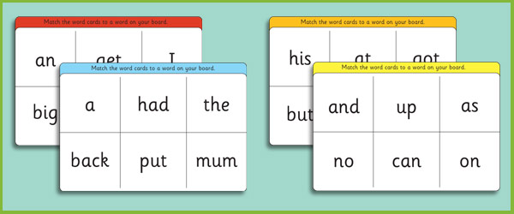

Resources needed:
- Bingo cards with the target words on
- Set of the target words written on cards.
- See bingo template below with examples

How to play
- Each player takes a bingo card.
- The caller pulls a question card from the bag and reads it aloud.
- Both players quickly scan their cards looking for the word, and say ‘mine’ when they find a match.
- If they are wrong then the card goes back into the bag.
- If they are correct they put the card over the matching square on their bingo card.
- When a player has covered a complete row or column they shout ‘bingo’! They then have to accurately read aloud each word on the row/column to win. If a word is read incorrectly it goes back in the bag and the game.
- You can carry on as above until all the column and rows are completed.

the | can | said
was | and | she

Print this out three times. One for each player and the third one can be cut up and used as flashcards that the caller reads out.

Blank proformas to insert target HFW in.

Easy Speed Sheets / Precision Testing
An activity to reinforce skills – not to teach something the pupil doesn’t yet know.

For pupils who:
- Lack automaticity, fluency and pace in their reading.
- Tend to want to decode known words.

Method
- Initially choose 3 words from currently targeted work to place on a grid of about 3 x 5 squares. This can be increased to 5 words in larger grids to suit developing pupil needs.
- Choose two words the pupil knows automatically already plus one they have been targeting but are not secure on (usually these will be words the pupil wants to decode every time they meet them). Use words which are visually distinct at first.
- Keep copies of sheets used for later re-enforcement / revision. These could kept in a file as a record of progress.
- Simply time the reading of the words on each attempt. The aim is to get faster….
- Reward the ‘best score’ for the week, sticker, house points, note home or whatever (note that, therefore, a reward is guaranteed).
- This is a good exercise to be sent home over the weekend for practice.
- When the pupil knows the words automatically – change 1 word at a time.
* Many pupils feel more motivated if the sheet has some kind of visual interest. There are sheets which are commercially available using football themes or use clip art etc.

Alternatives for Speed Sheets / Precision Testing
Changing Precision Sheets
- For an added step. Once pupils become fluent with their words prepare a new sheet with the same words but this time with different fonts and sizes e.g.

go | in | man | seem | very
man | very | in | go | seem
in | seem | very | man | go

Active sorting activities
Look for ways of encouraging ‘overlearning’ e.g. ...
- Have the three target HFW from precision testing sheets on cards (four times each word).
- Mix the words up and let the pupil sort them into correct piles saying the word as he/she does so.
- This activity can be done with a timing element so that the pupil races to ‘beat’ their own time.
- Once the pupil can do this with ease have the same words but this time printed in different fonts and sizes for him / her to match.
- This activity can be done with a timing element so that the pupil races to ‘beat’ their own time.
- Change words as words change on precision sheets.
- Every so often revisit an old word – but remember this is revision – not a test. So don’t expect the pupil to recall the word. Simply put the word with the others and ask ‘point to …..’ to see if they can recognise the word. If he / she can’t teach it again.
- Keep a ‘star chart’ and give rewards or use the school’s reward system.

Other activities include:
- Matching letter cards to HFW.
- Matching word cards to words in text.
- Building sentences with the target words on card etc.
- Highlighting target words in different texts / collecting examples of target words from different texts can also be fun.

