Dad, Dan, and a Pit
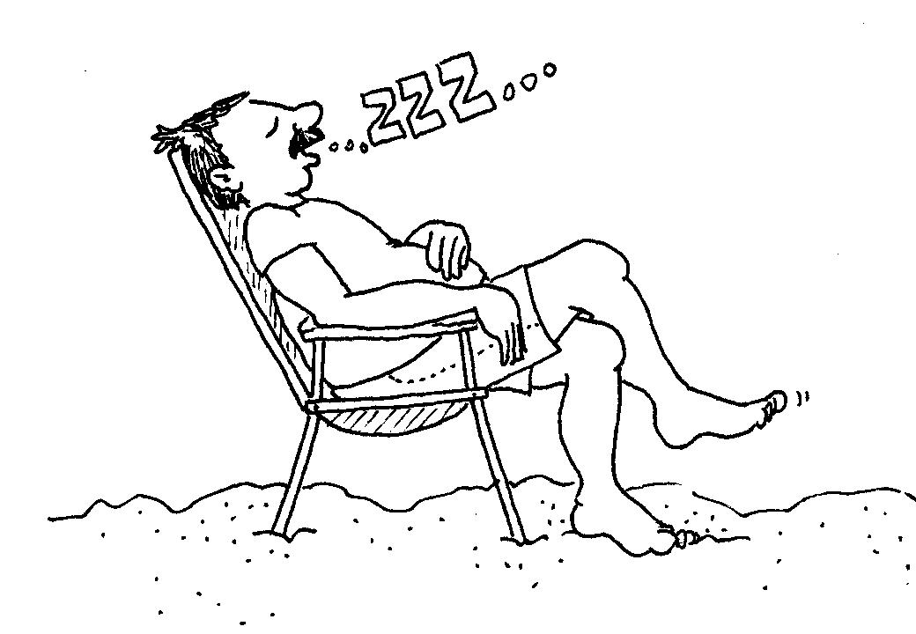  Dan’s dad sits and naps.  Dad naps and naps and naps. | 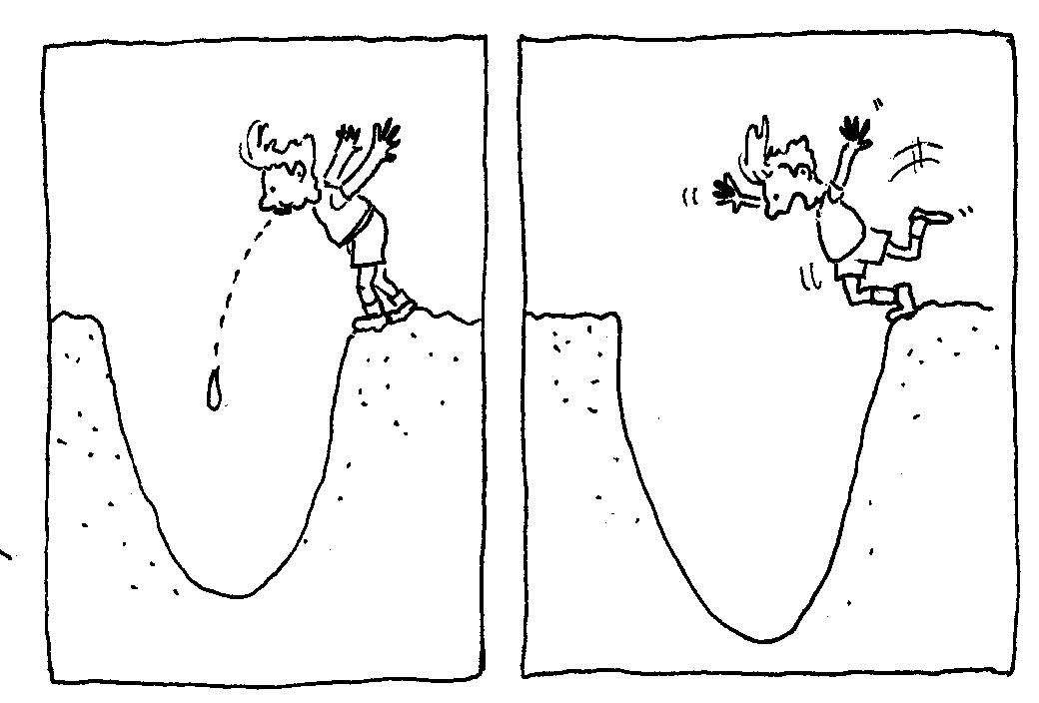  Dan didn’t nap.  Dan spits in a pit. Dan tips in.
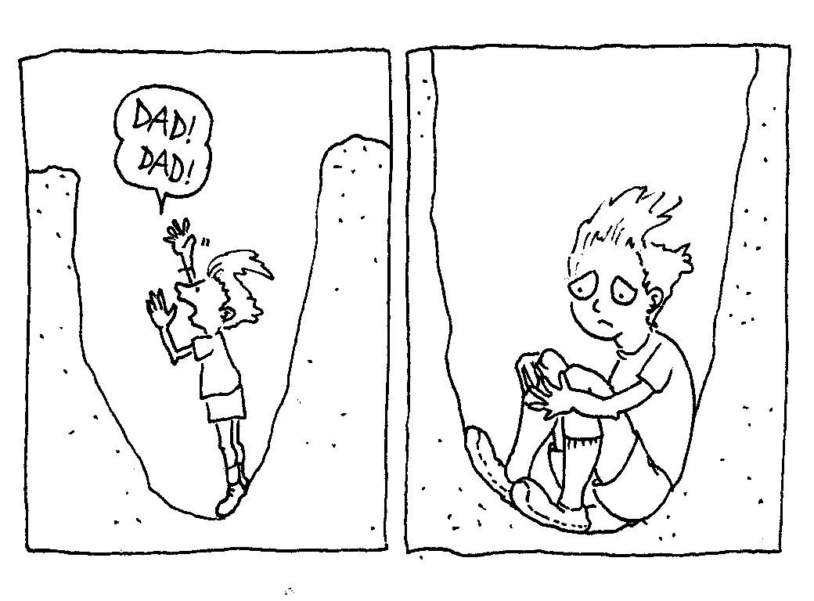  “Dad! Dad!” said Dan.  “I sit in a pit!” Dan is sad. | 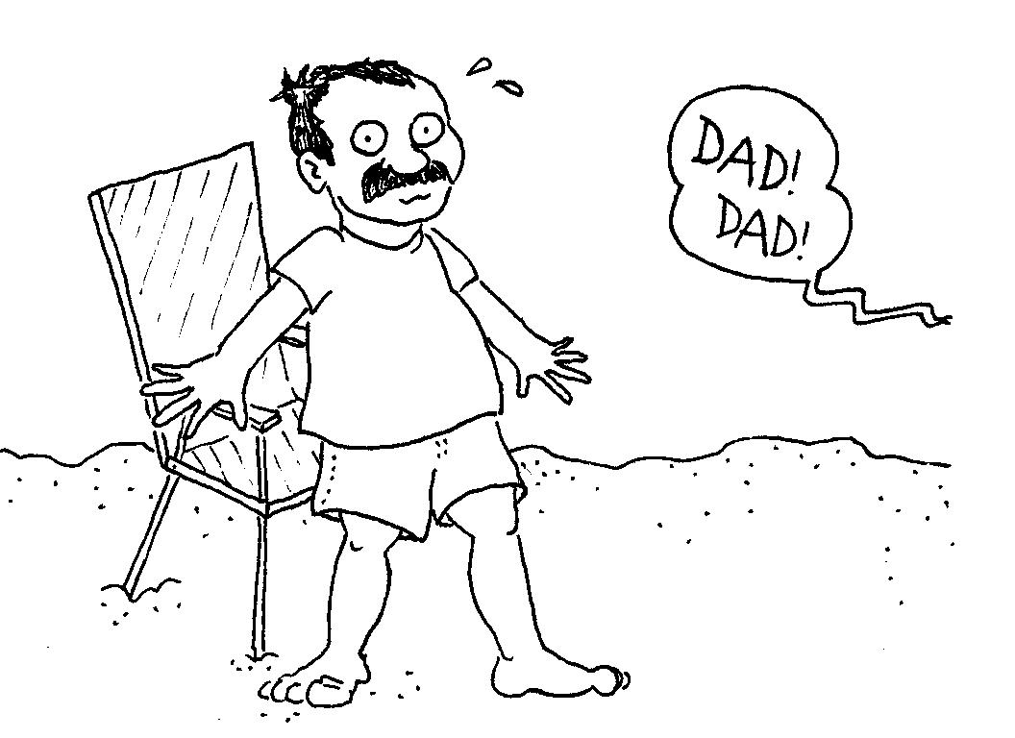  Dad didn’t sit and nap.  Dad stands.
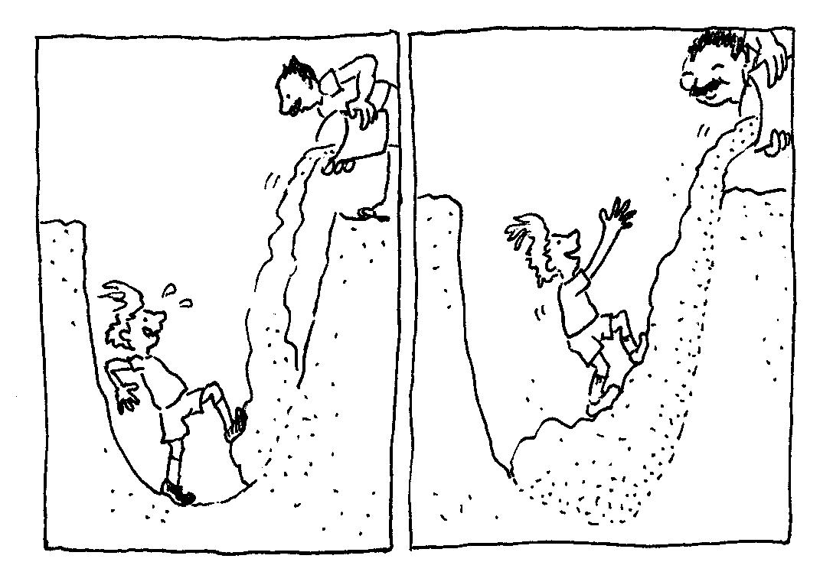  Dad adds sand.  Dan stands in sand. | 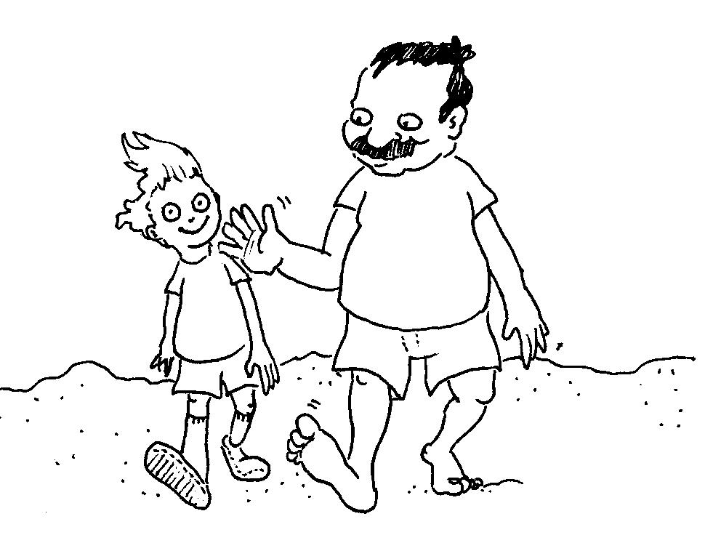  Dad did it! Dan isn’t in a pit!  Dad pats Dan. Dan isn’t sad.

1 | 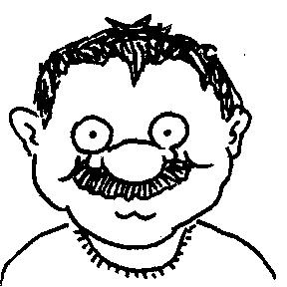 | Dad
2 | 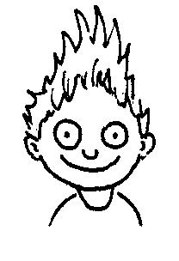 | Dan
3 | 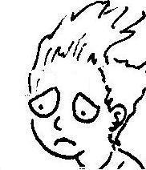 | sad
4 | 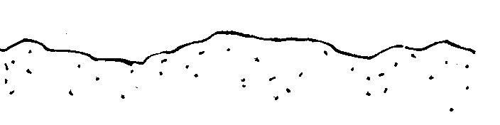 | sand
5 | 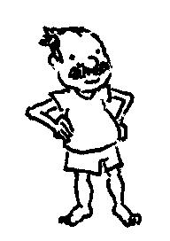 | stand
6 | 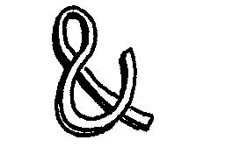 | and
7 | 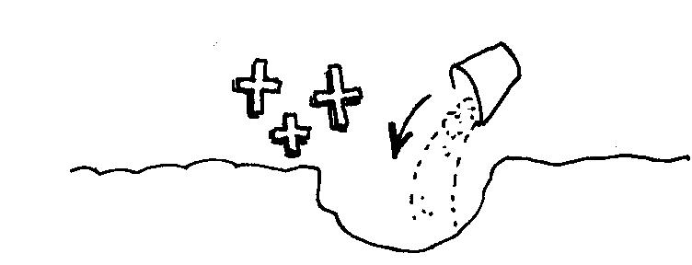 | add
8 | 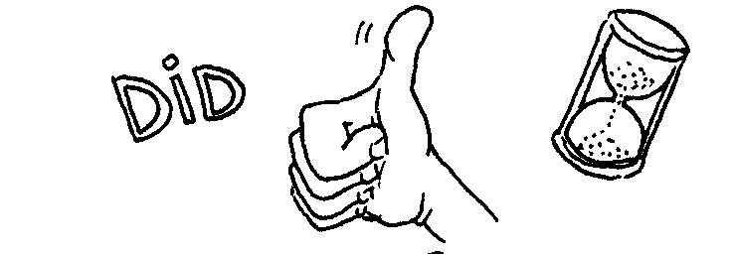 | did
9 | 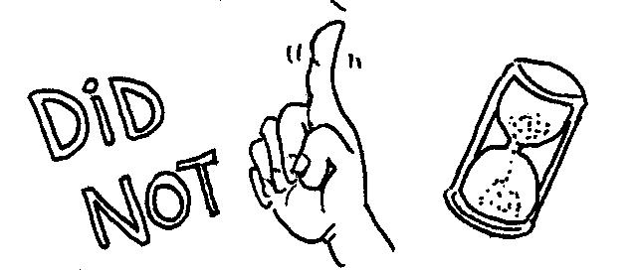 | didn’t
10 | 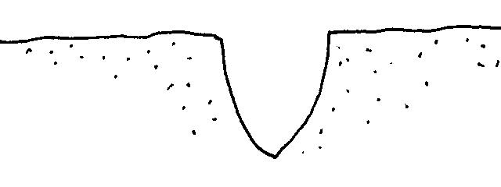 | pit
11 | 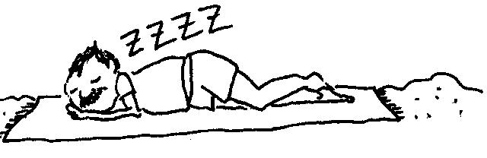 | nap
12 | 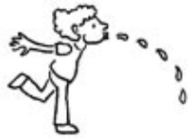 | spit

Puzzle: Help Dan Get Out of the Pit

Instructions to player: Fill in the pit with the words that match the pictures, in order from the bottom to the top.
Read the word out loud as you fit it into the puzzle.
When the words have filled the pit, Dan can get out and you win!

Instructions for preparing game:
1. Glue the following puzzle and picture of Dan onto cardboard or colored paper; cut out the puzzle pieces and the picture of Dan.
2. Cut out the pit/puzzle “cover” from the following page, to cover the pieces in the pit that have not been filled in. Crease at the indicated lines.
3. To play, cover all the picture pieces in the pit with the cover paper, except for the bottom word, place Dan on top of the cover at the bottom of the pit, and work your way up the puzzle.
Fold under the lowest visible strip of the cover to expose each ensuing line of puzzle pieces.
did
nap
pan
I
pit
stand
spit
Dan
Dad
sand
tin
didn'td
and

Cover for uncompleted part of puzzle: Crease backward on dotted fold lines, then unfold to start puzzle. Fold under from bottom to uncover layers of puzzle one by one.

sit

didn'td

