Ants In Pants!!
  Pat taps. | 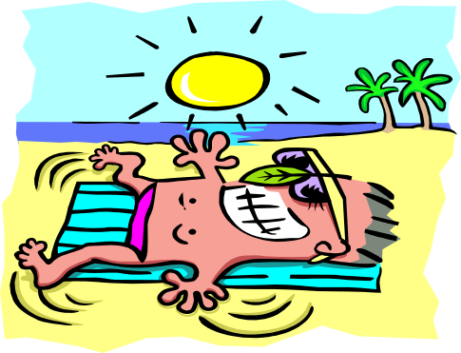  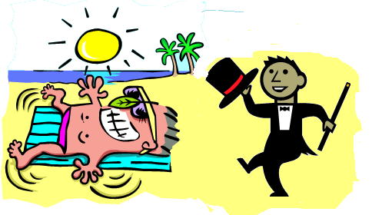  Stan tans as Pat taps.
  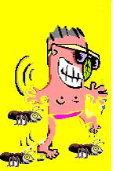  It’s ants in Stan’s pants!! |   Stan tips Pat.
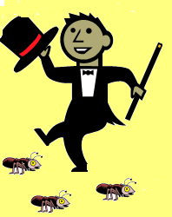  Pat taps at ants. |   Stan sips & tans.
Word List
1 |  | Pat
2 |  | taps
3 | 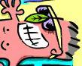 | Stan
4 | 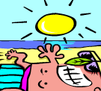 | tans
5 |  | ant
6 |  | ants
7 |  | pants
8 |  | tips
9 |  | sips
10 | 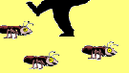 | at
11 |  | as
12 |  | in

Tic Tac Toe Bingo!!!!
Preparation: Laminate game boards, cut out game cards.
Play: 1) Learner picks Bingo card one or two and gives the other to the tutor.
- As learner and tutor take turns picking and reading game cards each puts his/her X or his/her 0 in the place where the word on the card is represented
- The first player to score a row of three in any direction wins.
Game Cards
Pat | taps |  | tans
tips | ants |  | Stan
as | in |  | ant
at |  | pants |  | sips

Bingo Card #1
Pat | taps | tans
tips | ants | Stan
as | in | ant
BingoCard#2
Pat | taps | Stan
tans | ants |   pants
tips | sips | at

