Kitten Kidnap
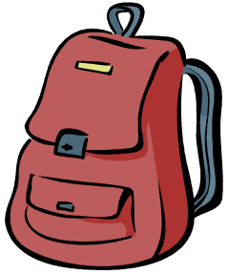  Ned has a tennis racket.  The tennis racket is in Ned’s backpack in the tent. |     Dan has a kitten in a basket.  The kitten is in a basket in Dan’s desk.
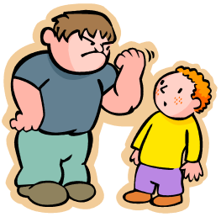  Dan hasn't a tennis racket. | Ned hasn’t kittens in a basket.
Ned kidnaps the kitten. Ned kept the kitten in the tent. | Dan is sad. Dan is mad. Dan spat at Ned.

Word List
1 | 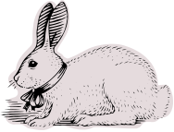 | rabbit
2 |  | tent
3 |  | eyes
4 |  | desk
5 |  | kitten
6 |  | Ned
7 |  | Ted
8 |  | tennis racket
9 | 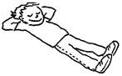 | rest
10 |  | backpack
11 |  | basket
12 | 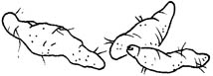 | yams

Game: Match It


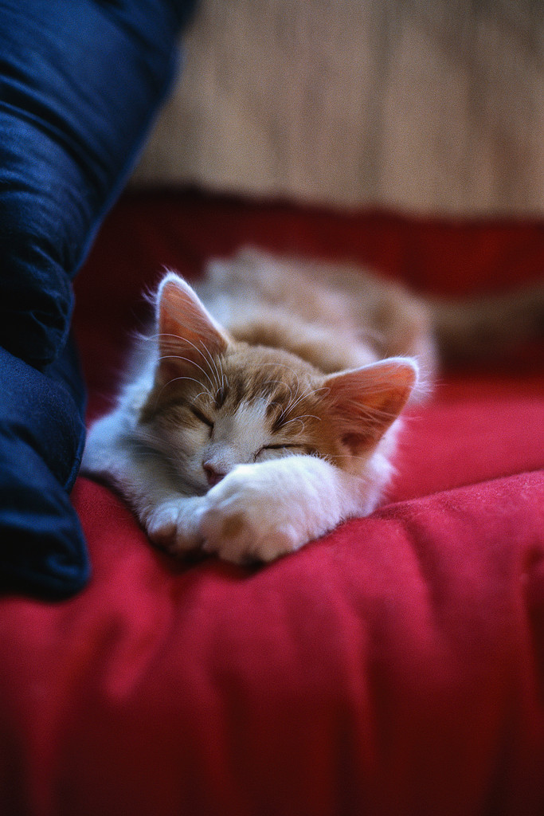

backpack
desk
Laminate and glue onto stiff material. Cut the puzzles out and cut each one apart on the lines. Have the child match the word to the picture

