Kittens and a Rabbit at Tennis
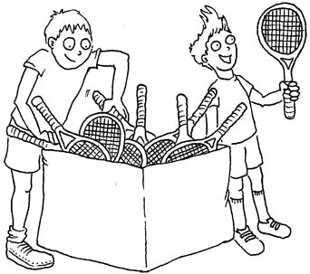  The kids pick tennis rackets. | 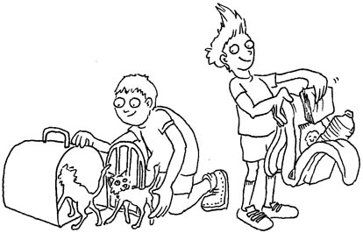  Ned packs Can-Can’s kittens in a basket. Dan packs napkins and a snack.
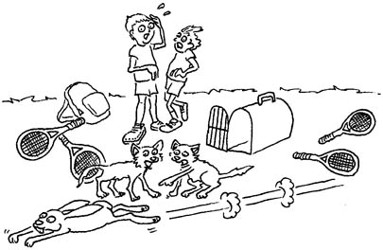  A rabbit ran past the tennis rackets. | 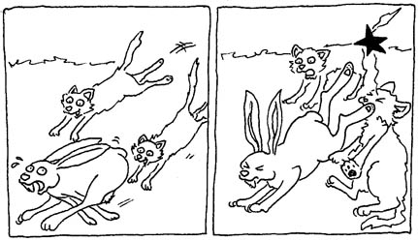  The kittens attack the rabbit!  The rabbit kicks a kitten in the eye!
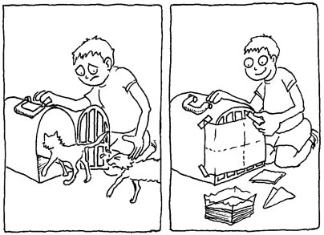  The kids kept the kittens in the basket. A napkin hid the kittens. | 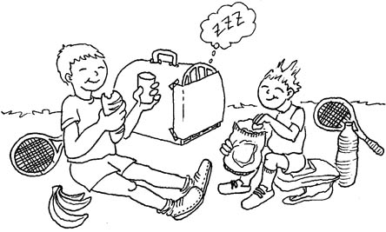  The kids skip tennis.  They sat and had their snack.

1 | 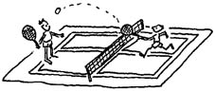 | tennis
2 | 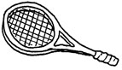 | racket
3 | 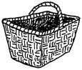 | basket
4 | 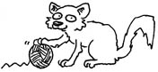 | kitten
5 | 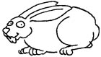 | rabbit
6 | 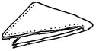 | napkin
7 | 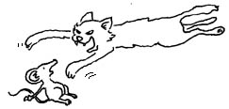 | attack
8 | 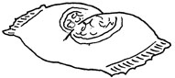 | snack
9 | 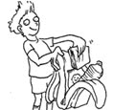 | pack
10 | 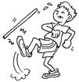 | kick
11 | 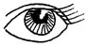 | eye
12 | 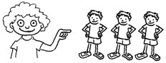 | they

VC/CV Dominoes
Preparation: Glue the following dominoes onto foam board, corrugated plastic board or other three-dimensional material that can be cut into pieces that are fun to handle (could even be cardboard) and cut out dominoes on the dotted lines only. (DO NOT CUT on the solid lines.) Color if you like, uniformly for all instances of a word.
Play: Mix the dominoes; each player chooses seven. The first player puts one down and the other player has to put down a matching domino to complete one of the words. (To match, find the other half of the vc/cv word. Read words aloud.) If you don’t have a match, choose another from the “pot” until you have a match to put down. (Facilitate finding a match by leaving them face-up in the “pot.”) Turn corners when you run out of table space. The first person to use up her dominoes wins.
kin | bas |  | ket | at
nis | bas |  | ket | rac
bit | bas |  | ket | Bat
ten | ten |  | nis | rab
ket | ten |  | nis | nap
man | ten |  | nis | bas
tack | rac |  | ket | ten
ket | rac |  | ket | rab
kin | rac |  | ket | kit
ket | rab |  | bit | ten
kin | rab |  | bit | Bat
ten | rab |  | bit | at
nis | at |  | tack | nap
bit | at |  | tack | kit
ket | at |  | tack | Bat
ket | Bat |  | man | ten
tack | Bat |  | man | rab
ket | Bat |  | man | kit
bit | nap |  | kin | at
ten | nap |  | kin | bas
man | nap |  | kin | rac
nis | kit |  | ten | nap
man | kit |  | ten | bas
tack | kit |  | ten | rac

Save these dominoes to add to the game and play again in the next lesson (Lesson 13 –ic)
nic | at |  | tic | pic
nic | at |  | tic | pic
nic | at |  | tic | pic
tic | pic |  | nic | at
tic | pic |  | nic | at
tic | pic |  | nic | at

