The Man in the Mask and the Picnic
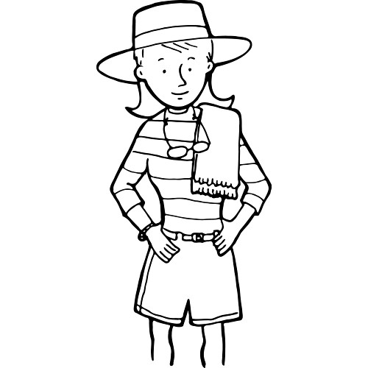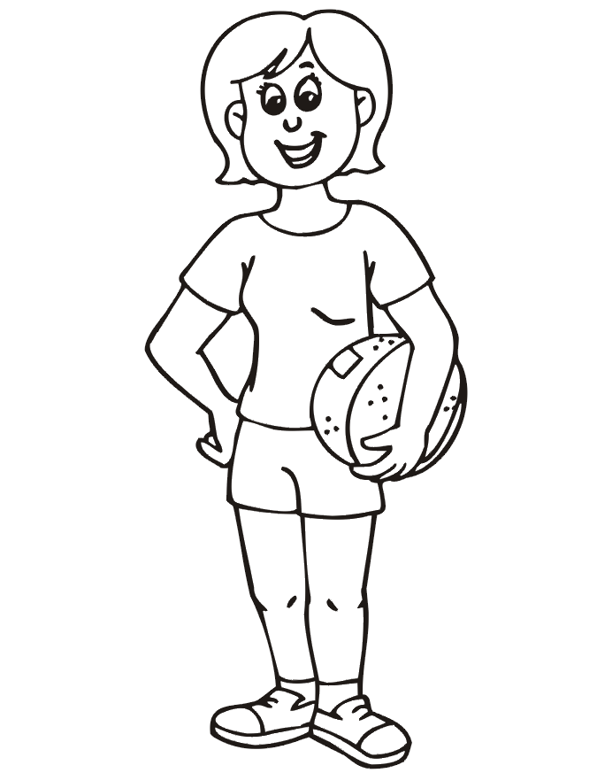  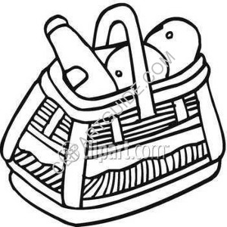  Iris and Kim pack a picnic basket. | 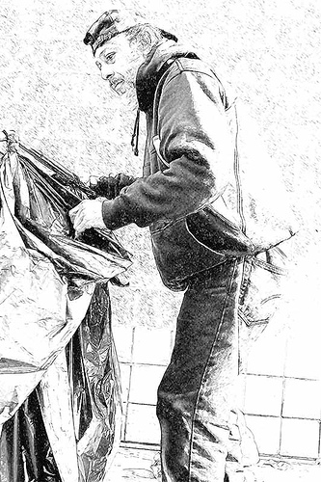  Sam is a bandit. He has a sack.
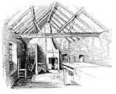  Iris and Kim didn’t panic.  They hid in the attic. | 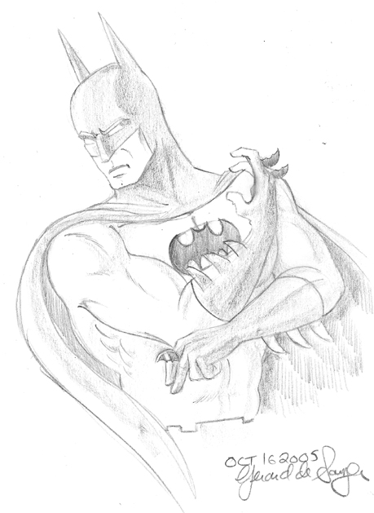  The man in the mask is Batman.
Batman trips Sam.  He has the basket. | 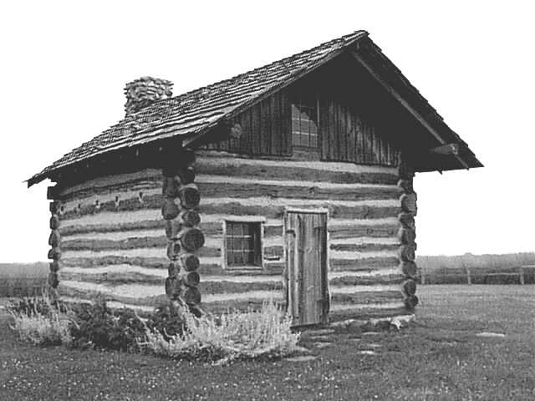  Iris and Kim and Batman had a picnic in a cabin.

Word List
1 | 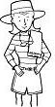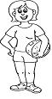 | Iris and Kim
2 | 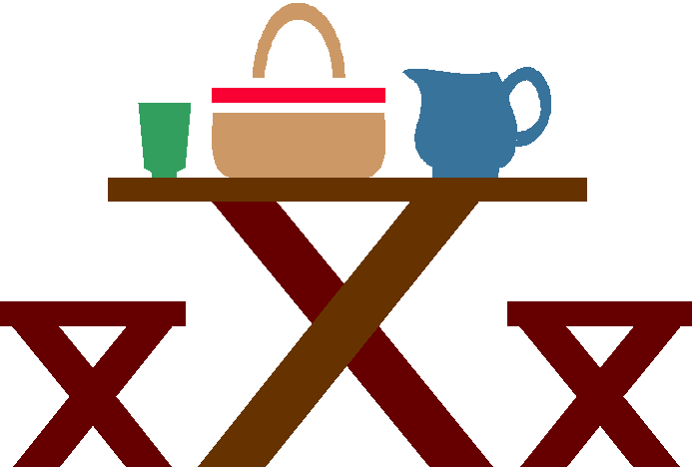 | picnic
3 |  | cabin
4 |  | basket
5 | 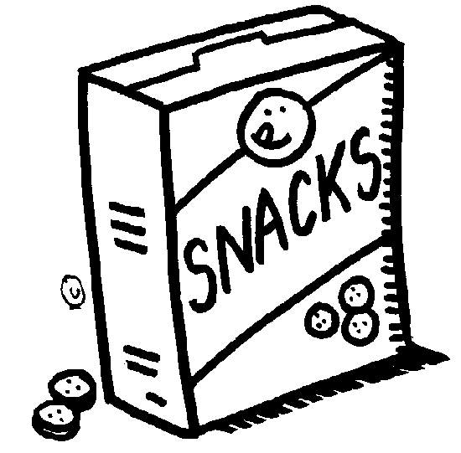 | snack
6 |  | Batman
7 | 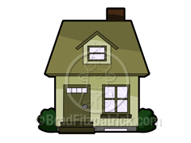  | attic
8 |  | panic
9 | 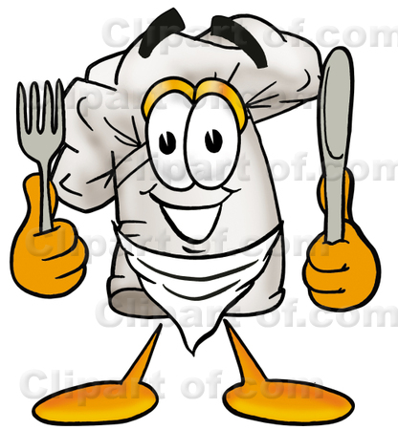 | napkin
10 |  | bandit
11 | 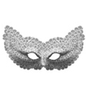 | mask
12 |  | best

Game: Word Search

Look for the words below in the word mix.

The words can be in any direction, so look carefully!

I | A | C | N | C | M | B | A | K
R | T | A | J | I | D | A | E | C
I | T | B | Y | N | D | T | N | A
S | I | I | I | C | X | M | A | N
S | C | N | Y | I | S | A | P | S
T | S | E | B | P | T | N | K | K
T | E | K | S | A | B | Q | I | S
T | I | D | N | A | B | B | N | A
C | I | N | A | P | E | I | D | M

ATTIC | BANDIT | BASKET
BATMAN | BEST | CABIN
IRIS | MASK | NAPKIN
PANIC | PICNIC | SNACK

