The Kite in the Pine
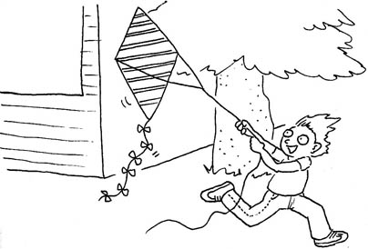  Dan’s kite has nine stripes. | 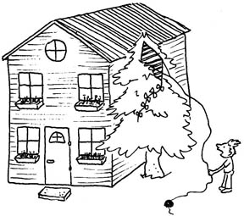  The kite rises. The kite is in the pine!
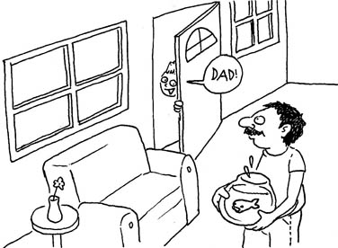  Dan didn’t panic. “Dad,” he said, “The kite is in the pine!” | 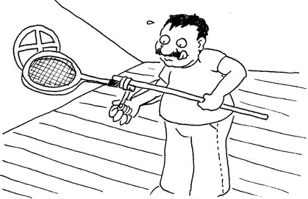  Dad has a stick and a tennis racket. He stands in the attic.
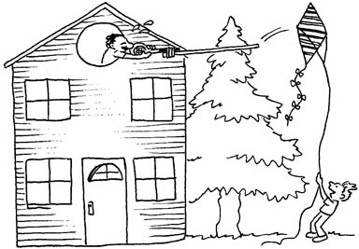  He hits the kite. It rises! | 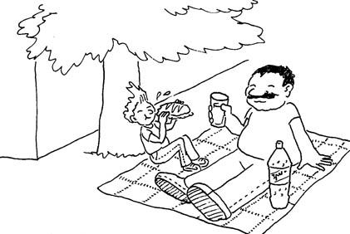  Dan and Dad had a picnic and Sprite.

1 | 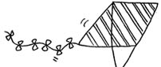 | kite
2 | 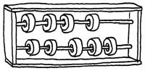 | nine
3 | 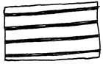 | stripes
4 | 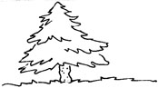 | pine
5 | 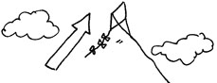 | rise
6 | 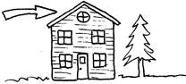 | attic
7 | 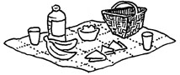 | picnic
8 | 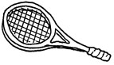 | tennis racket
9 | 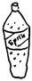 | Sprite
10 | 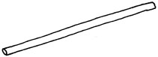 | stick
11 | 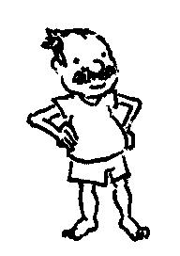 | stand
12 | 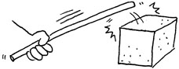 | hit

Snakes and Ladders
Preparation: Glue board on stiff back and cut out (lamination optional).
Play: Roll one or two dice and move your “soldier” forward. When you land on a square, you read the word aloud. If you land on a ladder you climb up. If you land on a snake you slide down. If you know the definition of the word, you can choose to have another turn (or if you landed on a snake you can choose not to slide down.) The first person to reach 100 wins. (Or make up your own rules.)

11
12
13
14
15
16
17
18
19
20
10
9
8
7
6
5
4
3
2
1
51
52
53
54
55
56
57
58
59
60
50
49
48
47
46
45
44
43
42
41
31
32
33
34
35
36
37
38
39
40
30
29
28
27
26
25
24
23
22
21
70
69
68
67
66
65
64
63
62
61
71
72
73
74
75
76
77
78
79
80
90
89
88
87
86
85
84ז
83
82
81
91
92
93
94
95
96
97
98
99
100
84
hat pine print be back yes basket kite a rise
is test ran Sprite an stick I bed nine as a rise
it the in pipe stripe ride back sit cat neck
picnic at she red I me man met net hen
be bad it ask cat an bad kind kept best
pin am kite ten kitten are her attic pack hi
panic its it’s pin pen bit bite men rabbit I
kid they kick side at rises kites pines bin a
it at a in me rides him he them her
tennis had racket has nine ten it’s yes bites men

(Thanks for board template to Beit Berl College Curriculum Center)

