Ann’s Best Present
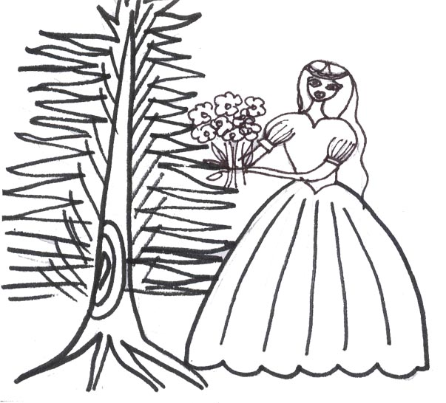 | 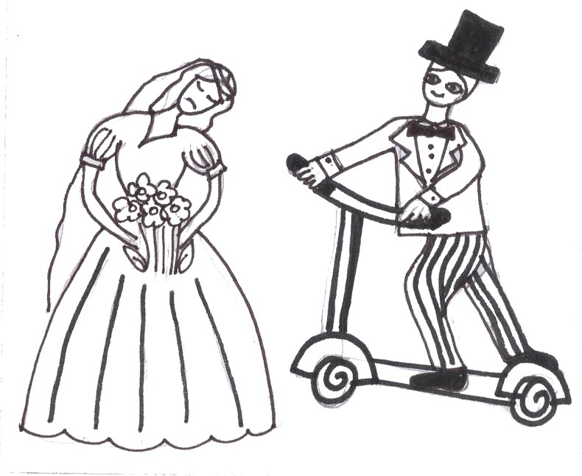
Ann is a bride.  She stands beside the pine . | Ann didn’t hide that she’s a bit sad.  Nick rides beside Ann.
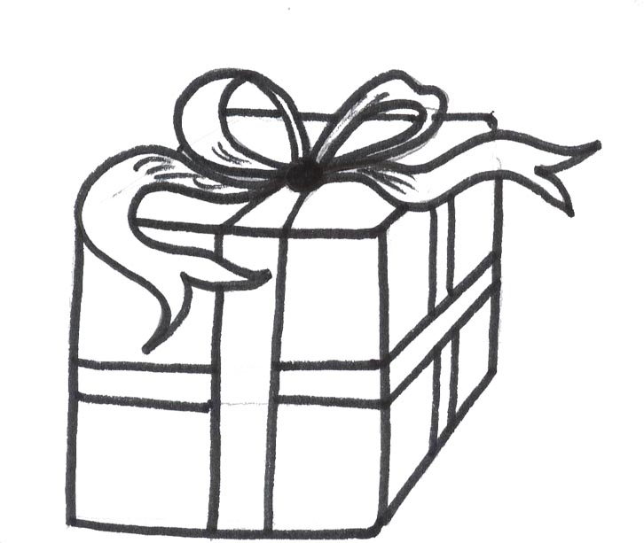 | 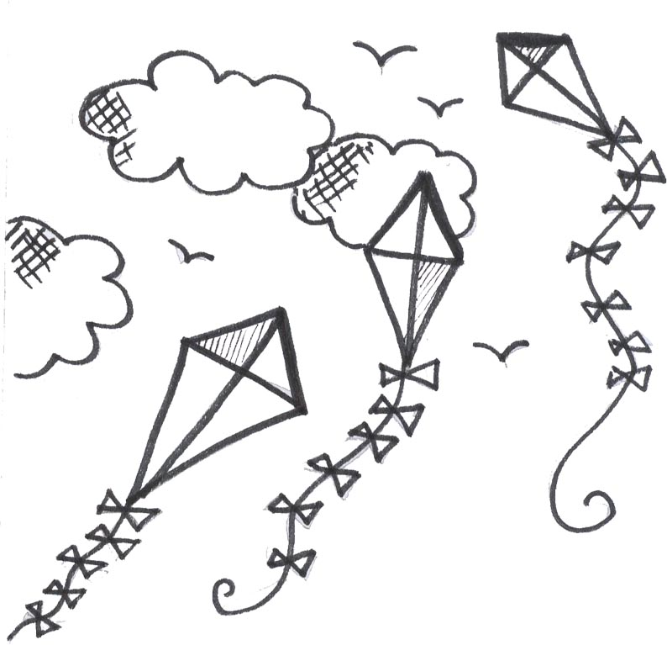
“This is a present “ Nick said.  “It is a red kite.” | In time, the kite rises.  The kite rises and rises and rises.
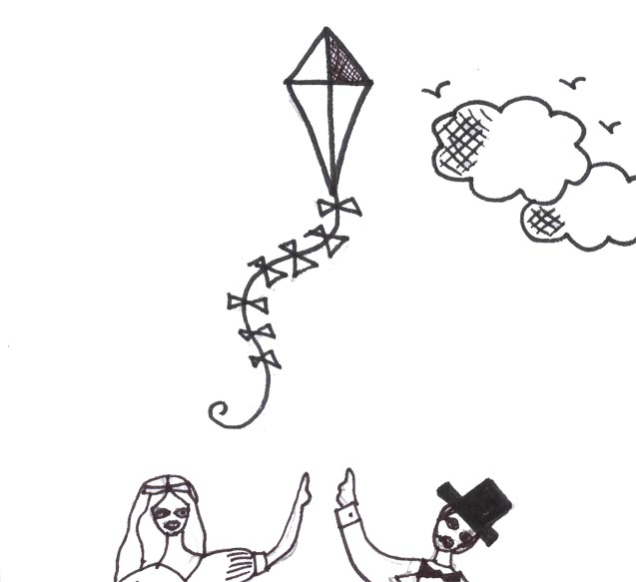 | 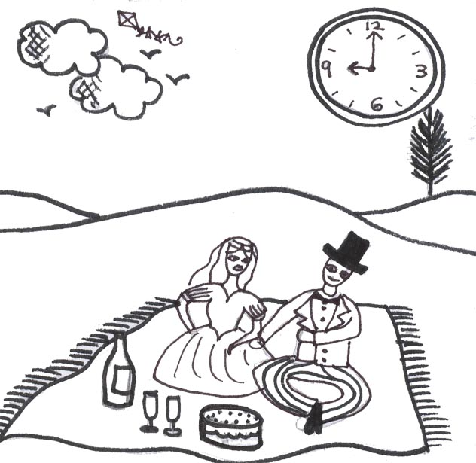
“It’s the best kite!!!!” Ann said.  “Yes, it’s the best kite, the best present,” said Nick. | The time is nine. It’s picnic time.  Nick and Ann sat and had a picnic.
Word List
1 | 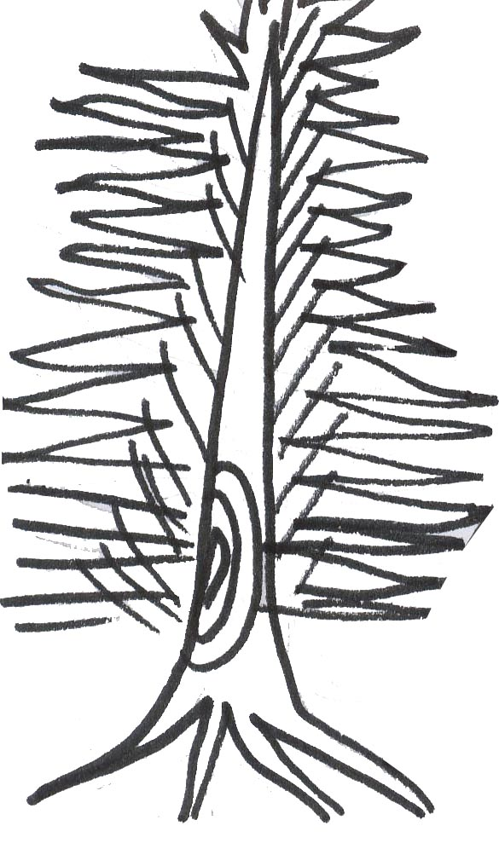 | pine
2 | 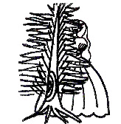 | hide
3 | 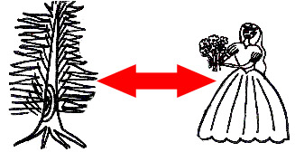 | beside
4 | 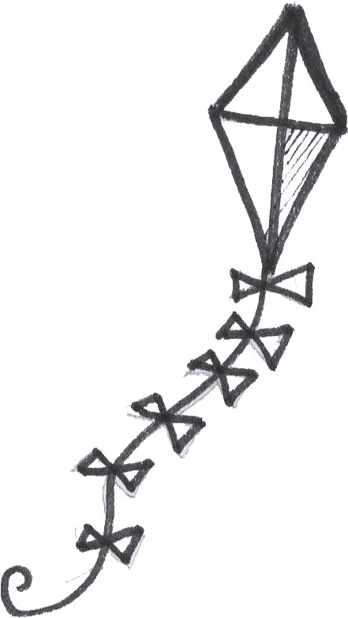 | kite
5 | 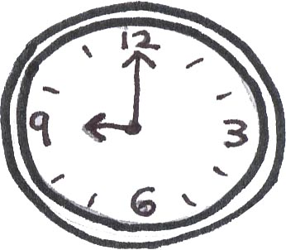 | time
6 | 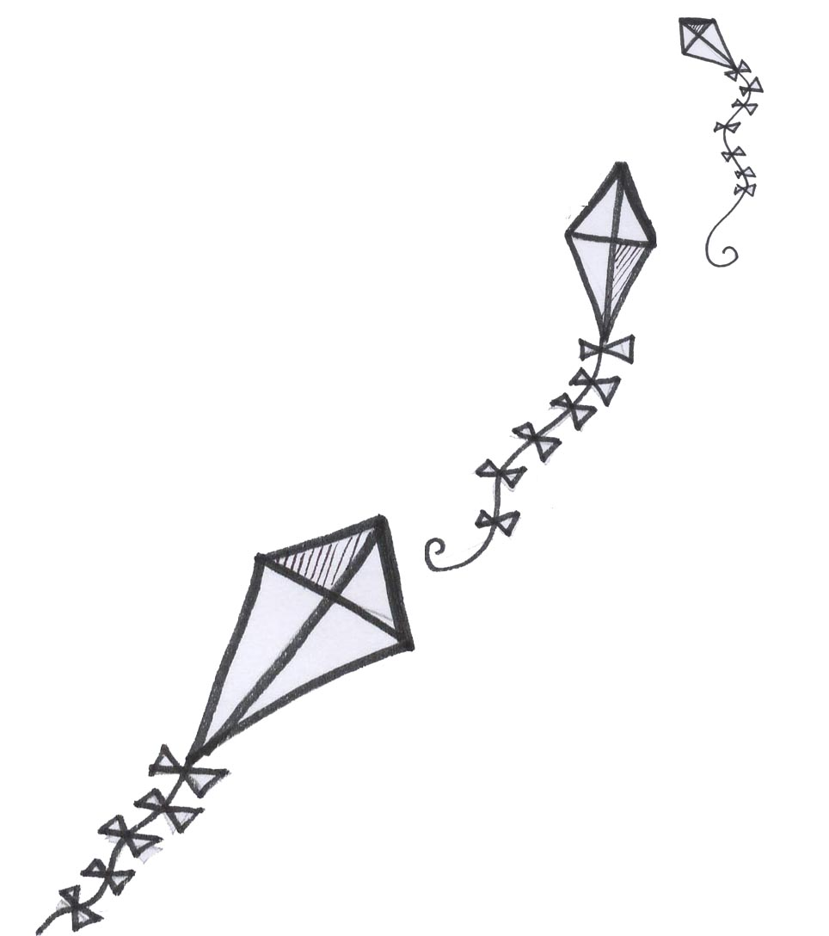 | rise
7 | 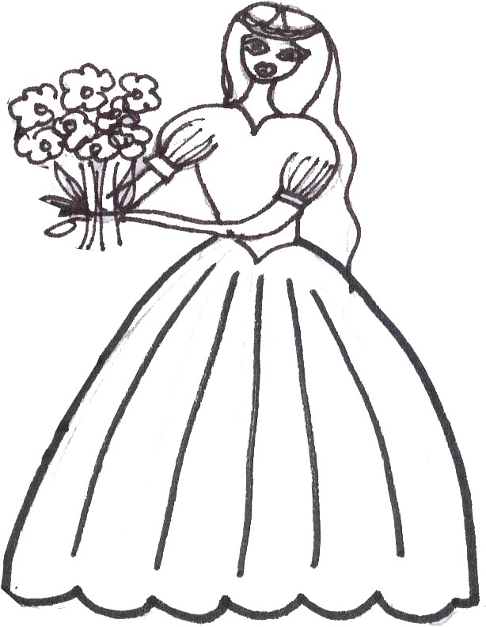 | bride
8 |  | nine
9 | 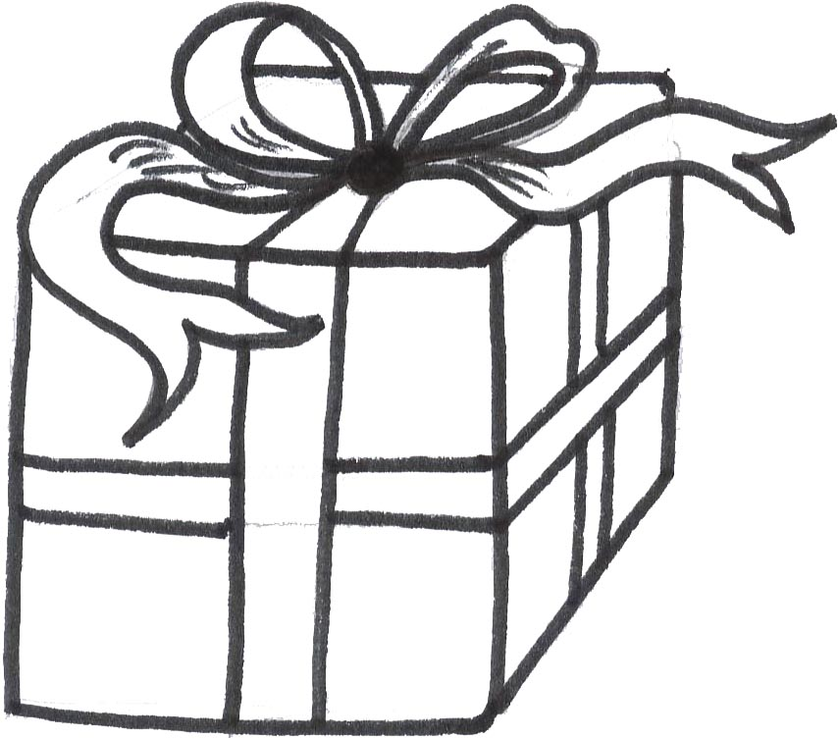 | present
10 |  | best
11 |  | red
12 | 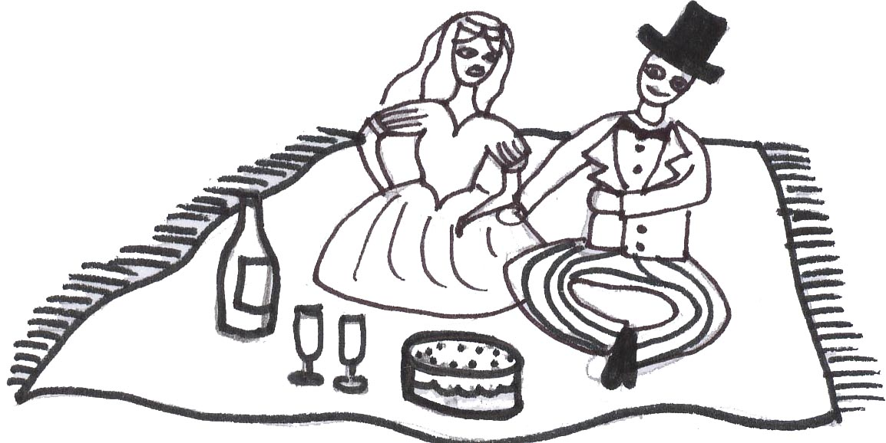 | picnic
Board game
Preparation:
- Print out board game below (you could laminate it).
- Print out word and smiley cards. Stick a smiley card on the back of each word card.
- Place the cards in the middle of the board.

Instructions on how to play the board game
- Place your counter on start.
- Roll the dice.
- When you land on a word, read out the word. If you read it correctly, then you get a point. If you land on a smiley, pick up the card and read the words. If you read the words correctly, they are worth a point.
- When your counter reaches FINISH count up your points. Ten points warrants a prize (points can be carried over from week to week).

nine brides | nine kites | nine pines
nine kites | a kite | red kite
☺ | ☺ | ☺
☺ | ☺ | ☺


