The Bride
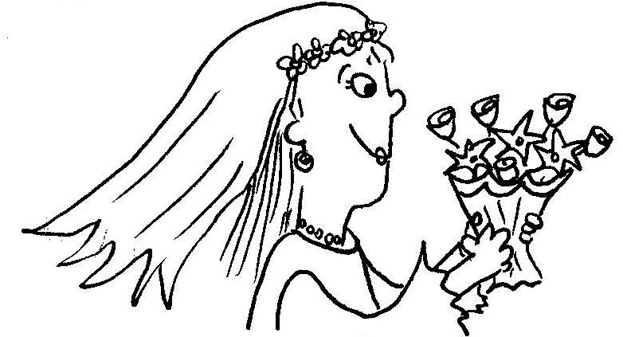  Pride time.  I am the bride. | 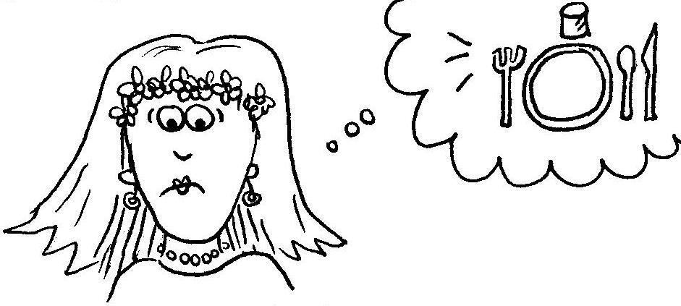  I can't dine yet.  I am sad, I panic.
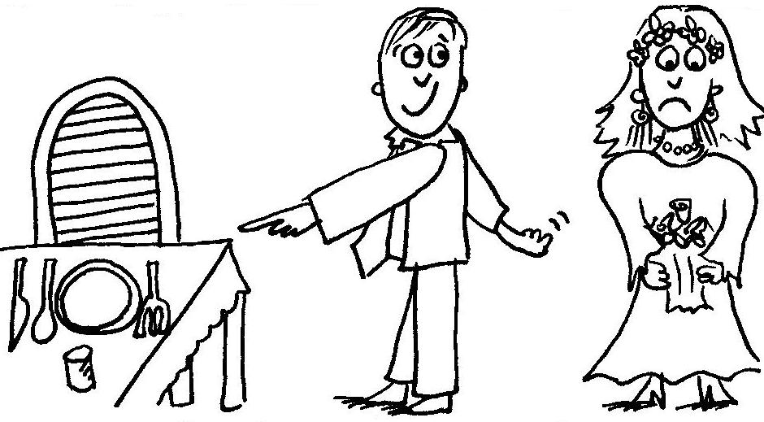  Ben is kind. He insists.  He is the best. | 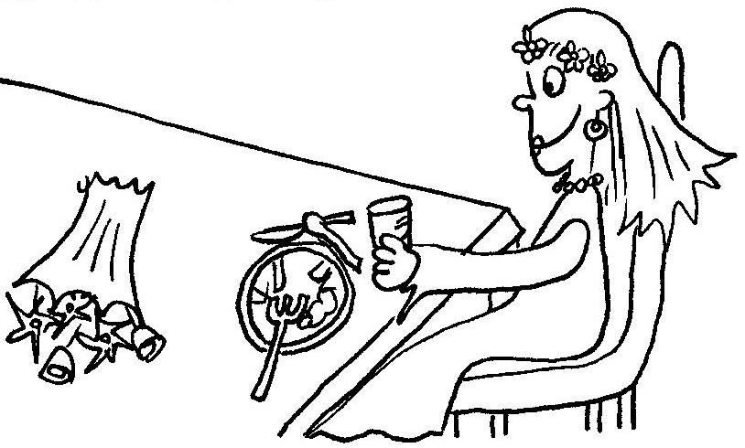  I sit. I sip a Sprite. I bite a snack.
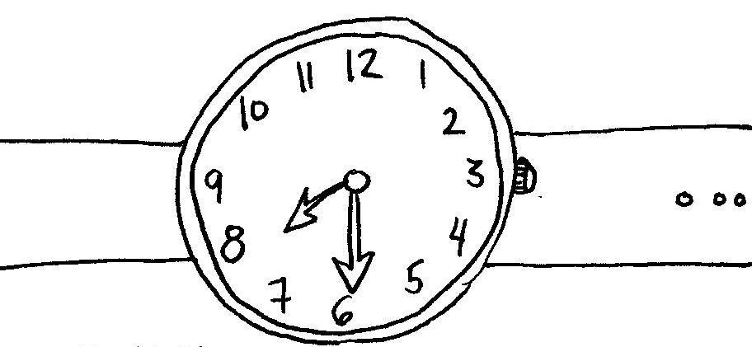  Is it time yet? It is time. | 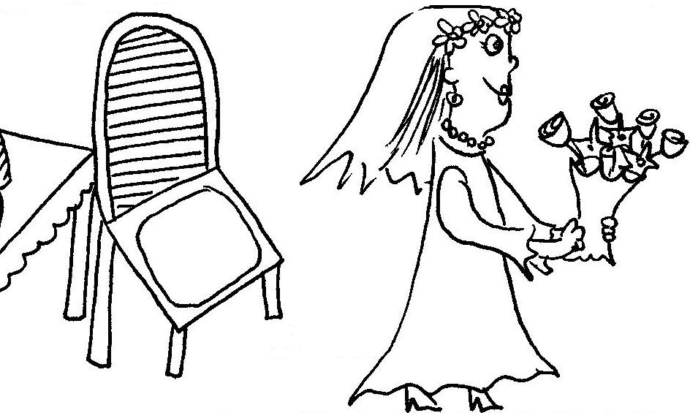  I rise.
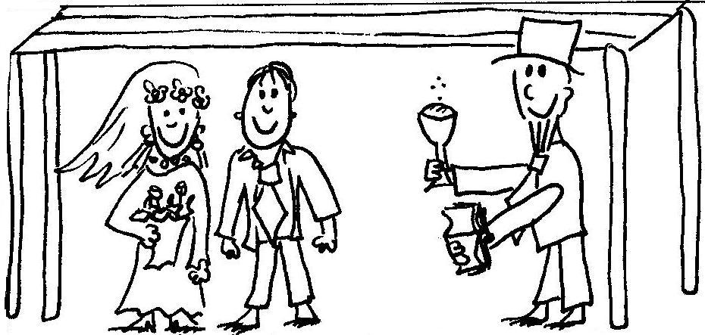  I, the bride, stand beside Ben. | 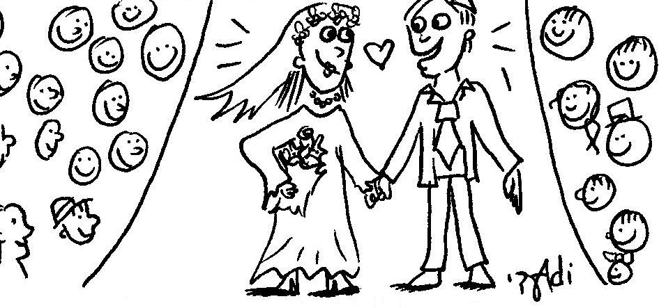  I am his and he is mine!

Word List
1 | 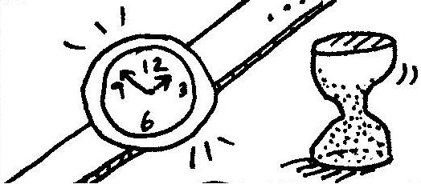 | time
2 | 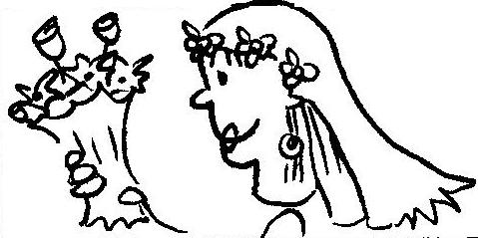 | bride
3 | 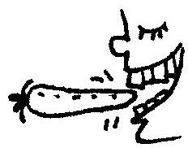 | bite
4 | 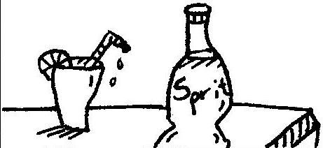 | Sprite
5 | 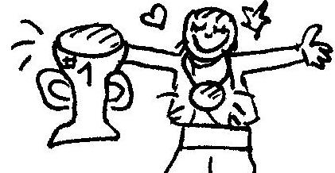 | pride
6 | 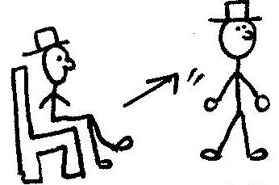 | rise
7 | 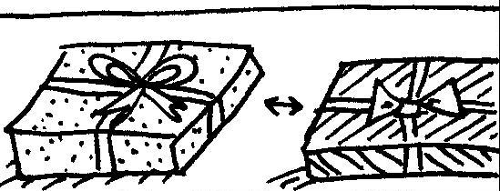 | beside
8 | 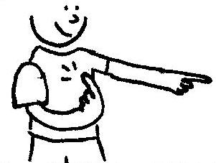 | mine
9 | 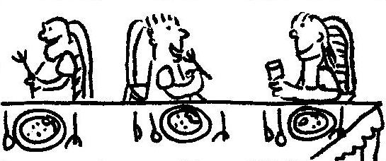 | dine
10 | 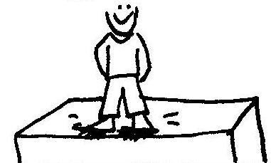 | stand
11 | 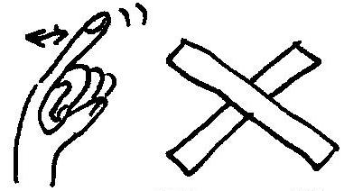 | can't
12 | 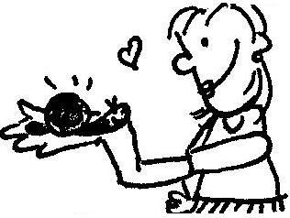 | kind

Board Game
i -with and without magic e
Instructions:
The purpose of the game is to reach the last square on the board game first, while reading the words accurately along the way.

How to play: Place the players in the "start" square. Decide who goes first. Roll the die to know which square to land on. If you land on a word, read it accurately, paying attention to whether it's a short or long i sound (according to the magic e rule.)

*If you read it accurately, you get to stay on the square.

*If you didn't, go back 1 square as a penalty and if there's a word there, read it. Then, proceed in the same fashion as above (if you read the word accurately, you get to stay; if you didn't- go back 1 space, etc. Hopefully, the student won't go back too many times…) The partners have to listen to each other carefully, in order to determine if the other player gets to stay or has to go back. By telling the student to listen if you make a mistake or not, the student doesn't only read his/ her words, but yours, too!

*If you land on a picture, you get to rest.

* If you land on an arrow, go forward or backward 1 space, according to the direction of the arrow and then try to read the word you just moved to, accurately.

* Obviously, try to let the student win by "messing up" occasionally yourself, resulting in you moving backwards.

A List of the words that appear on the board game:
spin- spine sit- site
spit- spite kit- kite
dim- dime slim- slime
Sid- side rip-ripe
bit-bite

Good luck and enjoy!

Board Game
i -with and without magic e

START! |  |  |  | spine |  |  |  |  |  | dim |  | side
spin |  |  |  | Sid |  |  |  |  |  |  |  | site
 |  |  | kite |  |  |  |  |  | bit
 |  | slime |  |  | kit |  | slim |  | dime
 | sit
 | ripe |  |  |  |  | bite |  |  |  |  | spit
 |  | spite |  |  |  | rip |  |  |  |  | The end!!

