Mike is O.K.
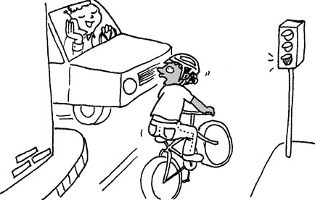  Mike is on his bike.  A careless man in a car  doesn’t stop. | 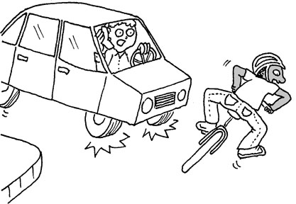  The car almost hits Mike.  Mike falls off his bike.
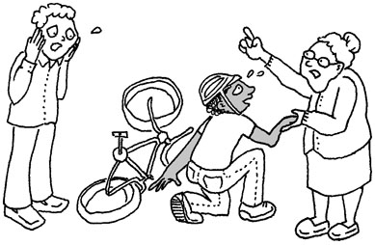  A kind old lady helps him.  “Take him to the hospital,”  she tells the man.  “No, I’m O.K.,” said Mike. | 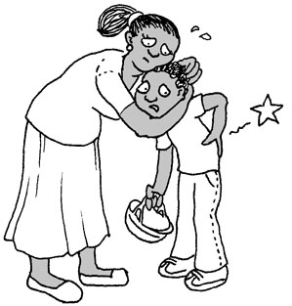  “My back is a little stiff,” he told his mum, Nell.
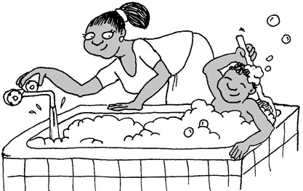  “Take a hot bath,” she told him.  The hot bath helps his stiff back. | 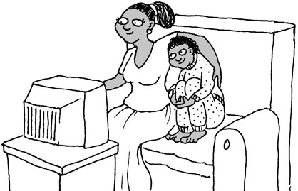  He is happy to be safe.

Word List
1 | 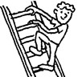 | on
2 | 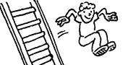 | off
3 | 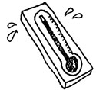 | hot
4 | 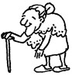 | old
5 | 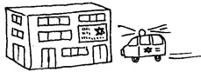 | hospital
6 | 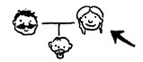 | mum
7 | 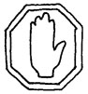 | stop
8 | 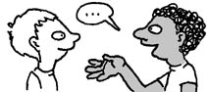 | tells
9 | 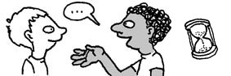 | told
10 | 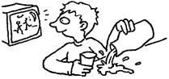 | careless
11 | 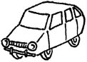 | car
12 | 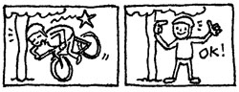 | safe
Spell Out the Words
Preparation: Glue the following picture cards and letter tiles onto colored paper, (laminate; if you have foam board, you can make the letter tiles 3-D) and cut out. Play: Lay the phrase picture cards in a vertical column on the table. Turn the letter tiles face down; each player chooses 7 tiles. In turn, each player has to lay down the first letter of the word that appears in a picture card, or the next letter of a word (if the first letter has been laid down). When a player places the last letter of a the phrase on the picture card, he keeps the picture card and the tiles go back into the pot.
On his turn, if a player doesn’t have an appropriate tile to play, he takes tiles from the pot until he finds one he can lay down. The first player to finish all his tiles, (or if you prefer, the player with the most picture cards) wins.

Picture cards:
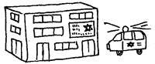  the hospital | 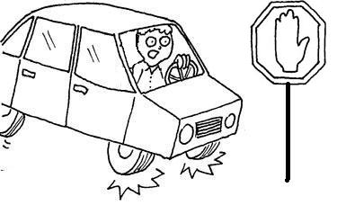  the car stops
an old lady | 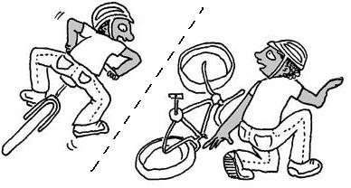  Mike falls off
a hot bath | 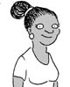  Mike’s mum Nell

t
h
e
h
o
s
p
c
a
r
s
t
o
p
i
t
a
l
t
h
e
s
a
n
o
l
d
l
f
a
l
l
s
o
f
a
d
y
M
i
k
e
f
i
k
e
h
o
t
b
a
t
h
o
e
l
l
a
M
‘s
m
m
N

