Rose and Hope
Rose is alone.  She makes tones on her trombone. | Hope is also lonely.  She is still in her robe at 11 o’clock.
Rose spoke to Hope.  “Can I come?” she asks.  “Yes, come!” Hope tells her. | Hope dresses.  She makes a snack.
Rose rode to Hope’s home.  She takes one rose from her garden and she takes her trombone. | Rose and Hope lick their cones.  Hope listens to Rose’s trombone.  Rose and Hope are not alone.
Word List
 | Rose | 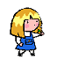
 | alone | 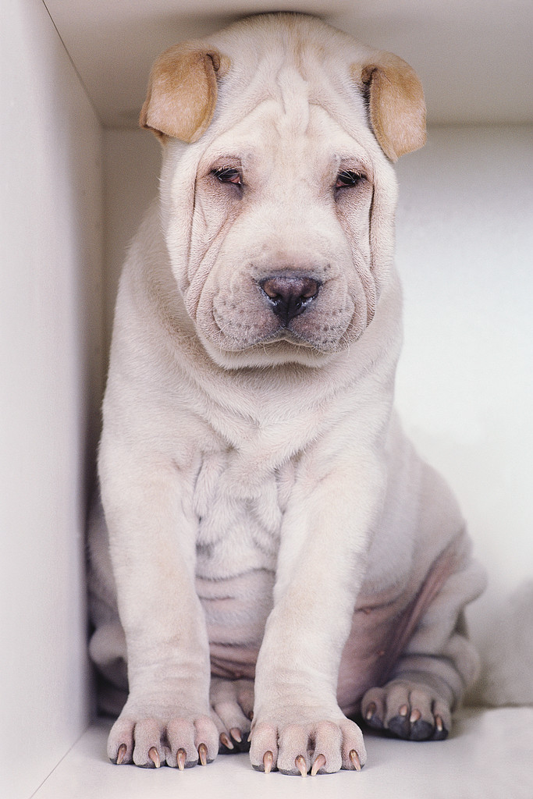
 | tones | 
 | trombone | 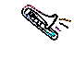
 | Hope | 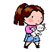
 | lonely | 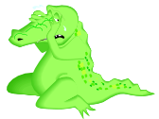
 | robes | 
 | spoke | 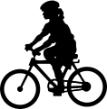  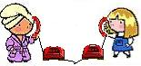
 | rode
 | one | 
 | home | 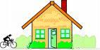
 | rose |   
 | cones

Find the Hidden Words

Read the –o_e words, below. Find them in the picture (use the word list for clues). Write the word in the crossword puzzle – the number in the picture tells you where it goes.
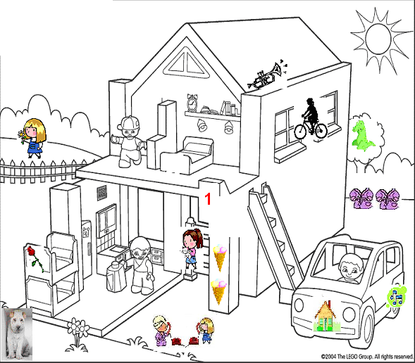 Rose, Hope, trombones, rose, cones, alone,
9.
7.
2.
11.
6.
5.
12.
4.
10.
11 (down)
3.
8.
11. (across)
one, home, lonely, robes, rode, spoke, tones.
Crossword Puzzle
 |  |  |  |  |  |  |  |  |  | 1
 |  |  |  |  |  |  |  | 2 |  |  |  |  | 6
 |  |  |  |  |  |  | 3 |  |  |  | 5
 |  |  |  |  |  | 4
 |  |  |  | 7 |  |  |  |  |  | 8
 |  |  |  |  | 9
 |  |  |  | 10
 |  | 11
12

Fold paper to hide answer key until you are ready to check your answers.

Answer Key to Crossword Puzzle:
 |  |  |  |  |  |  |  |  |  | 1
 |  |  |  |  |  |  |  |  |  | H
 |  |  |  |  |  |  |  | 2 | r | o | s | e | 6
 |  |  |  |  |  |  | 3 |  |  | p | 5 |  | c
 |  |  |  |  |  | 4 | t | o | n | e | s |  | o
 |  |  |  |  |  |  | r |  |  |  | p |  | n
 |  |  |  | 7 | a | l | o | n | e | 8 | o | n | e
 |  |  |  |  |  |  | m |  |  |  | k |  | s
 |  |  |  |  |  |  | b |  |  |  | e
 |  |  |  |  | 9 | R | o | s | e
 |  |  |  | 10 |  |  | n
 |  |  |  | l |  |  | e
 |  | 11 | r | o | b | e | s
 |  | r |  | n
12 | h | o | m | e
 |  | d |  | l
 |  | e |  | y

