Minky and Dinky
This is a kitten.  His name is Minky.  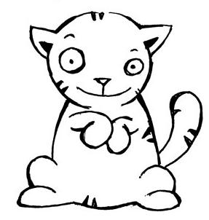 | "Tap! Tap! Tap!" Minky thinks there is something by the candy box. He hopes it isn't a fox. 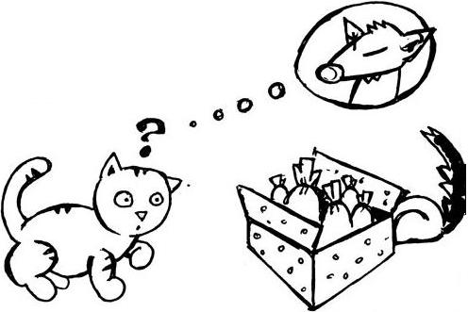  It isn't! It's Dinky the skunk!
Minky jumps at her. Minky hits his nose. Dinky the skunk runs and hides.  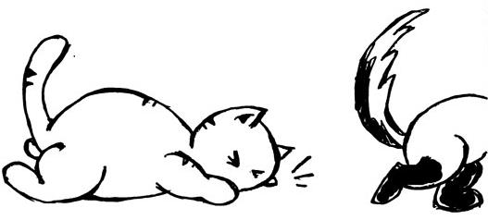 | It is cold. Minky is cold and his nose is sore. Minky rests before the fire and drinks hot milk.  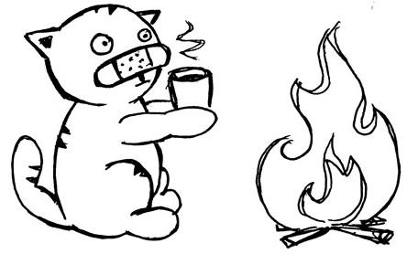
Dinky the skunk is happy. She is safe.  But she wants candy from the box.  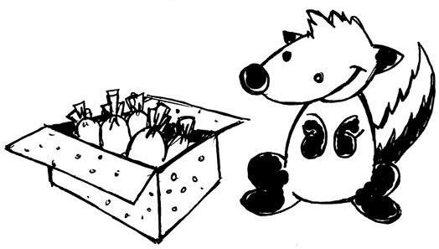 | Minky is still resting by the fire.  Finally Dinky takes six pink bonbons from the candy box. Yummy!  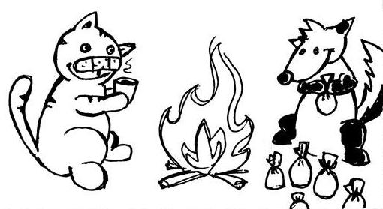

Word List
1 | 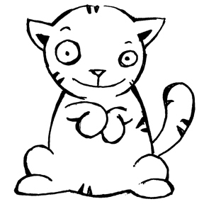 | Minky the Kitten
2 | 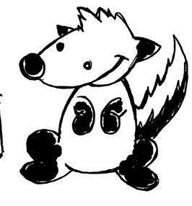 | Dinky the Skunk
3 | 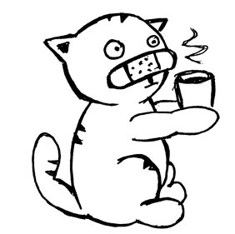 | drink
4 | 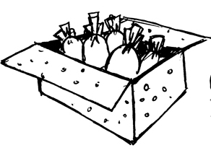 | candy box
5 | 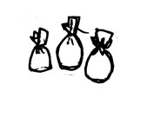 | pink bonbons
6 | 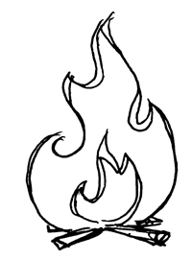 | fire
7 | 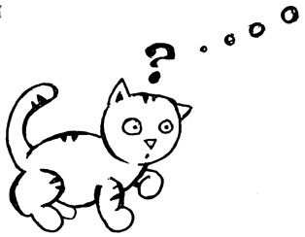 | think
8 | 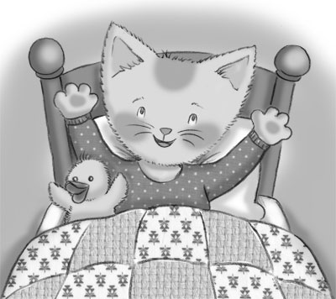 | blanket
9 | 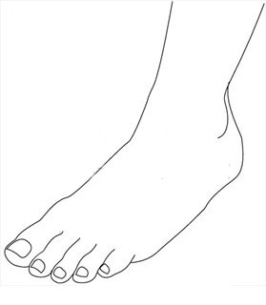 | ankle
10 |  | ink
11 | 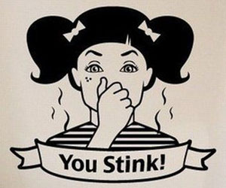 | stink
12 | 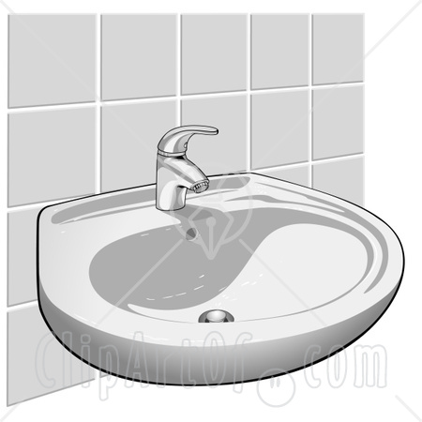 | sink

Bingo
Preparing the game: Print out the two different BINGO cards plus the word sheet.
Cut the word sheet into small squares and put the squares into a hat or bowl / bag.
Playing the game: Hand out one Bingo card to each player (each card should be different).
The caller should pull out one word and read it aloud and match it to a picture. Mark the picture with a bean, button, or other marker. (If you laminate the cards, you can mark them with an erasable pen.)
Winning: Four words in a row / column – call out Bingo

Bingo
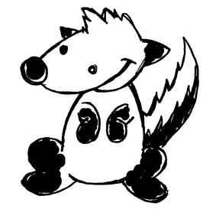

Bingo

The Words Sheet

ink | Minky the Kitten | fire
stink | pink bonbons | blanket
Dinky the Skunk | sink | thinks
candy box | drinks | ankle

