Zip the Fuzzy Zebra
  Kate has a pet zebra.  His name is Zip. Kate adores Zip. | 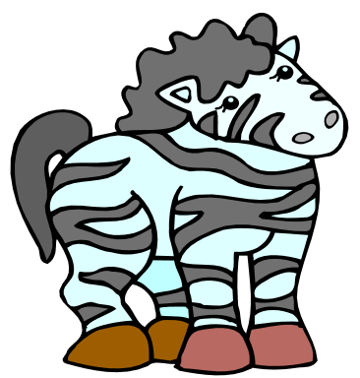  Zip is small and fuzzy.  He has black stripes on his back.
  Kate has a problem: Zip is sick.  He can’t even sip a fizzy drink. |   Kate and zebra Zip drive to the vet’s home. They listen to jazz on the car radio.
  Kate presses the bell at the vet’s. It buzzes. |   The vet is a woman.  Kate asks her for help. The vet gives Zip six zebra pills in a jar.
  Kate and Zip go back home.  Kate gives Zip his zebra pills.  Zip revives. He is well again. |   Kate is very happy.  She gives Zip a prize!

Word List
1 |  | Zip
2 |  | zebra
3 |  | fuzzy
4 | 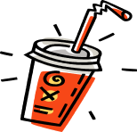 | fizzy
5 |  | jazz
6 | 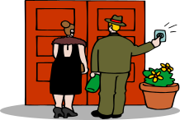 | buzzes
7 |  | woman
8 | 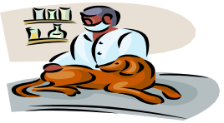 | vet
9 |  | presses
10 | 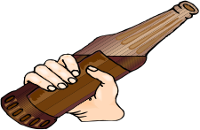 | drink
11 |  | stripes
12 |  | prize

Zip the Zebra Word Bingo

Materials: Bingo Board, pencil, word list
Directions: Tell the pupil to select and write 9 words from the list on the bingo board. Then give pupil clues, using a sentence which describes the word, or from which the word is missing (sentences with missing words are on next page).
Pupil "x's" out the word when he guesses correctly.
As soon as he gets 3 in a row (vertically, horizontally or diagonally) he wins.

Sentences with clues to missing words

1. Kate has a pet _________. (zebra)

2. His name is_________. (Zip)
3. Zip is small and ________. (fuzzy )

4. He has black ________on his back. (stripes)
5. Zip is sick. He can’t even sip a ____________ ____________. (fizzy) (drink)
6. Kate and zebra Zip drive to the vet’s home. They listen to __________ on the car radio. (jazz)
7. Kate __________ the bell at the vet’s. (presses)

8. The bell ________. (buzzes)
9. The vet is a _________. (woman)

10. The _________ gives Zip six zebra pills in a jar. (vet)
11. Kate is very happy. She gives Zip a ___________! (prize)

