Jay Plays with Clay
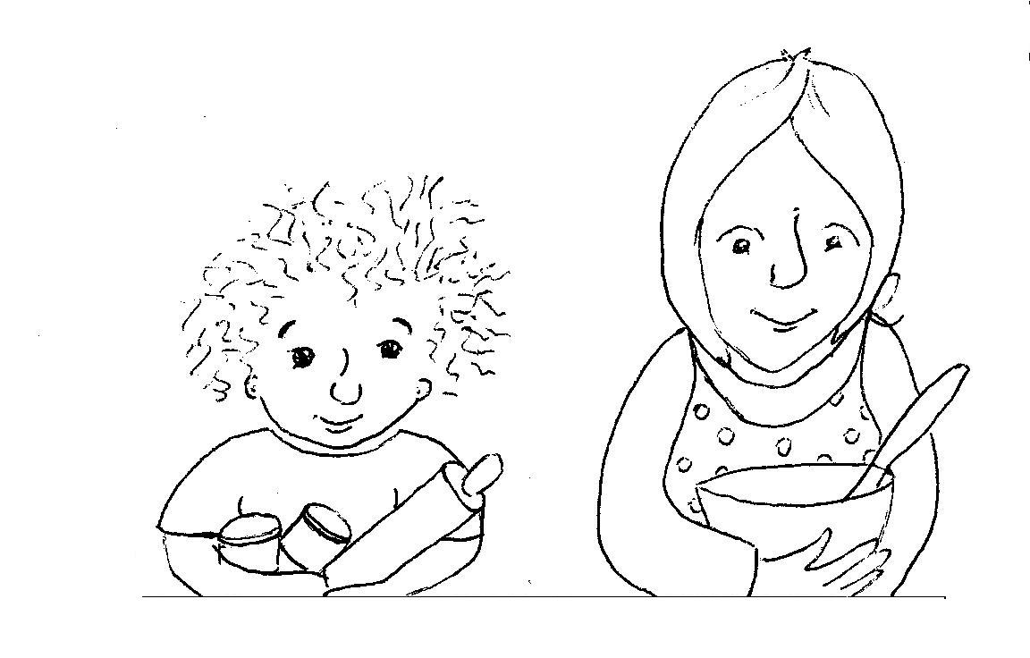  It is Sunday evening.  Jay wants to play with his clay.  Mother says,  “Not until dinner is finished.” | 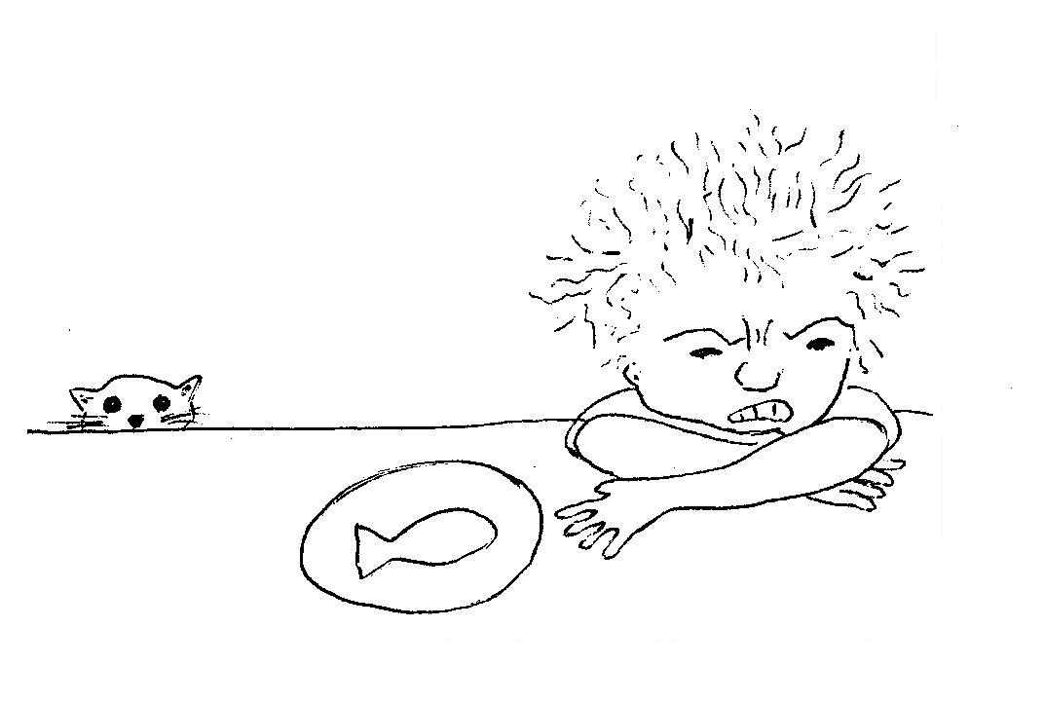  “I hate fish,” says Jay.  “No, no, no.  I will not finish my dinner.  Never, never, never.  Take it away!”
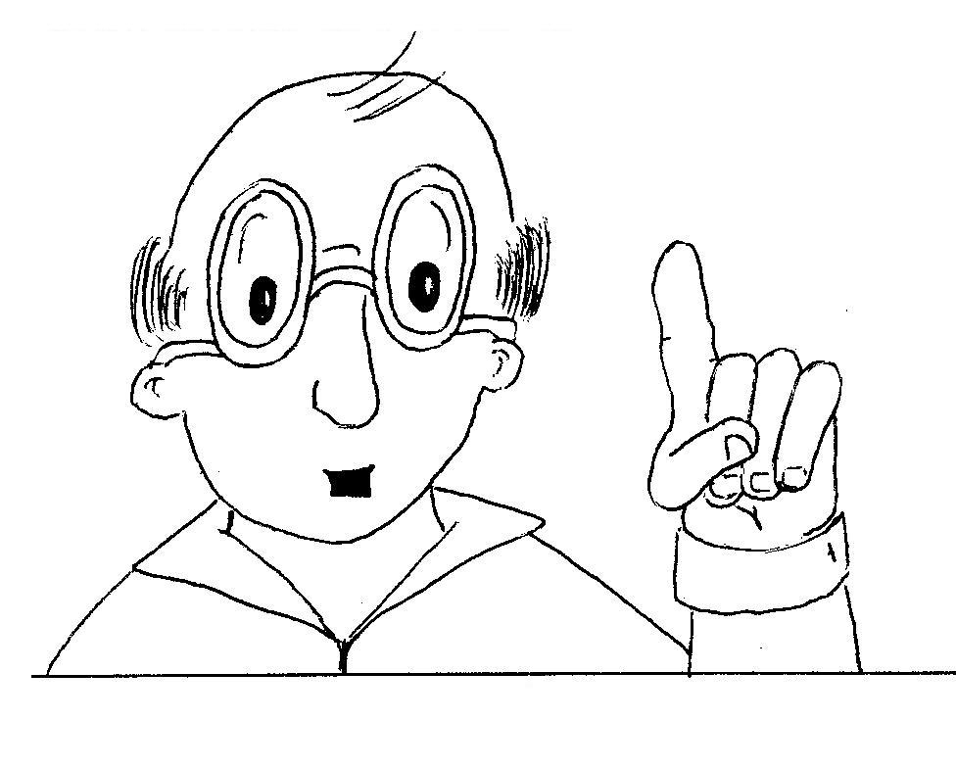  Father says, “Fish is good for you!  Jay, you cannot play with your clay  until dinner is finished.” | 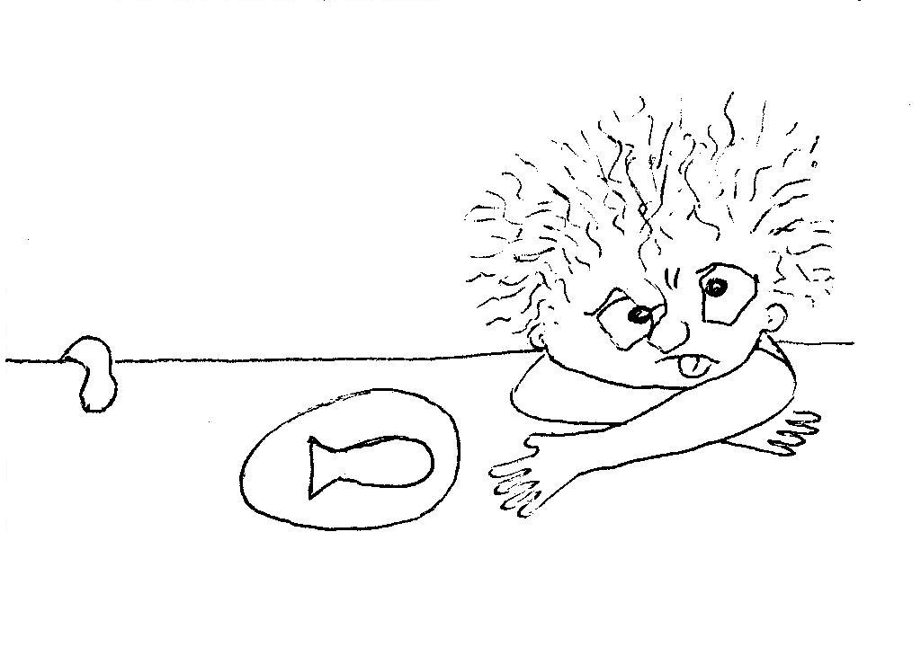  “I hate fish,” says Jay.  “No, no, no.  I will not finish my dinner.  Never, never, never.  Take it away!”
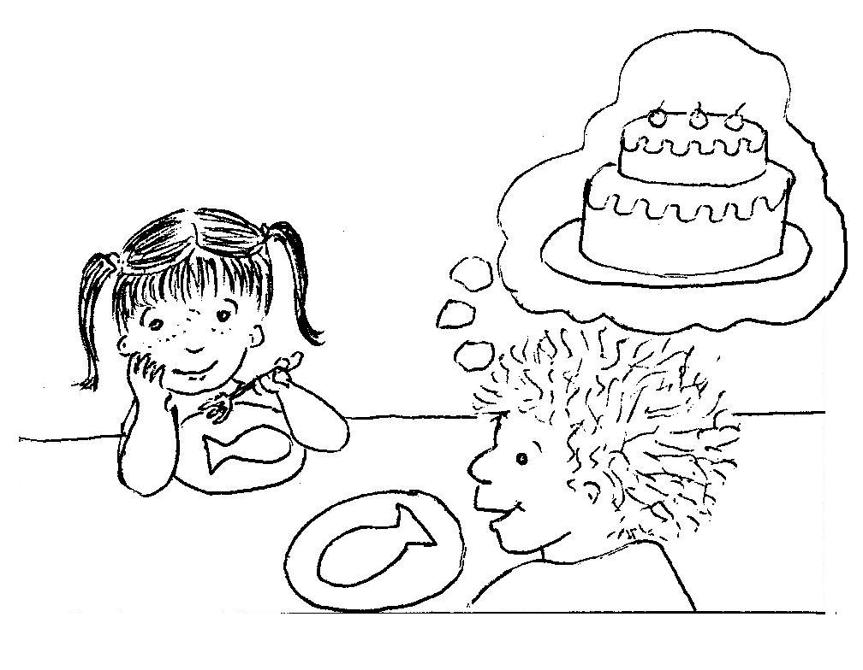  Sister says, “Pretend, Jay.  Pretend the fish is cake.  Yummy, yummy cake.  If you finish your dinner,  you can play with your clay.” | 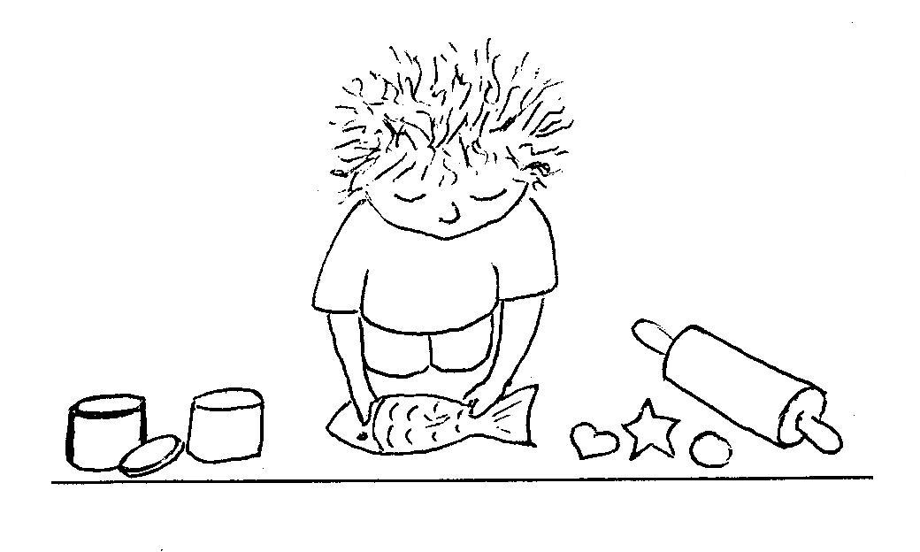  “I love cake,” says Jay.  “Yes, yes, yes.  I will pretend the fish is cake.  I will finish my dinner  so I can play with my clay.”
Word List
1 | 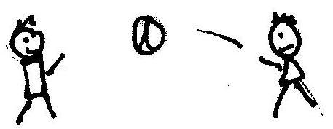 | play
2 | 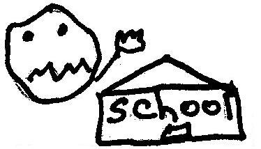 | hate
3 | 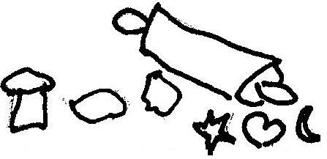 | clay
4 | 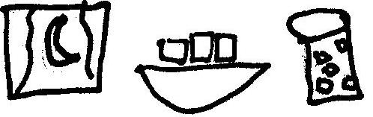 | dinner
5 | 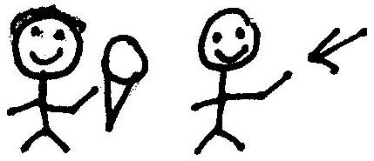 | finish
6 | 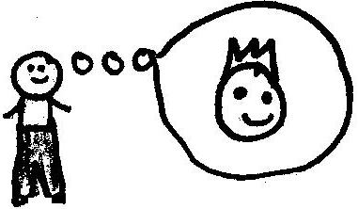 | pretend
7 |  | love
8 | 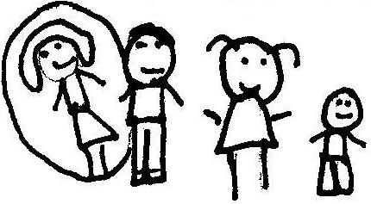 | mother
9 | 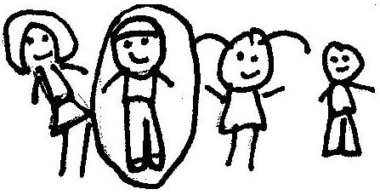 | father
10 | 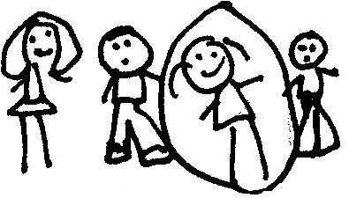 | sister
11 | 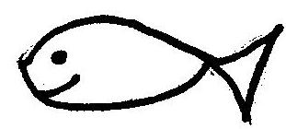 | fish
12 | 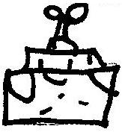 | cake
Guess the Word
Materials: You will need two copies of the game board and two colors of chips or markers (buttons, beans). You will also need a folder or some other kind of divider to put up between the boards so neither player will be able to see the opponent’s board.
Play: Erect the divider. Each player places a chip on one word in each line. The object is to guess the word in each line that your opponent has “marked.”
The first player guesses a word. If s/he is right, s/he will wait until the next turn and try to guess a word from the second line. If s/he doesn’t guess correctly, s/he puts a different color marker on the wrong word so s/he knows not to ask that word again. Then the second player takes a turn guessing. Continue until one player has successfully guessed all the marked words on the opponent’s board.

yes | helped | sister | nine | day
happened | father | hide | say | ship
mother | love | away | wish | so
hate | clay | finish | can | fished
play | dish | no | pulled | baby
fish | I | opened | brother | name

