My Family Plays
Ray is my brother  and Gay is my sister.  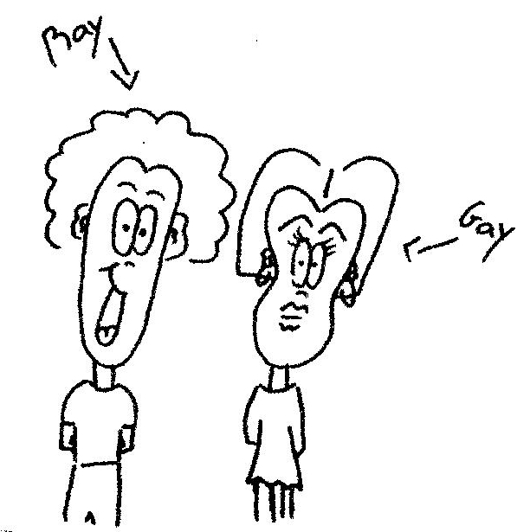 | They never play together.  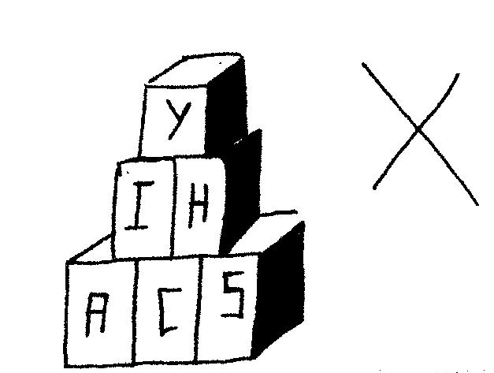
It is Sunday.  I say: "Let's play together."  Ray says: "After dinner."  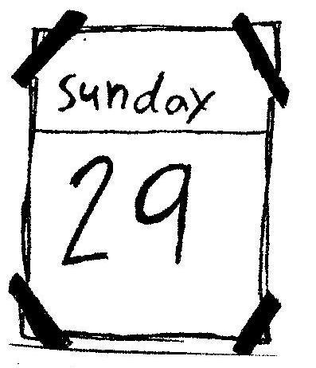 | Today is Monday.  I say: "Let's play together."  Gay says: "I want to look at this book."  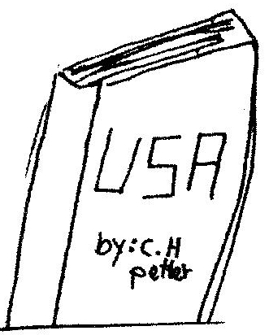
"Hey! Do you remember?  Today is my birthday!"  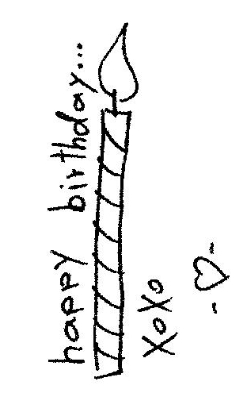 | Mother, Father, Ray and Gay say:  "We will all play together for your birthday."  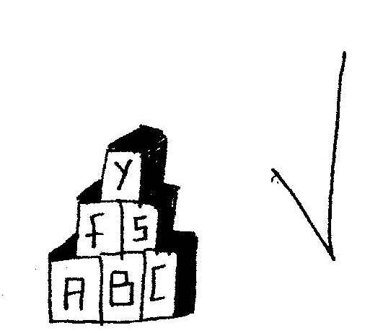
*Tutor: pre-teach "birthday" as a sight word on the yellow card

Word List
1 | 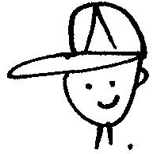 | brother
2 |  | sister
3 | 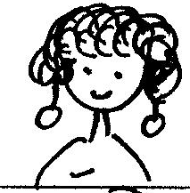 | mother
4 |  | father
5 | 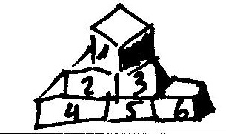 | play
6 |  | together
7 | 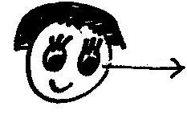 | look
8 |  | book
9 |  | remember
10 | 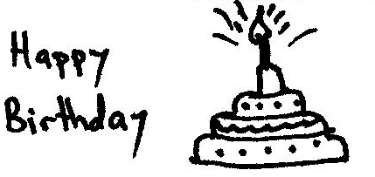 | birthday
11 |  | Ray
12 | 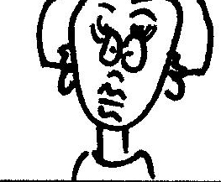 | Gay

Concentration or Matching Game
Cut apart the squares. Match each word or sentence to the picture it describes.
birthday
father
play
I want to look at this book.
Do you remember?
Ray is my brother and
Gay is my sister.
together
Ray
Gay
It is Sunday.

