Mother Cooks Rice
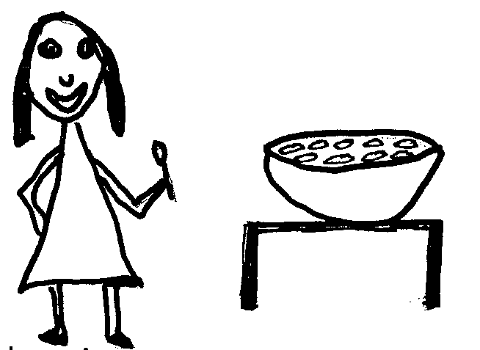  I love rice. | 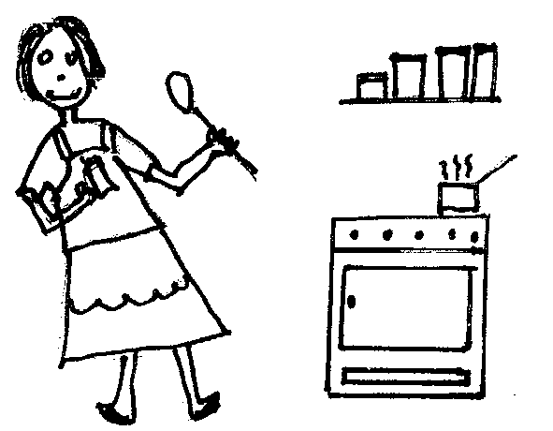  Mother cooked rice for me.  Mother added spices to the rice.  The rice was nice.
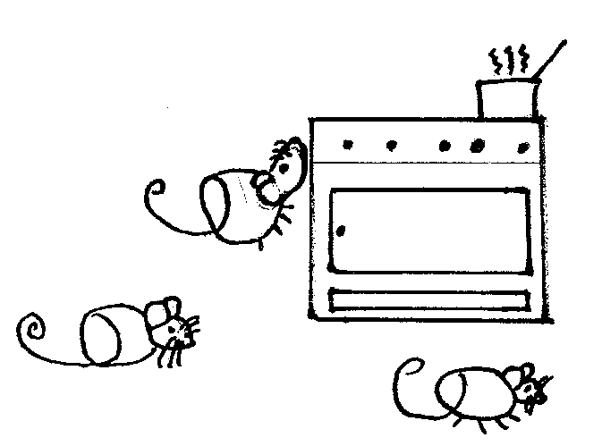  Mice like rice. | 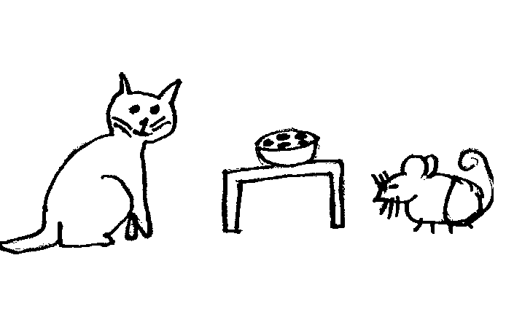  Prince, the cat, likes mice and rice.
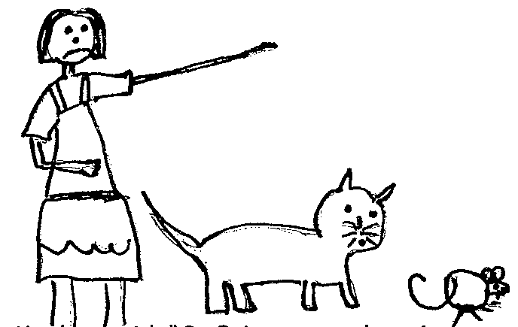Mother said, “Go, Prince, get the mice, and I will give you rice and a slice of cake.” | 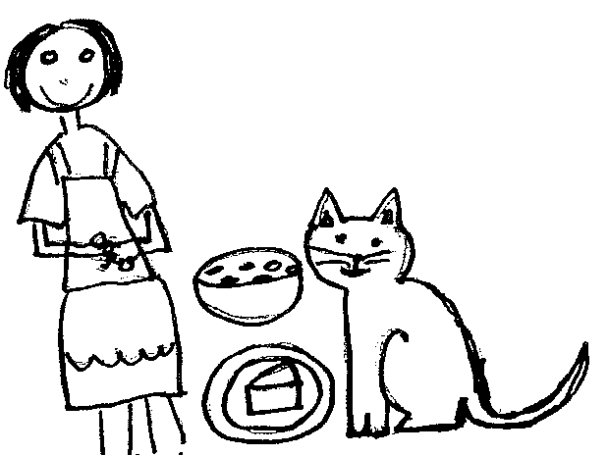No more mice! Happy Mother!  She has a smile on her face.  Happy Prince!  He has a smile on his face.

Word List
 | mice |  | 1.
 | face |  | 2.
 | France |  | 3.
 | rice | 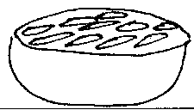 | 4.
 | trace |  | 5.
 | disgrace |  | 6.
 | slice |  | 7.
 | nice |  | 8.
 | glance |  | 9.
 | prince |  | 10.
 | ice |  | 11.
 | advice |  | 12.



