Mother, Father, and the Dance
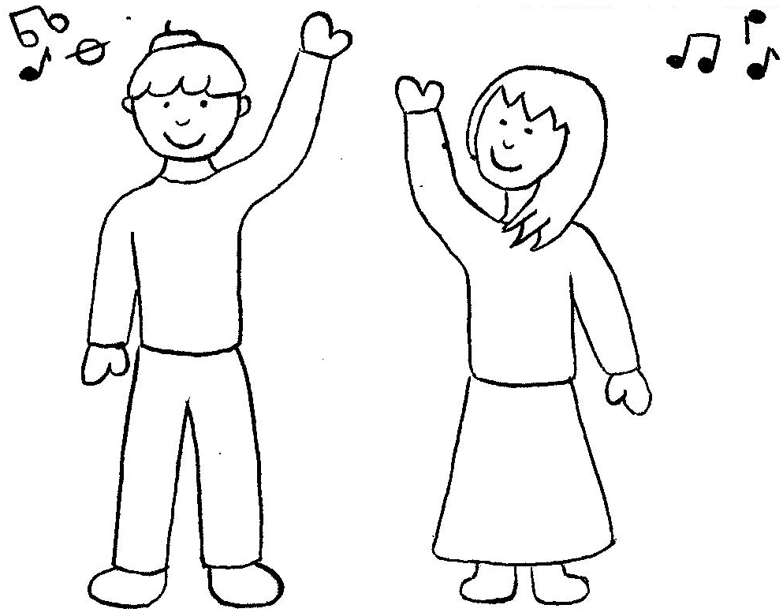  Mother and Father dance fast to the song. | 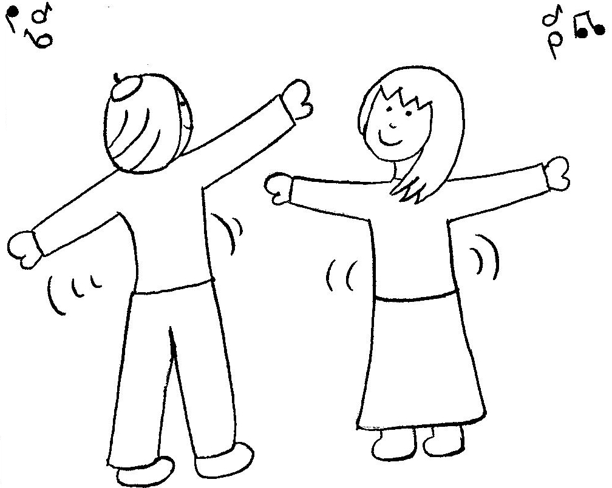  Father spins Mother to the nice music.
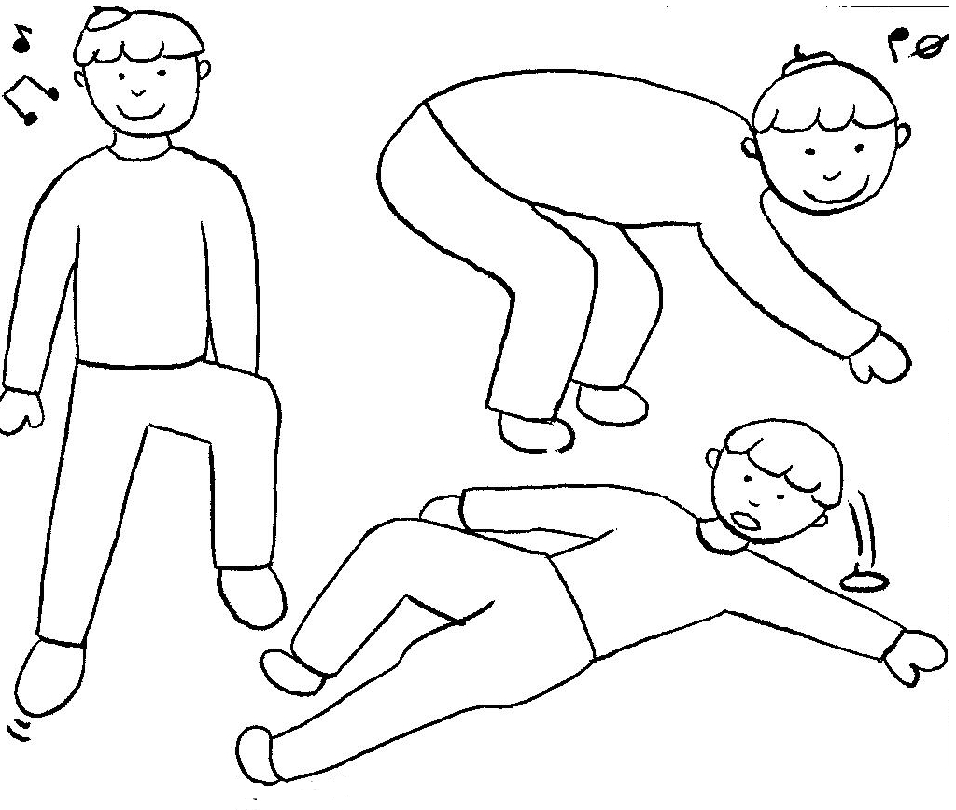  Father dances fast: he hops and drops. He slips and trips. | 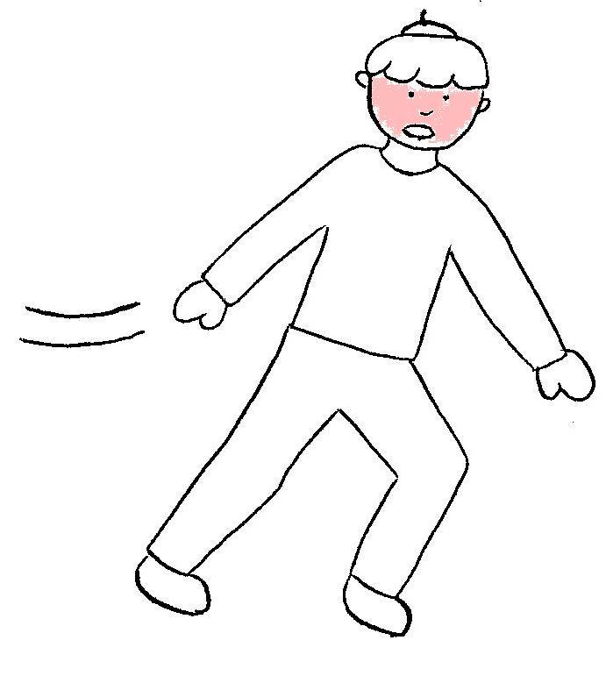  Father’s face is getting red as he races all over the place.
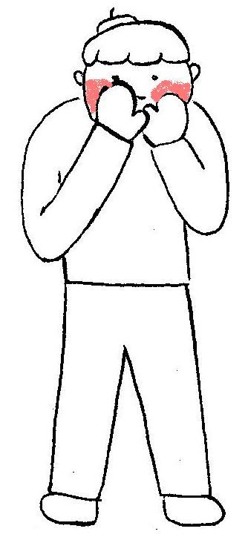  Father is trying to dance too fast. He wants to look good for mother. His face is redder and redder. | 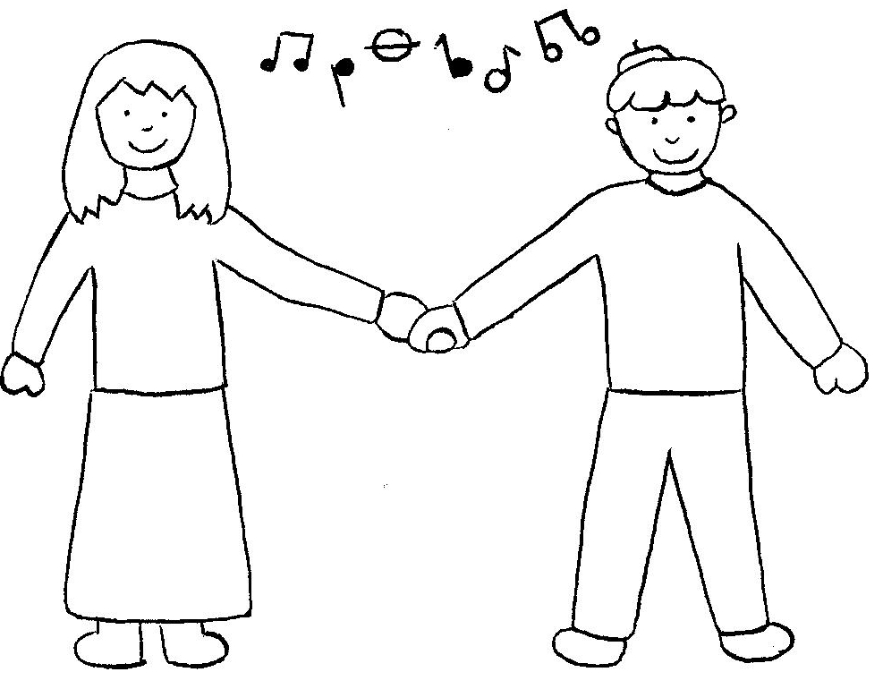  You don’t have to dance so fast, Father. Mother loves to dance together.

Word List
1 | 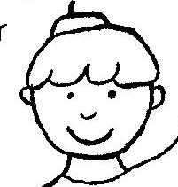 | Father
2 | 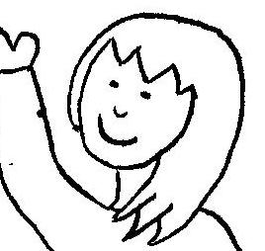 | Mother
3 | 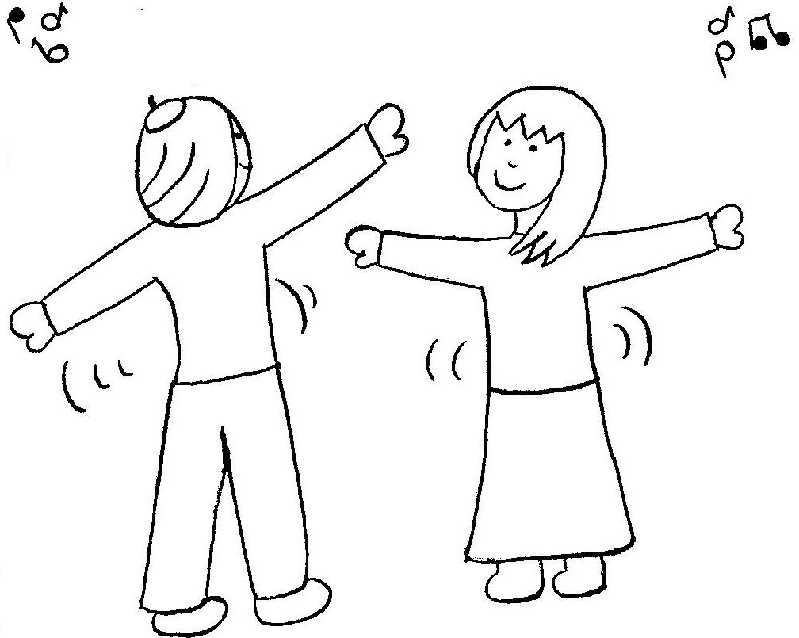 | dance
4 | 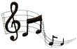 | music
5 |  | face
6 | 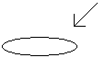 | place
7 | 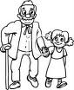 | nice
8 | 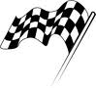 | race
9 | 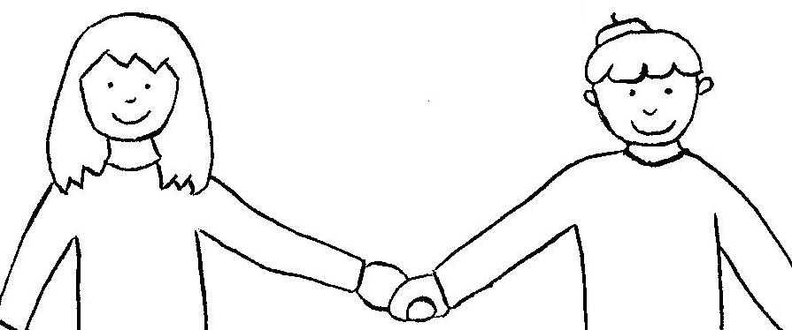 | together
10 | 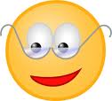 | look
11 | 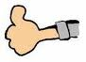 | good
12 | 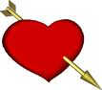 | love

Help Mother and Father Finish the Dance
Laminate board and this page. Cut out the words and phrases by following the lines, to make tiles. To play: lay out the tiles on a table. Look at the next picture on the game board. Using the story as a reference, choose the words and phrases to build a sentence to match the next position on the game board. You may reuse tiles to build a sentence.

dance fast |  |  | Mother |  |  | and |  |  | Father
trips and slips |  |  |  | drops |  |  |  | spins |  | hops
all over the place |  |  |  | races |  |  | face is red
 | . | ‘s |  |  | dance together

Answer sheet:
Mother and Father dance fast.
Father hops.
Father spins Mother.
Father drops.
Father trips and slips.
Father’s face is red.
Father races all over the place.
Father and Mother dance together.



