A Nice Day in the City
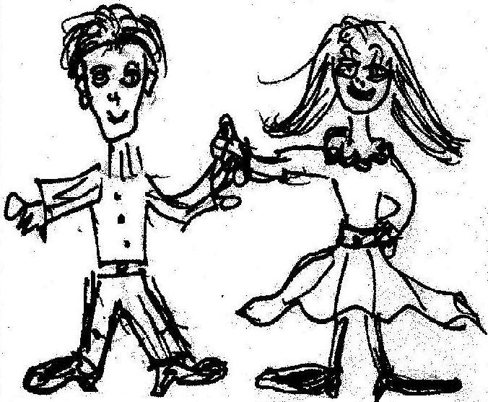  Cy asked Cindy to go with him to the big city. | 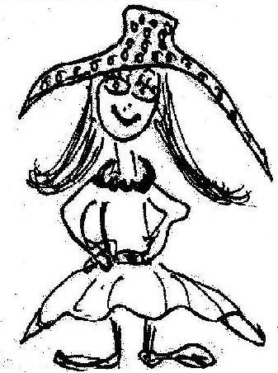  Cindy took her fancy hat. Her face looked so nice in it!
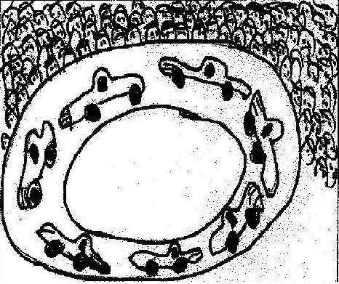  Cindy wanted to go to the racetrack to see the cars race. "It's an exciting place!" she said. | 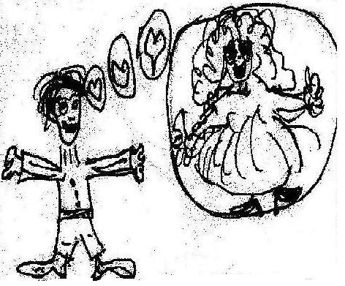  Cy wanted to go to the cinema and see Cinderella.  "It's so romantic!" he said.
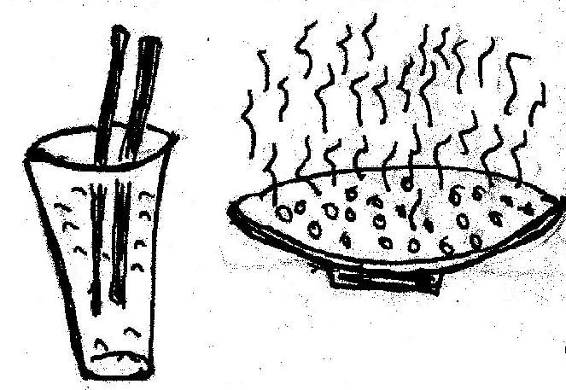    They didn't agree. Cy said, "Let's drink cider with cinnamon, have some spicy rice, and go to both the cinema and the racetrack." | 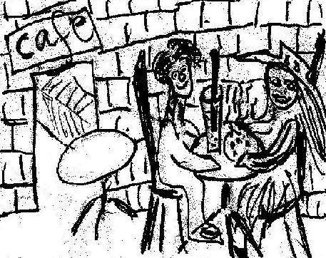  They sat in the racetrack's café, drinking their cider and having some rice. It was a nice place.  They anticipated an exciting day!

Word List
1 | 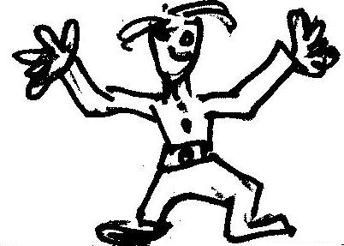 | Cy
2 | 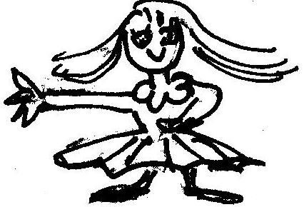 | Cindy
3 | 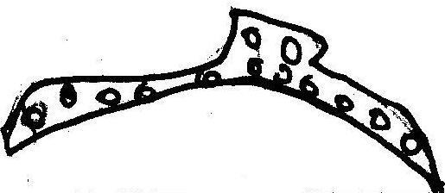 | fancy hat
4 | 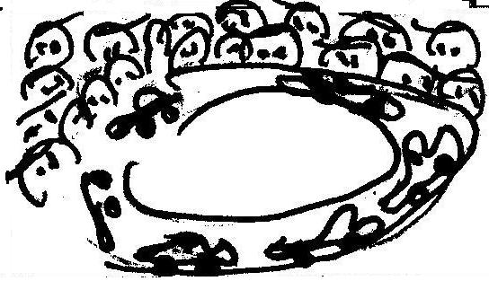 | racetrack
5 | 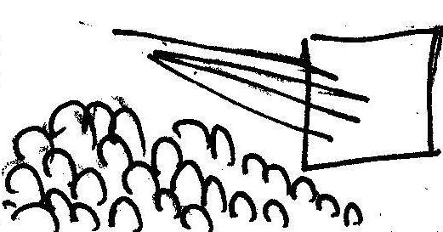 | cinema
6 | 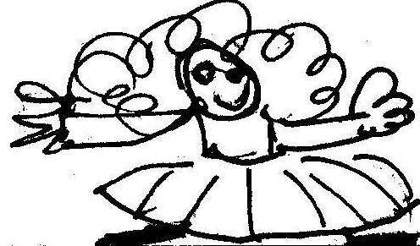 | Cinderella
7 | 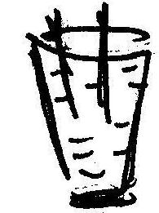 | cider
8 | 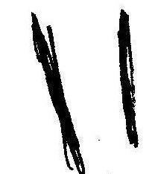 | cinnamon
9 | 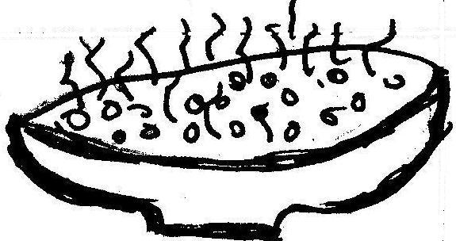 | spicy rice
10 | 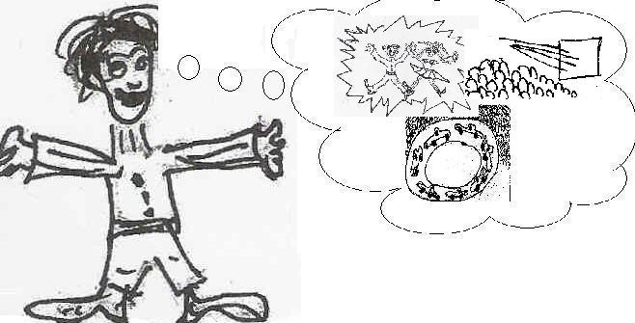 | anticipate
11 | 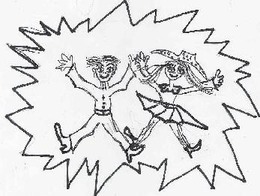 | exciting
12 | 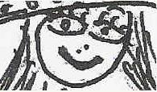 | nice face

Concentration or Matching Game
Cut apart the squares. Match each word or sentence to the picture it describes.
 | Cy and Cindy
 | fancy hat
 | racetrack
 | cinema
 | Cinderella
 | cider with cinnamon
 | spicy rice
 | They sat in the racetrack's café.
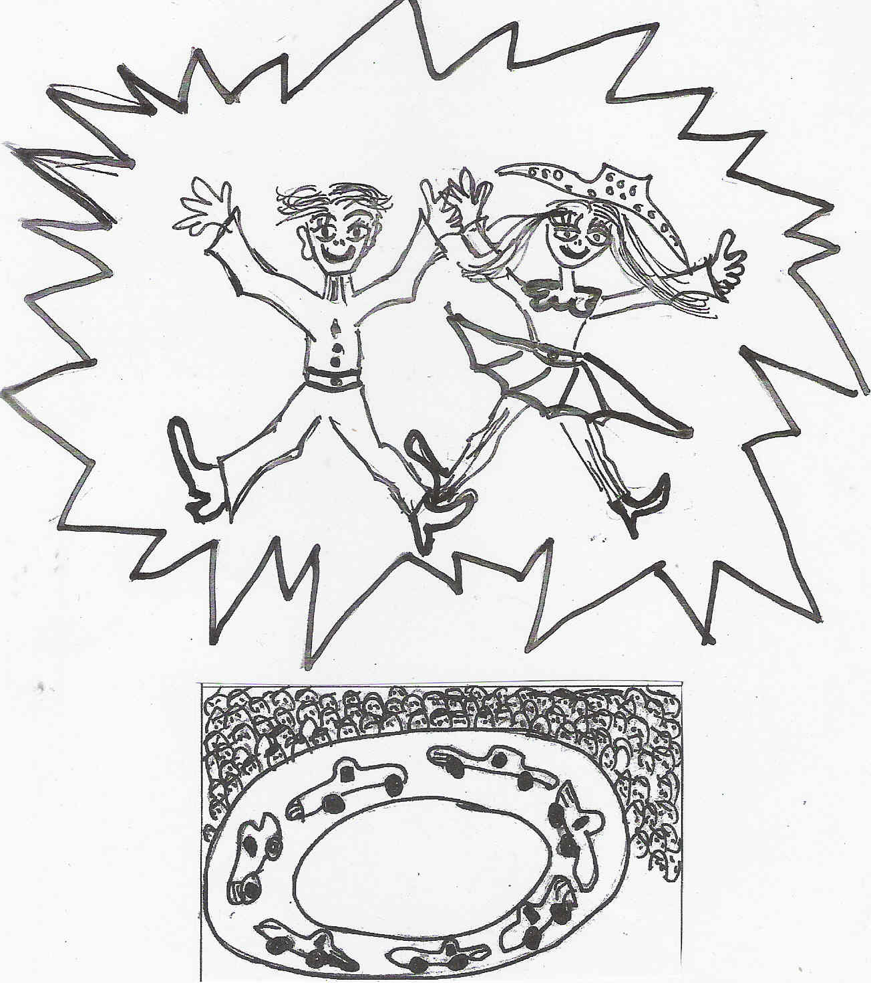 | Races are exciting.
 | They went to the cinema and the racetrack.

