Our Summer House
My family has a house in the mountains.  We drive there every summer.  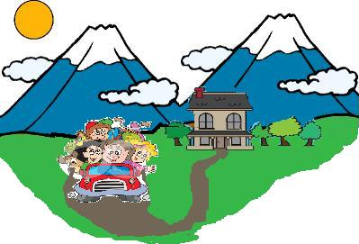 | All around the air is fresh.  
We love being outdoors.  We spend our days outside.  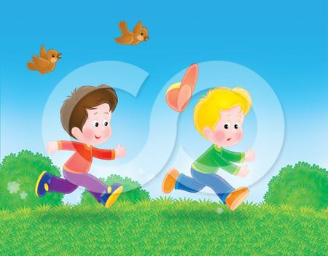 | We love waking up to the sound of the rooster.  
There are trees and flowers  all year long.   | We love our summers in our  summer house.  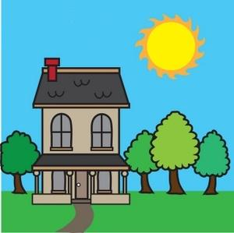

Word List
1 |  | house
2 |  | drive
3 |  | mountain
4 |  | our
5 | 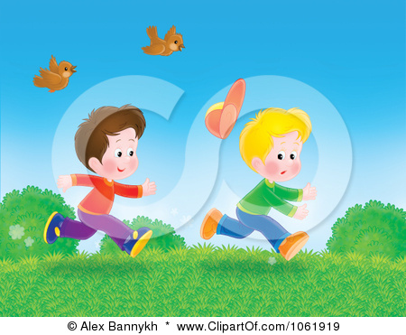 | outside
6 | 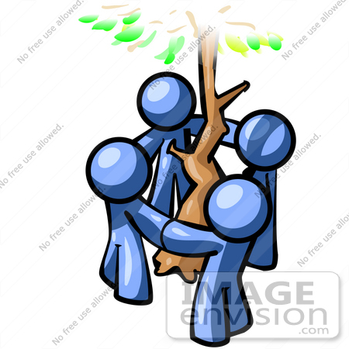 | around
7 |  | sound
8 | 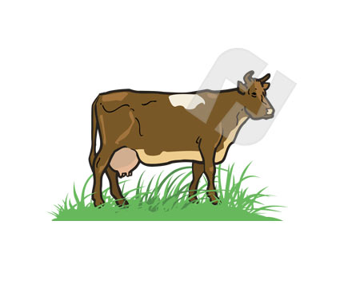 | cows
9 |  | rooster
10 |  | summer
11 |  | flowers
12 |  | ducks

Charades: Guess the Word

The game is for two players (or more, up to four). There are 24 cards, a picture card and a word card for each word. If there are more players- more cards will be needed, one more set of words for each one.
Place the cards in the middle face down. Each player picks up a card on his turn, and acts out the content to the other player. The other player will try to guess which word is being communicated. If the word on the card is guessed successfully, the card will be taken out of the game. If not, it will be put back at the bottom of the pack. Since each word appears once in a picture and once in a printed word, it will give the student two chances to exercise the word, once by acting it out and once by trying to guess it.

house
drive
mountain
our
outside
around
sound
cows
rooster
summer
flowers
ducks

