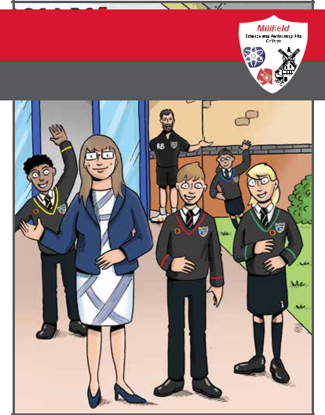
Welcome to Millfield Science and Performing Arts College

Your Pocket Guide

Be Exceptional  Be Exceptional Be Exceptional Be Exceptional

Wear the correct uniform
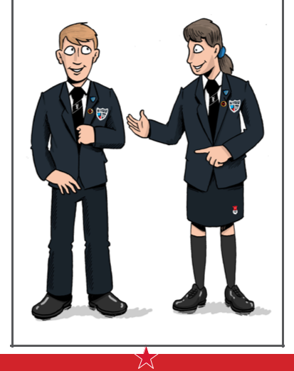

Be Exceptional  Be Exceptional ² Be Exceptional Be Exceptional

What will I need for my first day?

- Wear the correct uniform. We have high standards of presentation from the very first day.

- Remember a pen, pencil, calculator, planner and bag to hold it all.

- Mobile phones must be switched off and kept inside your bag during school hours.

- Get everything ready the night before.

What happens on my first day?


- First you will meet your Form Tutor and other pupils, and start making friends.

- Then you will have assembly with the Headteacher and Head of Transition.

- Your Form Tutor will take you back to your form room and give you your timetable (don’t lose it!), register you for cashless catering and show you where to go for lunch.

- You will be the only students in the school for periods 1 and 2. You will get a tour of the school in period 3 and lessons will begin period 4.

You will also join one of our houses:

Bronte’s Bears Hawking’s Hawks Rowling’s Rhinos Shakespeare’s Sharks

Be Exceptional Be Exceptional ³ Be Exceptional Be Exceptional

‘Millfield Way’
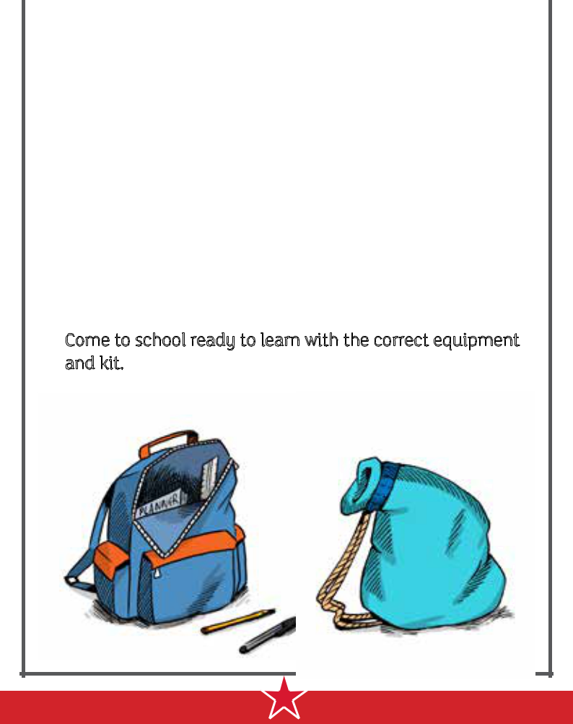

We have developed the ‘Millfield Way’, which has some simple rules to help keep Millfield a kind and supportive place. This will help you to become happy, confident and successful members of our school community.

- Respect fellow pupils and staff and your environment.

- Full attendance is very important.

- Arrive on time for school and each lesson.

- Be smart, so wear the correct uniform. We have clear, simple rules about clothing and appearance.

- Excellent behaviour is expected at school and in the community.

- Enjoy your lessons.

- Come to school ready to learn with the correct equipment and kit.

Be Exceptional Be Exceptional ⁴ Be Exceptional Be Exceptional

‘SMART’
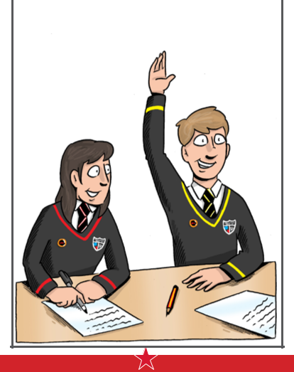

We prefer to concentrate on good behaviour, so you can earn ‘SMART’ house points in every lesson for:

- Smartness in appearance.

- Manners and respect.

- Achieving and attending.

- Resilience in attitude.

- Tolerance of others.

Everyone should follow the

above so they can be

exceptional.

Be Exceptional Be Exceptional ⁵ Be Exceptional Be Exceptional

What happens in a school day?

Each school day looks like this:

- Registration: 8:25am – 8:45am

- Lesson 1:8:45am – 9:45am

- Lesson 2:9:45am – 10:45am

• Break: 10:45am – 11:05am

- Lesson 3:11:05am – 12:05pm

- Lesson 4:12:05pm – 1:05pm

• Lunch: 1:05pm – 1:50pm

- Lesson 5:1:50pm – 2:50pm

- Finish:2:50pm

Who can I talk to if I am upset or worried about anything, or just need to talk?


You can speak to any teacher, but the best people are:

- Your Form Tutor. You will see them every day at registration if you need to talk.

- Head of your house. You will see your Head of House regularly and they will be able to help if you need to talk as well.

It is normal to have worries and it helps to share them, so let us know when you need help. We promise that whoever you speak to will be able to help.

Be Exceptional Be Exceptional ⁶ Be Exceptional Be Exceptional

How can I see what home-learning I have?

Regular home-learning is an essential part of the curriculum for all our students and is given high priority in all subject areas. Home-learning provides an opportunity for students to consolidate and extend the work done in class, for example through Knowledge Organisers. Students use the Millfield Student Planner on a daily basis to help organise and record their home-learning commitments. Teachers, parents and carers also use the planner as a means of regular communication between school and home.

We also have a Homework Club after school where you can get support and advice.

What clubs and trips are available?
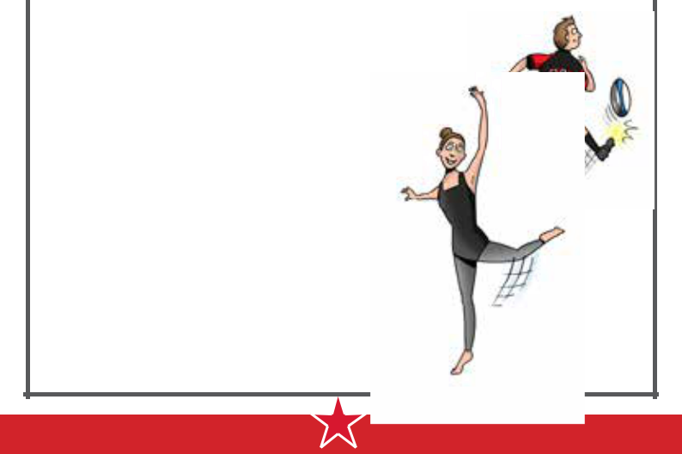

Joining a club is a great way of discovering new interests and talents and making new friends.

We have something for everyone, so why not have a go and do something you love or something new!

Drama and School Productions/

Dance/ Music/ Millfield Band/ Art

Workshops/ Choir/ Mandarin Club/

Eco Warriors/ Rounders/ Stem Club/

Astronomy Club/ Rugby/ Football/

Netball and lots more!

Be Exceptional Be Exceptional ⁷ Be Exceptional Be Exceptional

Find your way around

MAIN YARD

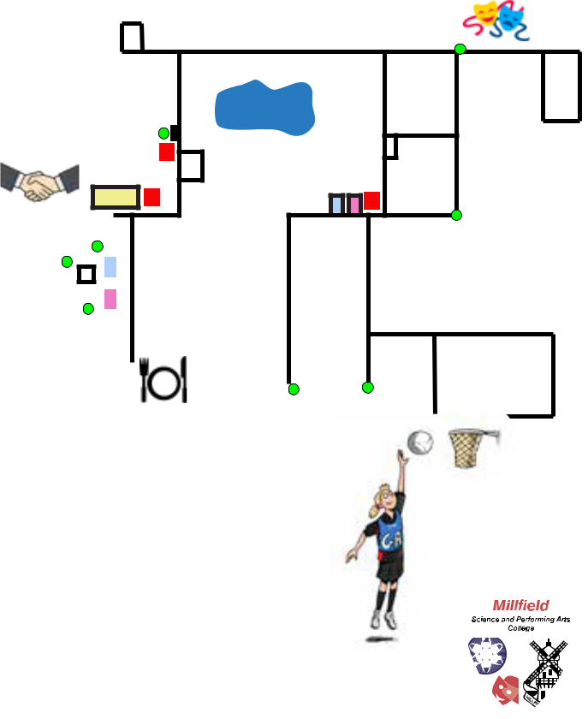

A29 |  |  |  |  | A21
 |  | A28 | 7 |  | A17
 |  | POND |  |  | A17
 |  | POND |  |  | THEATRE

STUDENT ⁶ _{A32 QUAD} SUPPORT

LIBRARY

4 | 8

MATHS |  | 5 |  |  |  |  |  |  |  |  |  |  | A41 |  |  |  |  |  |  |  | MAIN |  |  |  |  |  |  |  |  |  | YEAR 7 YARD
 | LIFT |  |  |  |  |  |  |  |  |  |  |  |  |  |  |  |  |  |  |  |  |  |  |  |  |  |  |  |  |  | YEAR 7 YARD
 |  |  |  |  |  |  |  |  |  |  |  |  |  | COURTYARD |  |  |  |  |  |  | HALL
 |  | 3
 |  |  | A51
 |  |  |  |  |  |  |  |  |  |  |  |  |  |  |  |  |  | 9 |  |  |  |  |  |  |  |  |  |  |  |  | SPORTS
 |  |  | 2 |  | A53 |  |  |  |  |  |  | KITCHEN |  |  |  | A54 |  |  |  |  |  |  |  |  |  |  |  |  |  |  | HALL
 |  |  |  |  | DINING |  |  |  |  |  |  |  |  |  |  | DINING
 |  |  |  |  | ROOM |  |  |  |  |  |  |  | 1 |  |  | ROOM |  | MAIN |  |  |  |  | HEAD’S
 |  |  |  |  |  |  |  |  |  |  |  |  |  |  |  | ROOM |  | ENTRANCE |  |  |  |  | OFFICE

Millfield Science and Performing Arts College

Belvedere Road, Thornton Cleveleys, FY5 5DG Headteacher: Mrs Nicola Regan Telephone: (01253) 865929

Email: Mrs. J. Hall (Head’s PA/Office Manager): admin@millfield.lancs.sch.uk

Website: www.millfield.lancs.sch.uk

Twitter: @Millfieldhighsc

