Find someone who...is like me! Transition Day

Plays a musical instrument  Name: | Has a birthday in June, July or August  Name: | Loves  Science and/or Maths  Name: | Has been on an aeroplane  Name:
Loves ART  Name: | Is about the same height as you  Name:  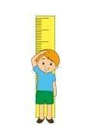 | Has a pet  Name: | Can tell you a joke  Name:
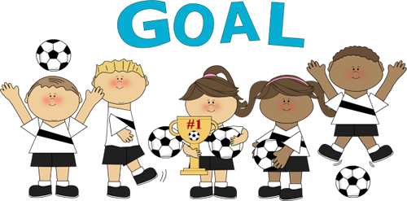  Plays for a sports team  Name: | Has the same eye colour  Name: | Enjoys reading  Name: | Has a birthday in September, October or November  Name:
Has a brother and/or sister  Name: | Is wearing a watch  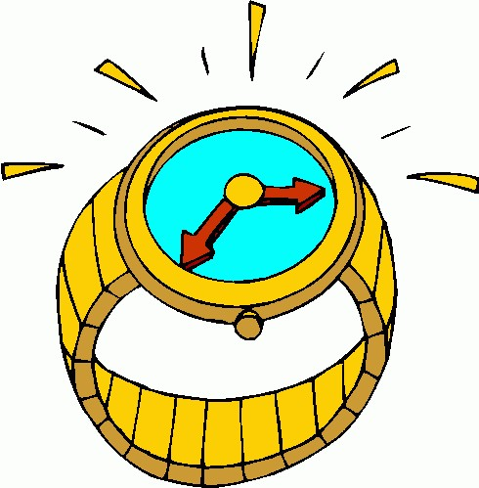  Name: | Who likes  Name: | Who goes to… school  Name:
.
Find someone who...is like me! Transition Day

Plays a musical instrument  Name: | Has a birthday in March, April or May  Name: | Loves History and/or Geography  Name: | Has been on a boat or ship  Name:
Loves ART  Name: | Is about the same height as you  Name: | Has a pet  Name: | Can do a magic trick  Name:
Plays for a sports team  Name: | Has the same eye colour  Name: | Enjoys reading  Name: | Has a birthday in December, January or February  Name:
Has a brother or sister  Name: | Is wearing a watch  Name: | Who likes  Name: | Who goes to .. school  Name:

