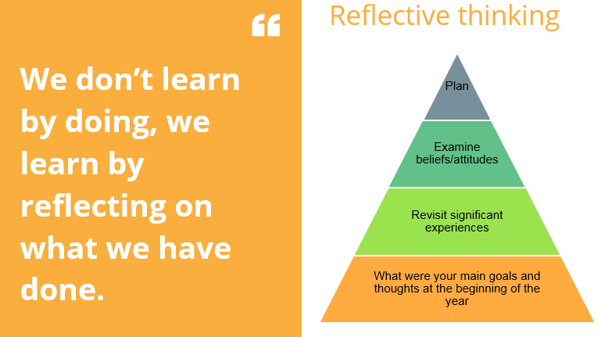
WHAT WERE YOUR MAIN GOALS AND THOUGHTS AT THE BEGINNING OF THE YEAR?
Guiding Questions:
- What were the perceived challenges at the beginning of the year?
- What were your learning goals?
- What were your personal goals?
REVISIT SIGNIFICANT EXPERIENCES
Guiding Questions:
- What was a significant learning highlight/accomplishment in each subjects?
- What have been the personal highlights of the year?
- What evidence do you have for these accomplishments?
- Do you have important shared experiences with your class or peers?
EXAMINING BELIEFS AND ATTITUDES
Guiding Questions:
- Have your attitudes and beliefs changed? If so how and can you identify why?
- What events have been important in your growth this year? Why were they so important?
- How do you feel about the prior goals, beliefs and attitudes you held at the beginning of the year?
PLANNING
Guiding Questions:
- What goals, beliefs and attitudes will you have at the start of next year?
- What is the importance of these in the big picture?
- What actions will you take to make sure you reach goals set?

