My Bubble Is Going Home
There is a virus in the world at the moment. It is known as Covid or CV-19.

If one person catches this virus it is easy for other people to catch it too.

This is why we have been staying in our bubbles and washing our hands a lot.

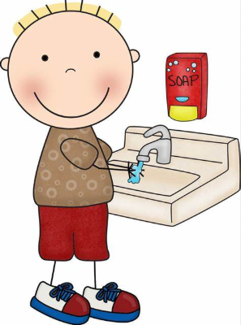
If someone in our bubble isn’t very well and their test says they have CV-19 we all have to go home.

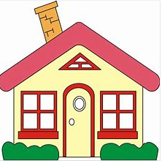
This will help us to stop the virus spreading.
When we go home we will still be able to do our work.
Some of the work may be on paper and some of it might be videos to watch on the computer.
To make sure that we haven’t got the virus too we will stay at home for 2 weeks.

If we have caught the virus we might get a high temperature and a cough but most people get better quickly and can soon be back in school.

