**TASK PLAN**

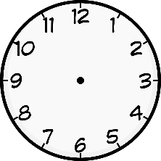

This should take ………………. Finished by

When I’ve finished

1…………………………………………………………………….. 

2…………………………………………………………………….. 



Anything else?

……………………………………………………………………… 

……………………………………………………………………… 

What do I need?

1…………………………………… 2…………………………………….

3…………………………………… 4…………………………………….

5…………………………………… 6…………………………………….

What do I need to do?

1……………………………………………………………………..

2……………………………………………………………………..

3……………………………………………………………………..

4……………………………………………………………………..